Access and transport

Main Conference site :
Salle Académique - Université de Liège (Place du 20 Août 7 – 4000 LIEGE)
https://www.campus.uliege.be/cms/c_1770920/fr/a1-batiment-central-rectorat-administrations (click on the link ‘Itinéraire’ for personalized directions)

To get from the airport (Brussels Airport) to the city center of Liège (distance: 90 km), the quickest and cheapest option is by train (be advised that taking the taxi would cost up to 200€ and you would need to arrange a taxi in advance):
- At the airport, go to the undergound train station and take the train to Liège-Guillemins (one direct train every hour; cost: 19.10 €; duration: about 1 hour; www.sncb.be)
- The Liège-Guillemins railway station can also easily be reached via international trains from Germany (DB-ICE), the Netherlands and France (Eurostar) (https://www.b-europe.com)
- When arriving at Liège-Guillemins railway station, take the tramway (direction: Coronmeuse or Liège Expo; https://www.letec.be/lines/L1000); get out at Place Saint Lambert or Opéra stops)

Public transport in Liège:
Tramway, Bus (company: LETEC)
Link for journey itinerary: https://www.letec.be/itineraries
Link for ticket information: https://www.letec.be/View/Ou_acheter_votre_titre_de_transport_/1063

Train (company: SNCB)
Link for journey itinerary and tickets: https://www.belgiantrain.be/fr
Taxi in Liège
You can find taxi companies via this link:
https://www.liege.be/fr/vie-communale/services-communaux/mobilite/se-deplacer/taxi

Address of Social Event location:

Orchestre Philharmonique Royal de Liège (OPRL)
Room Eugène Isaÿe
Boulevard Piercot 25/27 - 4000 Liège
https://www.oprl.be/en/practical/practical-info/access

To walk (11min) from the main conference site to the social event location:
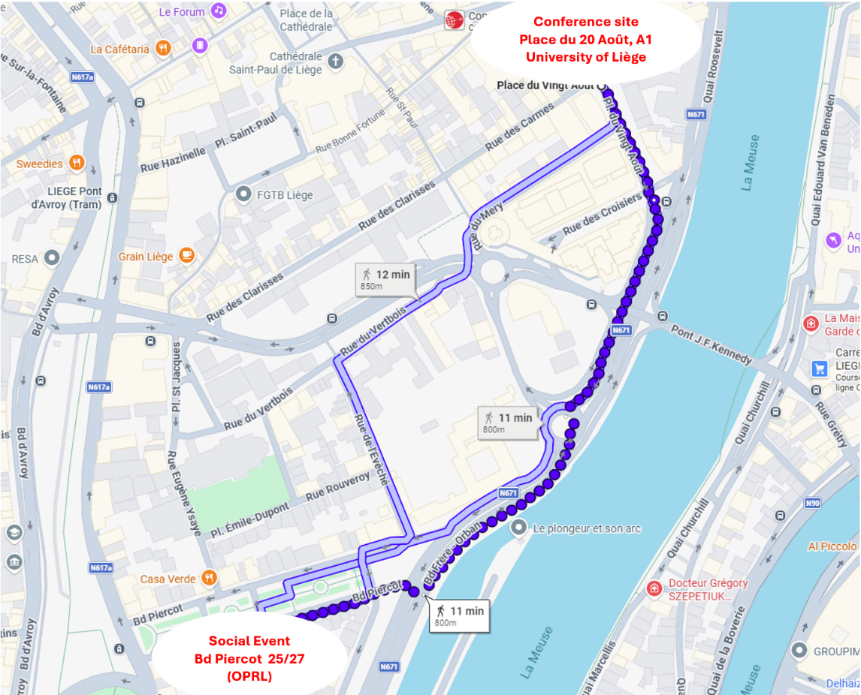

Address of NIDCD Mentoring event

Language training center, L5 building, Room 2/5
Rue des Pitteurs 18-20 – 4020 Liège
https://www.campus.uliege.be/cms/c_11284905/en/l5-language-training-centre

To walk (11min) from the main conference site to the mentoring event location:
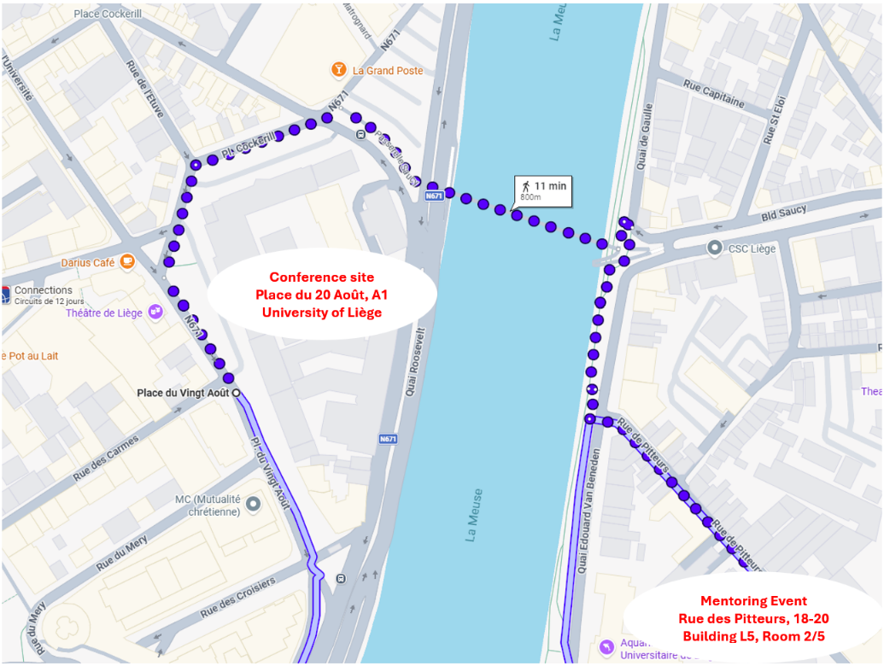

.

For checking visa/ESTA requirements and procedures:

https://unitedstates.diplomatie.belgium.be/en/travel-belgium (for US citizens)
https://etias.com/etias-countries/belgium-etias (for all citizens coming from outside the Schengen area)

Hotels

Selection of hotels at walking distance of the conference site

Ibis Liège Centre Opéra - About a 4- to 5-minute walk from the main entrance of University of Liège.
📍 Adresse : Place de la République Française, 41, 4000 Liège
🌐 https://all.accor.com/hotel/0864/index.fr.shtml

Amosa Liège City Centre Hotel - About a 4- to 5-minute walk from the main entrance of University of Liège.
📍 Adresse : Rue St Denis 4, 4000 Liège
🌐 https://www.amosaliege.be/fr/

Hôtel Neuvice – About a 6- to 7-minute walk
📍 Adresse : En Neuvice 45, 4000 Liège, Belgique
🌐 https://www.booking.com/hotel/be/neuvice.fr.html

Pentahotel Liège – About an 8-minute walk
📍 Adresse : Boulevard de la Sauvenière 100, 4000 Liège, Belgique
🌐 https://www.tripadvisor.fr/Hotel_Review-g188655-d206715-Reviews-Pentahotel_Liege-Liege_Liege_Province_The_Ardennes_Wallonia.html

Van der Valk Selys Liège – About a 9- to 12-minute walk
📍 Adresse : Mont Saint-Martin 9-11, 4000 Liège, Belgique
🌐 https://www.tripadvisor.fr/Hotel_Review-g188655-d20224611-Reviews-Ibis_Styles_Liege_Guillemins-Liege_Liege_Province_The_Ardennes_Wallonia.html

Restaurants

https://www.visitezliege.be/en/page/ou-boire-et-manger-a-liege

Two areas, very close to the conference site, are of particular interest for dining and having a drink:
Place du Marché (https://www.resto.be/restaurant/liege/place-du-marche) and En Roture (https://www.resto.be/restaurant/liege/en-roture)
LIEGE VISIT PASS
https://www.visitezliege.be/fr/page/visit-pass
The Visit Pass offers access to 13 museums in and around Liège for €18, including major cultural sites such as La Boverie, Grand Curtius, and the Préhistomuseum. The pass also includes a guided tour of the historic city center (seasonal) and access to the famous 12th-century baptismal fonts at Collégiale Saint-Barthélemy.
The pass costs €18, is valid for 48 hours, and can be purchased at the tourism office of the Liège region. Some museums may charge an extra fee for temporary exhibitions.

Family activities to do in Liège
Here is a selection of must-see places to discover with your family while visiting Liège.
See also https://www.visitezliege.be/en for a more complete selection of sites and activities.
1. Aquarium-Muséum Universitaire de Liège
🌐 https://www.aquarium-museum.uliege.be/cms/c_12768843/fr/aquarium-museum
📍 Quai Edouard Van Beneden, 22 – 4020 Liège

2. Maison de la Science
🌐 https://www.maisondelascience.uliege.be/cms/c_12769094/fr/maison-de-la-science
📍 Quai Edouard Van Beneden, 22 – 4020 Liège

3. Musée des Transports en commun de Wallonie
🌐 https://www.musee-transports.be/
📍 Rue Richard-Heintz, 9 – 4020 Liège

4. Maison de la Métallurgie et de l’Industrie de Liège
🌐 https://www.mmil.uliege.be/cms/c_12769422/fr/maison-de-la-metallurgie-et-de-l-industrie
📍 Boulevard Raymond-Poincaré, 17 – 4020 Liège

The must-see places
Here are some of Liège’s must-see places.
1. Cathédrale Saint-Paul de Liège
🌐 https://www.cathedraledeliege.be/
📍 Rue Charles Magnette, 98 – 4000 Liège
2. Église Saint-Jacques
🌐 https://www.visitezliege.be/fr/offre/eglise-saint-jacques
📍 Place Saint-Jacques, 8 – 4000 Liège
3. Coteaux de la Citadelle
🌐 https://www.visitezliege.be/fr/offre/les-coteaux-de-la-citadelle
📍 Montagne de Bueren – 4000 Liège
4. Montagne de Bueren
🌐 https://www.visitezliege.be/fr/offre/montagne-de-bueren
📍 Montagne de Bueren - 4000 Liège
5. La Boverie
🌐 https://www.laboverie.com
📍 Parc de la Boverie, 3 – 4020 Liège
6. Grand Curtius
🌐 https://www.grandcurtius.be/
📍 Féronstrée, 136 – 4000 Liège
7. Musée de la Vie wallonne
🌐 https://www.provincedeliege.be/viewallonne
📍 Cour des Mineurs – 4000 Liège
8. Rives de Meuse :
Very pleasant walks, with routes available for cycling or walking. https://tourismattractions.net/belgium/li%C3%A8ge-travel-tips-2025

