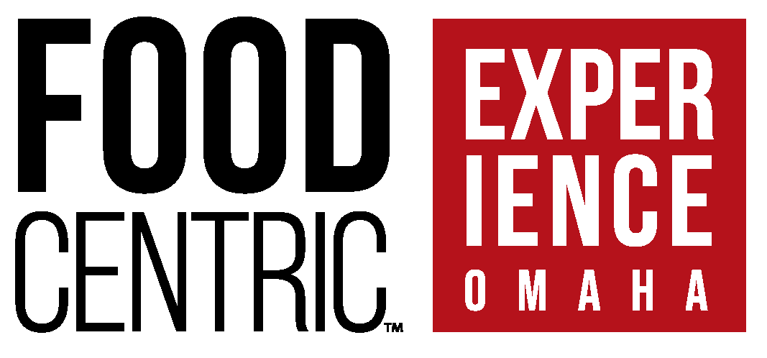

***Vendor Information Packet***

**Tuesday, September 23rd, 2025   
Mid-America Center, Council Bluffs, Iowa  
1 Arena Way, Council Bluffs, IA 51501**

**Show Time: 11 AM to 4:30 PM  
Customer & Vendor Appreciation   
Reception Begins at 4 PM**

***We will announce our 2025 Supplier of the Year &   
Broker of the Year at our Reception!***



**General Information – Performance Foodservice Fall 2025 Food Centric Event**

**Date & Location:** Tuesday, September 23, 2025 at the Mid-America Center – One Area Way, Council Bluffs, IA 51501

**Event Contacts:**   
Kara Teel, Marketing & Brands Manager [Kara.Teel@pfgc.com](mailto:Kara.Teel@pfgc.com) Cell: 970-800-1170   
Franz Keuser, VP of Procurement [Franz.Keuser@pfgc.com](mailto:Franz.Keuser@pfgc.com) Cell: 402-312-5692

**Show Hours:** 11:00 AM to 4:30 PM; Post-Party/Appreciation Reception 4:00 PM to 8:00 PM with live music, various food stations, and raffle prizes. All vendors, brokers and customers are invited to attend the reception after the show! We will also announce our 2025 Supplier of the Year and 2025 Broker of the Year at our after party!

**Show Set-Up Hours:** Monday, September 22nd from 12:00 PM – 5:00 PM AND Tuesday, September 23rd from 6:00 AM – 11:00 AM. Our Sales Team will walk the show floor Tuesday, September 23rd from 9:00 AM – 10:15 AM.

**Raffle Prizes**: We still have raffle prize opportunities available. Those who donate raffle prizes will receive recognition at the reception. Please call Kara Teel if you have a raffle prize you’d like to donate! (402) 457-3646

**Booth Assignments & Floor Plan:** The finalized floor plan will be available in early September. PFS reserves the right to change booth assignments and show layouts at any time. Each Booth is 10’ x10’ with one 8’ front table. Tables are covered & skirted. During the show, you have kitchen access and access to a PFS truck on dock with a frozen & refrigerated holding area. This event will be Open Style with limited back curtains in the center of Ball Room & Exhibit Hall. Booths located along the outside wall will have back drape/curtain on your booth.

**Electrical Needs:** All Electric needs must be communicated by **Friday, August 22nd** so that we can plan accordingly and set up your booth prior to the show. **Any electrical changes or request the day of show will be billed at double the cost.**

**Event Technology:** A mandatory technology fee has been communicated during the registration process. This fee includes access to our online allowance portal (Mealticket), a mobile app for lead captures & case bookings, on-site support and training, and post-show reporting. All orders will be processed through Vfairs. No hand-written paper orders will be accepted. Full access to these amenities and food show participation may not be provided if the technology fee is not paid. We will work with you to finalize allowances and import them into the portal prior to the show so both you and customers have visibility into these deals. Please reach out to your appropriate Buyer with questions.

**Featured Products:** Please contact your Performance Omaha Buyer to review all items prior to the deadline as all items shown must be pre-approved. There will be no deviations from this policy. **Any unauthorized products shown will be charged a new item fee of $1,000.** We also ask that the focus be on new & seasonally appropriate items, as well as products projected to have ample supply to ensure a successful booking show.  
  
**Samples**: Samples that are purchased/pulled from PFS stock must be ordered by Friday, September 12th and picked up by Friday, September 19th. We will not deliver your samples to the Mid-American Center dock. Vendors & brokers are responsible for all samples. All Vendors/Brokers must have a valid account set up with PFS-Omaha to bill back samples to.

**Booking Show Ship Period & Allowances:** The customer shipping period for all products ordered will be the 8-week period October 5th to November 29th, 2025. Product allowances are required on all stocked items included in the show. Allowances will be applied to customer purchases. Vendors are responsible for funding of these allowances. We recommend an allowance of minimum 5% of the case value. Participating vendors will be billed for all cases purchased by Performance Foodservice-Omaha during the twelve-week period September 7th through December 13th (8-week shipping period plus two week prior to show, plus two-week post shipping period, to ensure ample preparation & stocking). Vendor bill backs will be issued within four to six weeks after the completion of the purchasing period. Please have all allowances back to PFS no later than August 29th so we can import them into the Vfairs portal.   
  
**Health & Safety:** The health & safety of our supplier/broker partners, customers, and employee is our utmost priority. If you are displaying any cold/flu symptom (including a fever, cough, and shortness of breath) or may have been exposed to someone with Covid-19 at time of event, contact Kara Teel immediately and refrain from attending the show.

* All supplier/servers handling food samples must wear gloves.
* Please have hand sanitizer available at your booth.
* Wash your hands, there are several sanitation stations available.
* Practice food safety always.
* There will be a security guard at this venue during entire event, from set-up to tear down.

**House Keeping Notes:**

* No early teardown of booth is allowed before 4:30 PM on Tuesday, September 23rd.
* Please ensure that you leave the facility kitchen as you found it.
* If using the venue appliances and/or dishes, please ensure you wash and clean them, returning them to where you found them. Be considerate of other vendors & staff using the kitchen facilities as well.
* Booth/Vendors not in compliance with these house rules will be charged a $250 cleaning fee.
* Food Bank of the Heartland will be available at the conclusion of event to pick-up any suitable leftover products you wish to donate.

**Hotel Recommendations & Travel:**

For those flying into Omaha, you will fly into Eppley Airfield, which is about 3 miles from our OPCO and about 9 miles from the Mid-America Center. We suggest staying in the downtown area or in Council Bluffs near the event center. Below are hotel suggestions.

[Hilton Garden Inn Omaha East/Council Bluffs](https://www.hilton.com/en/hotels/omaeagi-hilton-garden-inn-omaha-east-council-bluffs/?SEO_id=GMB-AMER-GI-OMAEAGI&y_source=1_MjA4MzM5OC03MTUtbG9jYXRpb24ud2Vic2l0ZQ%3D%3D) (712) 309-9000  
[Harrah’s Casino-Council Bluffs](https://www.caesars.com/harrahs-council-bluffs?utm_campaign=GMB&utm_source=google&utm_medium=local&utm_term=HarrahCouncilBluffs&utm_content=Hotel&y_source=1_NDM2NjgwNC03MTUtbG9jYXRpb24ud2Vic2l0ZQ%3D%3D) (712) 329-6000  
[Courtyard by Marriott Omaha East/Council Bluffs](https://www.marriott.com/en-us/hotels/omauf-courtyard-omaha-east-council-bluffs-ia/overview/) (712) 318-3330  
[Springhill Suites Omaha East/Council Bluffs](https://www.marriott.com/en-us/hotels/omash-springhill-suites-omaha-east-council-bluffs-ia/overview/?scid=f2ae0541-1279-4f24-b197-a979c79310b0) (712) 256-6500  
[Country Inn & Suites by Radisson, Council Bluffs](https://www.radissonhotelsamericas.com/en-us/hotels/country-inn-council-bluffs-ia?cid=a:se+b:gmb+c:amer+i:localrs+e:rad+d:us&mc=llgoxxpx) (712) 318-5706