KNQA enhancing inclusivity in education progression through Recognition of Prior learning policy

The Kenya National Qualifications Authority (KNQA) is an overall facilitator within the education sector in Kenya, cutting across the Basic, TVET and University Sectors. KNQA also supervises the development of policies on national qualifications. The authority has developed Recognition of prior learning policy (RPL) which is the process used to identify assess and certify a candidate’s knowledge, skills and competencies acquired in non- formal or formal learning.

How does RPL work, the process is typically a 6 weeks process from the point you submit your evidence portfolio.
- A candidate is eligible for RPL if you have solid experience and knowledge in your field of work outside informal and non-formal learning setups.
- The candidate is requested to have a portfolio of evidence such as reference letters, work samples/ examples i.e. videos/photos, records of seminar, conference and workshop attended etc.
- Once an RPL assessor has gone through your portfolio they will call you in for a competency conversation and a practical observation.
- All certificates are Nationally Recognized and issued by a Qualifications Awarding Institution Accredited by the KNQA
- The cost of RPL varies based on the candidate and the number of units of competency for which they are seeking recognition.
- Candidates can appeal against a decision made by the assessment panel once the assessment process is done and concluded within three months from the date of receipt by Qualifications Awarding Institutions or authorized agents.

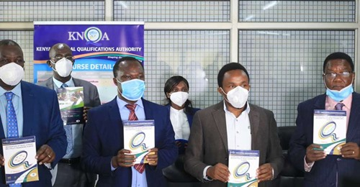
From Left P. S State department Vocational Technical and Training Dr. Julius Jwan, KNQA Director General Dr. Juma Mukhwana, CAS Zack Kinuthia and Chair KNQA Board Dr. Kilemi Mwiria during the launch of Recognition of Prior Learning

By Kelins Randiek

