Shared Streets and Walkability
Making Shared Streets More Accessible for the Blind

Introduction

Shared streets is a design approach that reduces the segregation between motor vehicles and pedestrians. This is typically done by removing features such as kerbs, road surface markings, traffic signs, and traffic lights. The elimination of these navigational cues can cause walkability issues especially for pedestrians impacted by blindness who may rely on these features while navigating the street.

This discussion paper will discuss the accessibility challenges of shared streets as well as give an overview of design recommendations taken from the comprehensive report Accessible Shared Streets: Notable Practices and Considerations for Accommodating Pedestrians with Vision Disabilities, to support people impacted by blindness navigating shared streets.

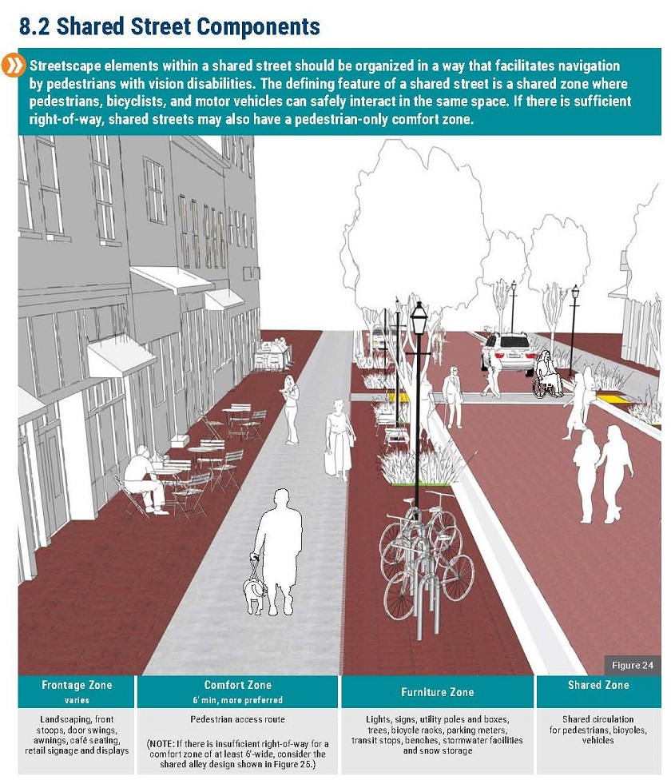
Shared Streets
Ph

Photo of a shared street design which outlines each zone described in text.
Source: Federal Highway Administration, 2017
Shared streets should be designed in such a way that individuals with vision impairments can navigate easily. A shared roadway is distinguished by a shared zone in which pedestrians, cyclists, and motor vehicles can occupy the same space.

The design of shared streets is typically categorized into 4 zones. These include a
frontage zone, comfort zone, furniture
zone and shared zone. Descriptions of
these zones are listed below.

- Frontage Zone: The frontage zone includes landscaping, outdoor café seating and retail signage and displays.

- Comfort Zone/ Sidewalk: The comfort zone is the pedestrian access route. The comfort zone is a crucial component of a shared street. The comfort zone provides a walkway, solely for pedestrians to travel. Comfort zones should be straight, well defined and free of obstructions. It is important to note that pedestrians have the option of using the entire shared street or staying within their comfort zone.

- Furniture Zone: Includes common outdoor amenities such as lights, benches, utility poles, greenery, transit stops and stormwater facilities.

- Shared Zone: Shared circulation for pedestrians, bicycles and vehicles.

The Challenges of Shared Streets

Shared streets can often cause accessibility issues for those impacted by blindness and low vision since many navigational cues such as curbs and defined crossings are not typically found in the streetscape. Shared streets also integrate both vehicles and pedestrians in the same zone which can cause potential challenges.

The Federal Highway Administration funded a project to develop and identify challenges and provide recommendations for cities when developing shared streets. Six Challenges of shared streets are identified and were taken from the comprehensive report Accessible Shared Streets: Notable Practices and Considerations for Accommodating Pedestrians with Vision Disabilities,

These challenges are listed below:

- Shared streets usually lack clearly defined zones for pedestrians of all abilities to seek refuge out of the way of impediments and potential confrontations with other users of the area, particularly automobiles and bicycles.

- Traditional roadways are governed by traffic control equipment and set "laws of the road" that all users must abide by. Shared streets rely on social engagement and negotiation, which are formed by visual awareness, eye contact or hand signals—activities that disadvantage pedestrians with visual impairments.

- Shared streets allow for a variety of uses, such as individuals utilizing the space for active transportation or for the delivery of products. Shared streets also allow for a variety of activities such as outdoor café patio furniture, markets, moveable seating and much more. It is important that these amenities do not protrude the comfort zone or paths of travel.

- Pedestrian infrastructure such as curbs, curb ramps, detectable warning surfaces, and crosswalks that assist pedestrians with visual impairments to orient themselves are typically not found in shared street streetscapes.

- Shared streets often use patterned pavement for an aesthetic appeal. This can, however, be confusing and disorienting to those with vision impairment, who may misinterpret the patterns for navigation indications.

- For pedestrians with vision impairments, the lack of defined crossings, along with more uncertainty about how other road users will react, makes deciding where and when to cross more difficult, contributing to a sense of confusion and making crossing a difficult task.

Recommendations

The report Accessible Shared Streets: Notable Practices and Considerations for Accommodating Pedestrians with Vision Disabilities gathered feedback from key stakeholders. People with mobility, hearing and vision impairments were asked to provide input in a series of workshops. Engineers, planners and orientation and Mobility specialists also contributed to the discussion.

Recommendations to make shared streets more accessible for those with vision impairment included:

- Tactile Walking Surface Indicators (TWSI). Shared streets must include TWSIs at corners and crossings. Shared streets should also include directional TWSI along a pathway to provide greater support to people impacted by blindness and low vision.

- Detectable changes. Detectable changes in surface texture and changes in colour should be included in a shared street design to help with identification. The shared zone should be of different colour and different surface texture from the comfort zone to help differentiate the areas.

- Comfort Zone. To help support people impacted by blindness and low vision, shared streets should be accompanied by a comfort zone. When designing comfort zones, it is important to ensure the zone is accessible for the visually impaired. A linear, obstacle-free pedestrian path should be defined using surfaces that are identifiable and detectable by long cane. Common outdoor elements such as trees, benches and seating should not obstruct the comfort zone.

- Traffic Calming Measures. Since vehicles share the road with pedestrians, it is advised for shared streets to include traffic calming measures to ensure pedestrian safety. Traffic calming measures for shared streets include gateway treatments to alert drivers that they are approaching an area where they must drive at a slower pace. This treatment may include signage, entry portals, speed tables, raised crossings, and curb extensions. For more shared street traffic calming strategies, visit Global Designing Cities Initiative

Jurisdictions around the world including cities in Canada have re-designed downtown streets into a shared street environment. To help make shared streets a more safe and enjoyable experience for people of all ages and abilities, it is important for the recommendations above to be implemented in the design to foster accessible and safe walkability for people impacted by blindness.

