Sharing Spaces with Micro Mobility Devices
A discussion about two popular and novel innovations; Personal Delivery Devices (PDDs) and e-Scooters.

1. Introduction
This discussion paper will give an overview of micro mobility devices, such as Personal Delivery Devices (PDDs) otherwise known as delivery robots, Automated micro-utility devices and electric scooters (e-scooters). This paper will explore the challenges amongst micro mobility devices and how they are impacting city sidewalks for people with disabilities. Recommendations will be presented to enhance accessibility of these devices.

2. Personal Delivery Devices

With the rise in popularity of online delivery services such as Skip the Dishes, Uber Eats and Amazon Prime, companies such as Amazon, Starship, FedEx and Uber are taking an innovative approach to the conventional human delivery service by developing, piloting and launching Personal Delivery Devices (PDDs) otherwise known as delivery robots in cities across the globe.

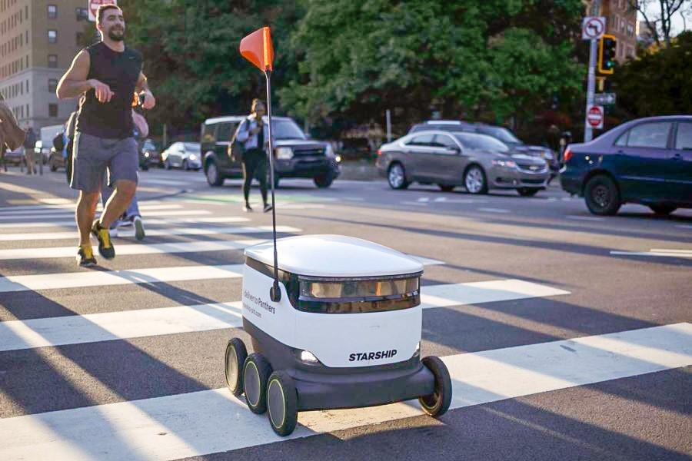
Photo of Starship delivery robot co-existing with pedestrians.
Source: The Pitt News, 2020

2.1 Advantages of Personal Delivery Devices
With new advancements and knowledge around robotics, GPS tracking, and navigation, PDDs may be the new craze amongst consumers as they offer practicalities such as faster, no-contact delivery, an attractive feature amid the COVID-19 pandemic. PDDs also provide food safety. Once the robot is packed with the consumer's order, the food compartment is locked so no one can touch what is inside. The extra security may help those who are anxious about their food being contaminated or stolen by delivery workers. Furthermore, due to the high demand for delivery services, robots may help to reduce the number of delivery trucks and vehicles on the road, thus, reducing traffic congestion and emissions.

2.2 Accessibility Concerns
PDDs do have their advantages, however, accessibility must be a standard during the development and deployment of such technology. These robots do provide convenience for seniors and people with disabilities by bringing goods and groceries to their doorsteps, however, PDDs could impact mobility and cause obstacles on sidewalks for pedestrians with disabilities.

The Pedestrian and Bicycle Information Centre (Pedbikeinfo) states in their document Sharing Spaces with Robots: The Basics of Personal Delivery Devices that although artificial intelligence has advanced throughout the years, these robots, do not share the same physical and cognitive skills as humans, making conflict between PDDs and humans is inevitable.

If a sidewalk is damaged, the robot may not be able to pass by, therefore resulting in the robot blocking a section of the sidewalk. For people who are blind, this could create a tripping and mobility hazard and can also result in navigation challenges for wheelchair users (Pedbikeinfo,2021).

For people impacted by blindness, they are already maneuvering around obstacles while walking on the sidewalk. Sidewalks typically include elements such as trees, planters, benches and restaurant patios, therefore the addition of robots on sidewalks could present greater congestion, resulting in mobility challenges and safety hazards.

Currently, there are no requirements for delivery robots to have any audio warnings, therefore, pedestrians who are blind are unable to tell if a robot is heading in their direction, which can result in injury. PDDs also create substantial safety implications for people who are deaf-blind. (Pedbikeinfo,2021).

These robots also cause concerns for wheelchair users. Wheelchair users require more room on the sidewalk as opposed to people who walk on foot. Many urban sidewalks are already quite congested with pedestrians and sidewalk amenities, therefore, adding PDDs to the sidewalk leaves less space for wheelchair users to navigate. Furthermore, the winter months could add greater frustration and hazards to wheelchair users as snow piles up, thus making the sidewalk even more narrow.

Regardless of these concerns, cities around the world have introduced robots allowing them to roll onto city sidewalks and on university campuses. The Government of Ontario has launched a pilot project to assess the viability of allowing these devices to operate. Appendix

Toronto recently introduced Geoffrey, it’s first delivery robot. The Accessibility for Ontarians with Disabilities Act Alliance have been advocating for PDDs like Geoffrey to be banned from sidewalks and in other public spaces as they can pose a tripping and safety hazards for people impacted by blindness or low vision.

2.3 Recommendations

With the sudden increase of PDDs on city sidewalks, cities must develop guidelines to ensure the safety of pedestrians of all abilities.

PDDs must be visible and/or audible for all pedestrians. Companies must do test runs and work with people who are blind and low vision to ensure audible features are loud enough to be heard over other city noise including traffic. PDDs must not travel too closely next to pedestrians and instead allow for necessary space.

Governments at all levels must develop and plan proactively. Opportunities and challenges caused by PDDs must be acknowledged. Certain limitations (e.g., speed, size, weight) must be in place to increase safety. Laws must be in place to ensure the PDDs do not jeopardize the safety and mobility of all pedestrians. PDDs will depend on regulatory decisions, public trust and acceptance, and the readiness of such technology (Pedbikeinfo,2021).

3. E- Scooters_

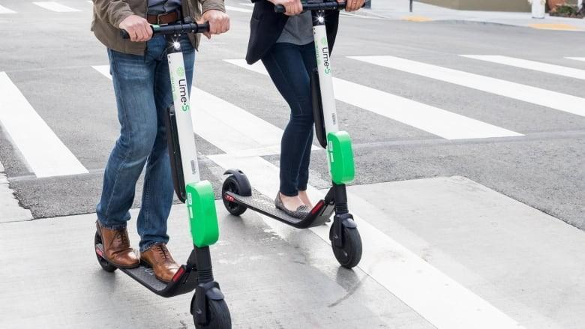
Photo of two people riding an e-scooter.
Source: CBC, 2019

Micro Mobility Devices, also known as e-scooters have become increasingly popular and are a convenient way for people to get around their city. E-scooters are typically designed with a large deck in the center, large enough for a person to stand on the scooter. E-scooters typically have 2 wheels and handlebars and are powered by an electric motor.

Many cities around the world have launched e-scooter sharing programs to give residents greater transportation options. In Canada, pilots have been launched in several cities including, Calgary, Edmonton and Ottawa, to name a few. CNIB is of the belief that more cities will adopt this method of convenient transportation in order to meet greenhouse gas reduction targets.
E-scooter sharing programs work by renting a scooter through a mobile app of the service provider. E-scooter sharing programs are typically “dockless”, meaning that people use an app to find the nearest scooter, then leave it on the side of the sidewalk when done. This, however, has created challenges with people improperly parking their scooters, which have caused additional challenges for people with disabilities while navigating already busy, congested city sidewalks.

3.2 Accessibility Concerns
3.2.1 E-scooters Riding on Sidewalks

In Canada, e-scooter laws vary from city to city. Several cities such as Kelowna, Calgary, Edmonton, Ottawa and Montreal have included dockless e-scooter sharing programs. Calgary, however, is the only city that allows e-scooters on sidewalks and bike paths. Nonetheless, due to the lack of law enforcement, people are still riding e-scooters on sidewalks in cities that have prohibited their use, creating additional barriers for people with disabilities.

Having e-scooters travel on the same path as pedestrians can cause serious challenges and can lead to injury. E-scooters can travel up to 20 kilometers per hour and are silent, therefore pedestrians who are blind might not be aware that an e-scooter, is present.

3.2.2. Scooter Liter
Photo of a stranded e-scooter on the sidewalk in Kelowna. The scooter is located very closely to the curb cut.
Source: Kelowna Capital News
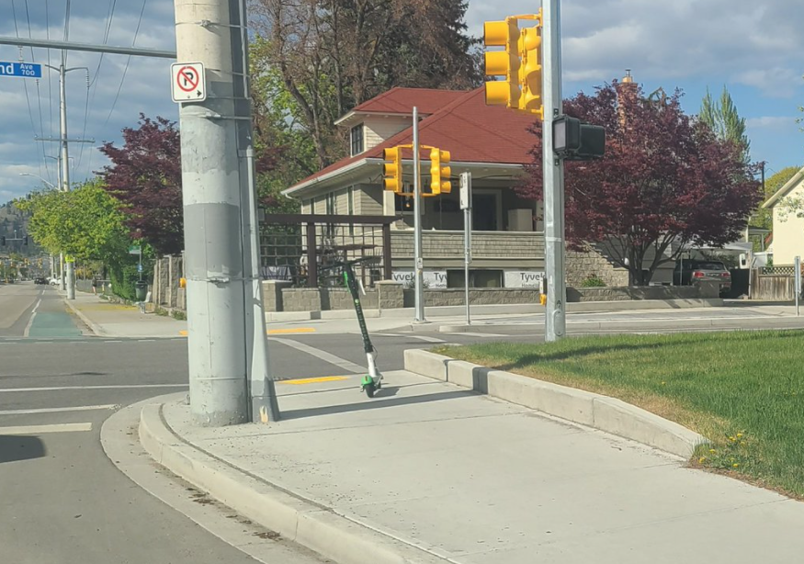

A large accessibility concern caused by e-scooter sharing programs is that they are littering public streets. Users are leaving the scooters on sidewalks, causing additional obstacles for individuals impacted by blindness or low vision, wheelchair users and people with mobility impairments.

Carelessly dumping scooters on the sidewalk creates impediments such as navigation challenges and tripping hazards.

Provinces across Canada have seen a rise in e-scooters being dumped on sidewalks blocking curb cuts, a path of travel, and businesses. This is not only a problem in Canada but has been an issue in the United States and the UK as well.

3.3 Recommendations

Rental companies have tested scooters emitting audible sounds as a method to let people who are blind or low vision know they are coming. Other features include GPS technology, for example, if a person is riding an e-scooter in an inappropriate location, the e-scooter would slow down if it's somewhere it shouldn't be.

These methods come with their own set of challenges and concerns from people with disabilities. The audio beeping that is emitted from the scooter is not loud enough when coupled with the sounds of heavy traffic. Another issue regarding the audible sounds
Is that different companies use different sounds, which can lead to confusion and people with blindness having to identify different beeping noises to differentiate them from common traffic sound (Molina, 2021).
Photo of Paris Dock System
Source: CleanTechnica, 2021
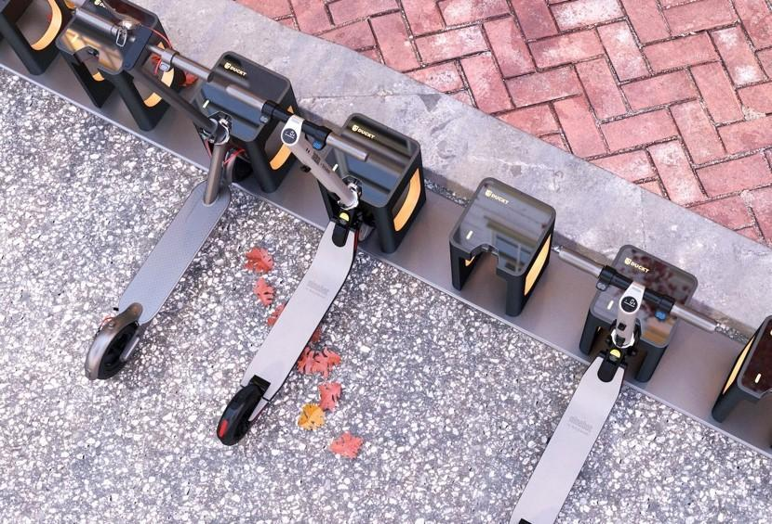

Furthermore, e-scooters with embedded GPS trackers does not solve the problem of scooter litter.

One solution to combat scooter litter is implementing more docks or designated parking zones. The city of Calgary adopted this approach repurposing designated parking which had previously been used by a car sharing program.

In Europe, Paris has begun testing docks where scooters from any manufacturer may dock and charge. Duckt, a e-scooter charging company created the docks, which accommodates 20 e-scooters into a space the size of a vehicle parking place.

The docks link to existing street furniture with an electrical connection, such as street lighting or transit shelters, to make installation easier.

Link to the study: https://cleantechnica.com/2021/03/05/so-many-e-scooters-so-where-to-dock-charge-them-all/

Below is a list of recommendations and responsibilities required for cities to ensure the safety of pedestrians and e-scooter riders. Some recommendations were taken from the comprehensive study The Electric Assist: Leveraging E-Bikes and E-Scooters For More Livable Cities by the Institute For Transportation and Development Policy. https://www.itdp.org/wp-content/uploads/2019/12/ITDP_The-Electric-Assist_-Leveraging-E-bikes-and-E-scooters-for-More-Livable-Cities.pdf

- Cities must ensure they are vigorously enforcing the ban on e-scooters. Fines must be given to those who do not comply.

- Cities must design and implement more docks and parking zones. Incentives can be given to those who properly park their scooters.
- When designing and implementing these infrastructures cities must consider the volume and demand needed and must develop universal standards for charging to increase the effectiveness and utility of public charging spaces.

- Greater public awareness and education around e-scooter etiquette is needed.
- Public safety riding courses should be offered. Cities can partner with civic groups, schools, operators to provide a riding course on how ride e-scooters safely.

Appendix

Ministry of Transportation consultation regarding delivery robots

6) Develop a pilot framework for the testing of automated micro-utility devices
Automated micro-utility devices (MUDs), including automated personal delivery devices, do not fall under the current AV regulatory framework as they cannot
be considered automated vehicles under O. Reg. 306/15 because they are not meant for on-road operation. This proposal would create a new 10-year pilot regulation for automated or remote-controlled MUDs under the pilot authority of section 228 of the HTA. Parameters under consideration for these MUDs include:

list of 12 items
∙
Defining MUDs to broadly cover devices that will not be defined as a motor vehicle in Ontario, are not meant for the transport of passengers, operate primarily off-roads in places such as sidewalks, and are task oriented and operated to primarily provide services such as delivery of goods;
∙
A 125 kg maximum weight and a 74 cm maximum width for all MUDs, except automated snow plows which have no proposed weight and dimension restrictions;
∙
A 10 km/hr maximum speed on sidewalks and a 20 km/hr maximum speed on shoulders of roads or bike lanes;
∙
A municipal opt-in and collision reporting regime, with authority to set by-laws and limit operations;
∙
Mandatory operator oversight, capable of creating a safe stop;
∙
Mandatory audible signals to alert those nearby;
∙
A requirement for reflectors and lights, with lights to be lit if operated between sunset and sunrise;
∙
A requirement for MUDs to be equipped with brakes;
∙
Prohibiting the carrying of controlled substances and dangerous goods that require a federal placard;
∙
General liability insurance, good working order, and secured loads requirements;
∙
A requirement to yield to pedestrians; and
∙
A requirement for an operator name, contact, and unique device number to be displayed on the exterior of the MUD.

