How to Improve Accessibility in Community Parks

1. Introduction
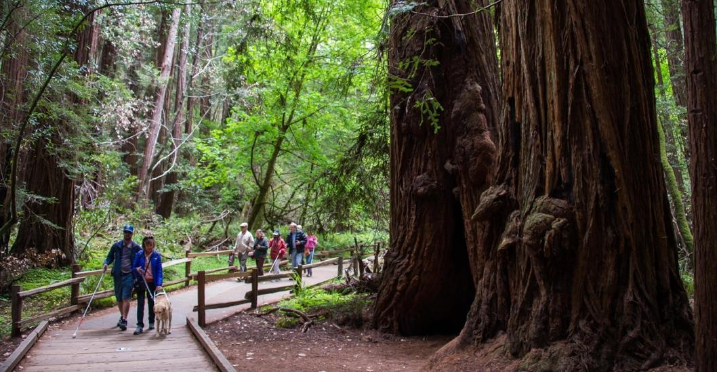

Photo of people who are blind walking a trail.
Source: Golden Gate National Parks Conservancy
Open green spaces such as parks are an important attraction to any community. Community parks play a pivotal role in the well-being of community members. Access to green spaces is incredibly important as it gives residents opportunities for recreational activities and contributes to the health and wellness of a community.

Parks can help ease symptoms of
anxiety and depression and have
been linked to several other
health benefits such as feeling less stress and fatigue.

People of all abilities must be able to access green spaces within their community and comfortably navigate the area.

This discussion paper will focus on community parks and trails and how they can be enhanced to be inclusive to people with disabilities, focusing on people impacted by blindness and low vision.

2. Navigation – Accessible Pathways

Elements such as braille and tactile signage and guide ropes are components that help to allow people impacted by blindness to navigate parks and nature trails independently.

Regular maintenance of parks and trails is highly important as potholes and rubbish (such as broken glass, cans and debris) can greatly diminish a pathway’s accessibility.

When a boardwalk trail is included in a park, the surface of the boardwalk should be firm and be of a contrasting color to the surrounding environment to support those impacted by blindness and low vision. A boardwalk trail should also have a defined edge to act as a wayfinding cue. Ensure the edge is cane detectable.

2. 1 Accessible Wayfinding

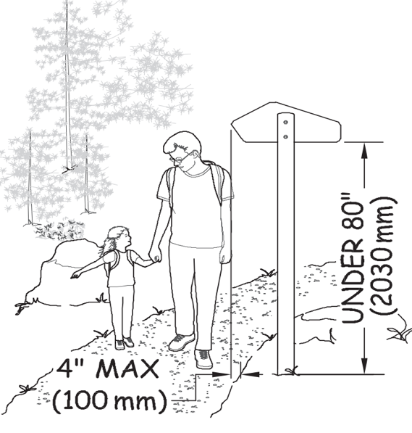
2.1.1 Signage and Maps

Illustration of signage dimensions (described in the text)

Source: United States Department of Agriculture

Braille and tactile wayfinding such as signage and maps must be
included within a park located at points of interest. All trails should begin with an information sign and a tactile map that uses contrast in colour, raised characters and braille. Additional braille-raised print and audible signage can provide information about a trail’s layout and points of interest.

Signage at the beginning of a trail should describe its length,
degree of difficulty and distinguishing features–especially hazards. Signage and maps should include a legend to explain the meaning of all symbols and cues along the trail.

Ensure pole signs that are placed along a trail to help with navigation do not protrude into the path of travel as they
can be potentially hazardous to people impacted by blindness.
Ensure pole signs are between 685 mm and 2030 mm in height.
The sign should not extend into the path of travel
more than 100 mm.

2.1.2 Audible signs
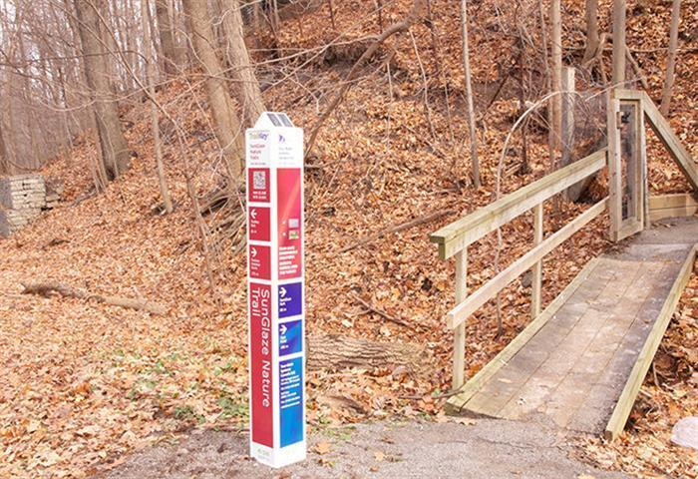

A photo of trail identification signage that incorporates large-print, tactile and audible information.

Source: Tour-Mate Systems Limited.

Audible signs are signs that use speech technology to supplement the information typically found on print signs. Audible signs should still include text and pictograms as they don’t provide an accessible solution for individuals with hearing loss.

Audible signs have become popular and are becoming part of the built environment for the benefit of all users, not just those impacted with blindness. Audible signs are commonly used in elevators to direct passengers to the correct floor and are used by public transit systems to automate the announcement of upcoming stops and the destination of arriving transit

Audible signs can also be of assistance in parks as it helps
visitors who are visually impaired find their way when
walking a trail.

Audible signs should be simple and intuitive to use. They should be audible only when required (i.e., to the user only, not to all passing people) and silent when necessary.

Audible signs can be manually activated by a button or other control, or automatically activated using technologies such as radio-frequency identification (RFID) or Bluetooth. Automatic activation is preferred, as buttons/controls can be difficult to locate by people impacted by blindness.

2.1.3 Guidance-Rope
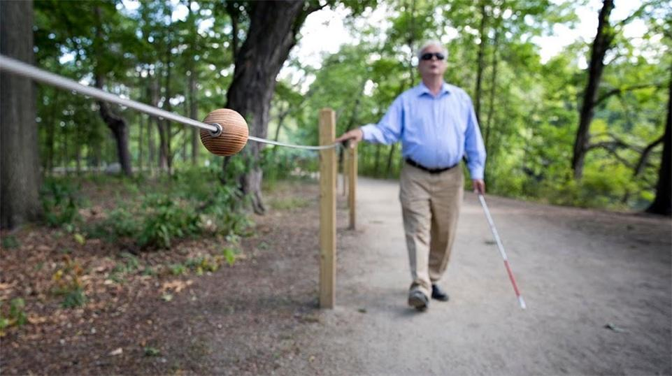
Bbbbb

Photo of a person who is blind trailing a guidance rope by hand to help guide him throughout the park.
Source: WBUR
A guidance-rope system can help those who are visually impaired travel a park and or trail without assistance. A guidance-rope acts as a wayfinding tool as it helps people impacted by blindness and low vision to hold and follow the rope and stay in the right direction.

A guidance rope should consist of a bright yellow rope at a height of 920 mm from grade running the entire length of a trail. The rope may be knotted at specific points to alert people impacted
by blindness to a tactile sign or a point
of interest. The rope system should begin
at the information sign at the trailhead.

3. Park Amenities

Parks include a variety of amenities such as picnic tables, benches, drinking fountains and waste bins.

Park furniture should be located as close as possible to the main trail roots without intruding on the path of travel. If furniture items are not located immediately off the main trail, a trail surface that is firm, non-slip and color contrasted should be used to help guide individuals traveling by cane to identify park amenities.

3.1 Picnic Tables
Outdoor picnic areas should be located close to an accessible path of travel and marked with appropriate signage. Picnic tables should have a ground surface (e.g. pavement pad) that’s firm, relatively level and slip-resistant.
Picnic areas are easier to distinguish by people impacted by blindness when the ground surface contrasts in colour and texture to the abutting accessible path. Picnic tables should be in good repair, without protruding nails, screws or large splinters.
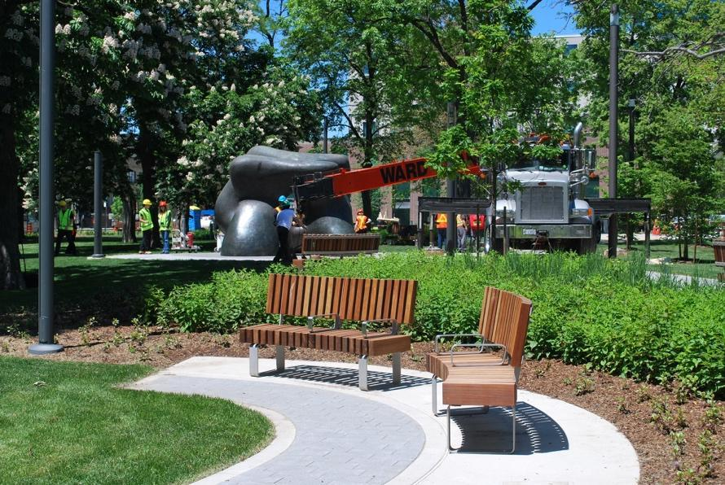
B

Tttt

Newly installed park benches in Toronto’s Grange Park. Benches are installed on a non-slip, level surface with good colour contrast from its surrounding areas. Adequate space for a guide dog to lay next to their handler or behind the bench is provided.

Source: Urban Toronto

3.2 Park Benches

Benches should be installed on the same level as a walkway, set back 600 mm from the walkway to ensure that benches are cane detectable. It is recommended to ensure there is a clear ground space adjacent to benches. Benches should colour contrast to their surroundings. A tactile change in the area surrounding the bench can be used to indicate to a pedestrian that a bench is nearby. Tactile and or colour change in ground surfaces helps people impacted by blindness and low vision to distinguish from
the path of travel.

Park benches should include components
such as back support and armrests as it is
more convenient and comfortable, especially
for seniors and for individuals with disabilities who
have difficulties sitting and rising.

To accommodate guide dog handlers; situate benches to provide adequate space for a guide dog to lay next to its handler. If benches cannot be situated at least 600 mm away from a walkway, provide adequate space behind or next to a bench for a guide dog to rest. A handler should be able to position the dog so that it does not lie in a public pathway and is safe from bicycles or other pedestrians.

3.3 Litter Receptacles and Recycling bins
Litter receptacles with open tops are easiest for people impacted by blindness to use. When a closed-top litter receptacle is necessary, the top should have spring-loaded hinges that can be easily opened with one hand.
A 100 mm wide strip of colour-contrasted material should be placed around the top of the receptacle to assist people impacted by blindness and low vision.

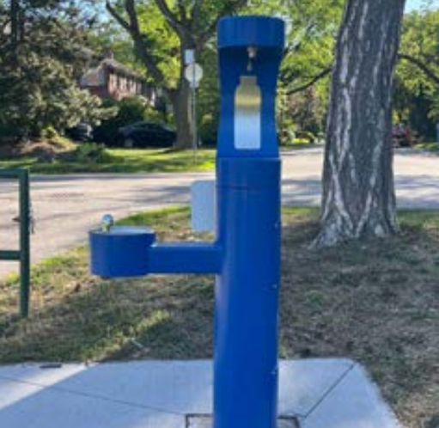
3.4 Drinking Fountains

Example of a water fountain located on a “pavement pad” The fountain contrasts well to its surrounding areas.
Source: Toronto Accessibility Design Guidelines

Drinking fountains should be placed adjacent to the path of travel making them easily detectable by long cane users. Drinking fountains should be placed on a non-slip, firm and level surface. Drinking fountains must be cane detectable and have good colour contrast to its surrounding areas.

The design of drinking fountains within a park should also be consistent.

According to Toronto Accessibility Design Guidelines, found here: https://www.toronto.ca/wp-content/uploads/2021/08/8ee5-Revised-TADG.pdf,
water bottle filling stations and drinking fountains should be
connected to an exterior accessible path of travel that:
- Has a clear ground space that is 900 mm by
1500 mm minimum for a front approach, or 900 mm
by 2200 mm minimum for a side approach.

- Has a clear turning space, within any enclosed areas, that is 2500 mm minimum in diameter.

