Roundabouts and Traffic Calming

Introduction

This discussion paper will focus on roundabouts and guidelines to enhance accessibility for people impacted by blindness and low vision. Types of traffic calming measures such as curb extensions and speed humps will also be addressed in this section.

Roundabouts

Roundabouts also known as traffic circles can present significant challenges for people impacted by blindness. In many cases, they will learn an alternate travel route to avoid encountering a roundabout. As cities choose to develop more roundabouts, they are creating barriers for people impacted by blindness to travel independently.

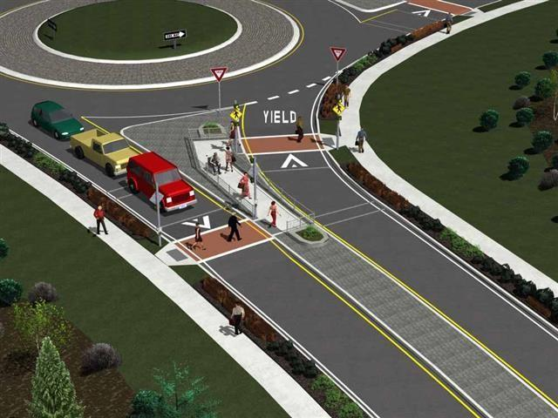
Where roundabouts are planned, an extensive public education campaign, targeted at both pedestrians and drivers, should be an integral component of any new installation.
A pedestrian crossing system at a roundabout featuring an offset island in the middle of the approach road. The pedestrian route consists of a raised crossing for traffic calming. Source: Institute for Transportation Research at North Carolina State University.

A pedestrian crossing system at a roundabout featuring an offset island in the middle of the approach road. The pedestrian route consists of a raised crossing for traffic calming.
Source: Institute for Transportation Research at North Carolina State University.

Take note of the following design guidelines:

- Don’t place water fountains or other features that produce background noise close to the roundabout. These features can mask the ambient sound of vehicular traffic.

- Avoid using visual barriers higher than 300 mm in the roundabout’s centre island. These barriers make it harder for drivers and pedestrians to see
each other. They also create
an auditory barrier for
pedestrians.

- Use clear and consistent wayfinding strategies to give pedestrians both visual and tactile cues on where to enter and safely cross the roundabout. A combination of textured ground surfaces and painted marking should be considered to enhance visibility and detectability of the crossing route.

- For roundabouts with approach roads consisting of one or two lanes approach and exit legs, install a marked crosswalk equipped with an APS on each approach road where pedestrians are able to cross. The standard red/yellow/green traffic signals should be used, continuously set to flashing green for vehicular traffic. In response to a pedestrian activation signal, the traffic lights would cycle through amber to red and remain red during the time allocated for pedestrian crossing.

- Non-signalized pedestrian crossings at roundabouts should only be considered for roundabouts with approach roads consisting of single-lane only approach and exit legs. In such locations, a stop line for vehicles should be indicated on the road surface accompanied by a “Yield to Pedestrians” sign that complies with the Manual of Uniform Traffic Control Devices; available through the Transportation association of Canada.It’s always preferable to have signalized pedestrian crossings equipped with APSs.

- Provide pedestrian overpasses or underpasses at roundabouts with approach roads consisting of three or more lanes approach and exit legs.

- Streetscape elements that require servicing by vehicles (e.g., bus stops, mailboxes and garbage bins) should be located at least 50 m from a roundabout, as these service vehicles visually and audibly obscure the pedestrian crossing.

- Design pedestrian crossings at roundabouts as mid-block crossings. For more information, see the section on curb ramps at mid-block crossings.

- Sidewalks around roundabouts should incorporate concrete barriers, fencing or landscaping at the edge of the roadway to discourage pedestrians from crossing to the roundabout’s center island.

An alternate type of guidance TWSI is recommended on road surfaces to assist persons with blindness to navigate road crossings at roundabouts. Further information is provided in the tactile walking surfaces indicator sub-section of the section Exteriors and Interiors – Common Design Elements.

A detailed study on the barriers created by roundabouts and possible solutions can be found in a report published by the NATIONAL COOPERATIVE HIGHWAY RESEARCH PROGRAM (NCHRP) REPORT 674 Crossing Solutions at Roundabouts and Channelized Turn Lanes for Pedestrians with Vision Disabilities (PDF).

Emerging technology using in-road sensors and/or video can detect approaching vehicles and determine whether they are yielding or if there is a safe gap in traffic to allow pedestrians to cross. Some systems incorporate both methods. These systems then trigger visual and audible pedestrian signals indicating that it’s safe to cross. The efficacy of these technologies is still under investigation.

Traffic Calming

Heavy, fast traffic may make people who are blind and partially sighted feel unsafe while navigating their neighborhoods due to vehicles travelling at a high speed. Implementing traffic calming measures can help to support pedestrians who are blind feel more at ease. In addition, these measures also help sighted pedestrians and bicyclists feel more comfortable as well, as it protects them from externalities inflicted by fast vehicle traffic.

Many cities and municipalities across the world have adopted traffic calming measures to decrease traffic volumes to aid in the pedestrian experience. The decrease of fast traffic also helps those with visual impairments feel safer travelling in their neighborhood.

Types of common traffic calming measures include the following:

1. Raised Pedestrian Crossings or zero grade crosswalks: Raised pedestrian crossings also known as 0-grade crosswalks provide a designated route across vehicular roadways where the pedestrian walking surface is raised above the surface of the roadway. The surface of the pedestrian walkway is at the same level, or close to the same level, as the sidewalks that provide access to the pedestrian crossing. As such, pedestrians can cross the roadway without encountering curb ramps. As vehicles have to “bump over” a raised pedestrian crossing, such crossings can act as traffic calming devices.

A raised pedestrian crossing can be used at mid-block crossings and intersections. If used at intersections, the vehicular roadway is typically raised throughout the entire intersection.

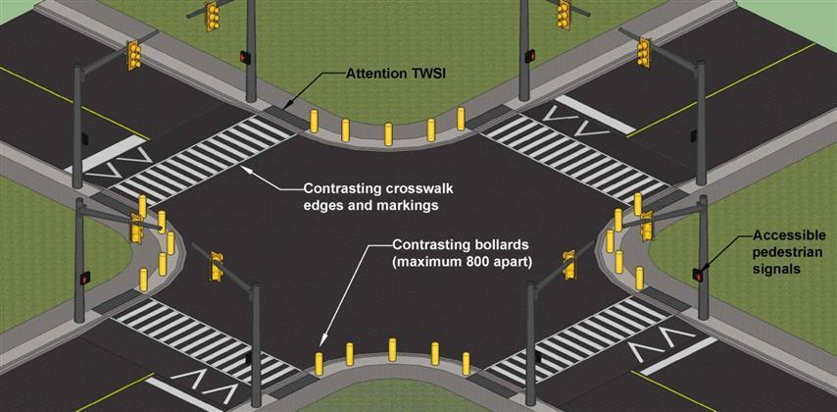

Raised pedestrian crossings at an intersection.

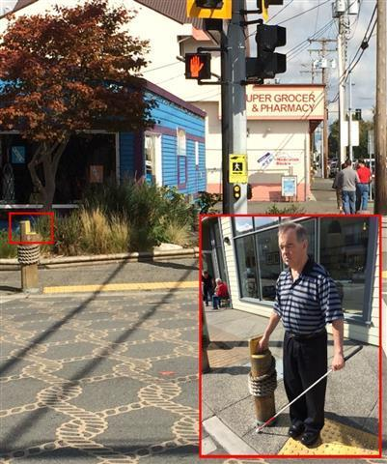
As with any pedestrian crossing, the safe walking route across the vehicular roadway must be clearly delineated on the road surface using pavement markings, such as high-contrast dashed lines or striping. It’s also critical to use an attention TWSI across the entire width of the pedestrian entry points onto the crossing. This will ensure that people impacted by blindness can identify the transition from the sidewalk to the pedestrian crossing. Where these traffic structures are deployed, marked bollards can serve to orient pedestrians with blindness as to the safest line of travel across an intersection. Further information can be found in the section on tactile walking surface indicators.
A good example of a raised intersection with accessible pedestrian signals and attention TWSIs. The top of the bollard is cut to indicate the direction of crossing.
\

A good example of a raised intersection with accessible pedestrian signals and attention TWSIs. The top of the bollard is cut to indicate the direction of crossing.

Ensure to provide line markings on the road surface to identify where vehicles should stop when the pedestrian crossing is being used.

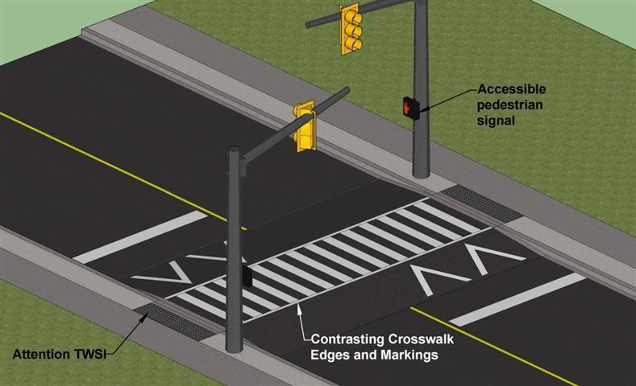
Raised pedestrian crossing at a mid-block crossing.

Raised pedestrian crossing at a mid-block crossing.

2. Speed humps/bumps: Speed humps are raised bumps in a roadway are used to reduce traffic speeds. These bumps must be kept well maintained as they can be a hazard for both drivers and bicycles if they are not designed correctly and properly maintained (FHWA ,n.d).
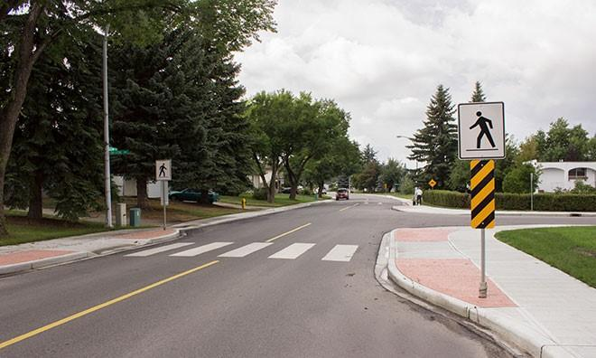
Hhhhr

Example of a curb extension.
Source: Strathcona County, 20221
3. Curb Extensions: Curb extensions helps pedestrians and drivers to see one another when parked vehicles on the side of the road would otherwise block visibility. Curb extensions also shortens the crossing distance therefore making crossing easier and safer (FHWA, n.d).

Advantages of curb extension include:
- Greater safety for pedestrians as it reduces crossing distances, creates greater visibility for drivers and pedestrians to see each
other and slows down the speed of
turning vehicles.

Disadvantages of curb extensions include
- Heavy swings in turning motions of large trucks and vehicles may occur as a result of curb extensions

4. Traffic Diversions: A traffic diversion reduces the number of automobiles on the road by restricting motor vehicle access while allowing pedestrians and bicycles to pass through. A diverter is a small island constructed at a residential street intersection, thus causing motor vehicles to slow down and change direction to travel around the barrier (FHWA ,n.d).

Example of traffic diversions
Source: TCAT. 2021
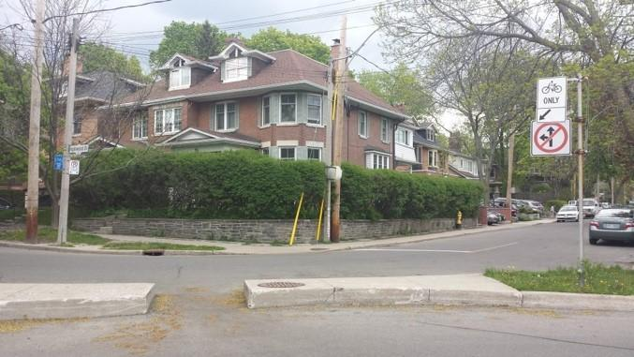
Advantages of a traffic diversion include:
- Greater opportunities for landscaping
- Fast and heavy traffic is eliminated
- Provides greater safety for pedestrians
- Provides a bicycle pathway connection

Disadvantages of a traffic diversion includes:
- Can be an inconvenience to residents to get to
their properties
- May inhibit access by emergency vehicles
- Would move traffic to other streets.

For more information on traffic calming devices visit
https://safety.fhwa.dot.gov/ped_bike/univcourse/pdf/swless11.pdf

