The Path to Accessible Multi-Use Trails
Prepared for Canadian National Institute for the Blind
University of Toronto
December 14, 2021
Authors: Sara Eng, Joshua Morales Franco, Katelyn Ling, Serena Sonnenberg, Sara Wasim, Matt Whittier

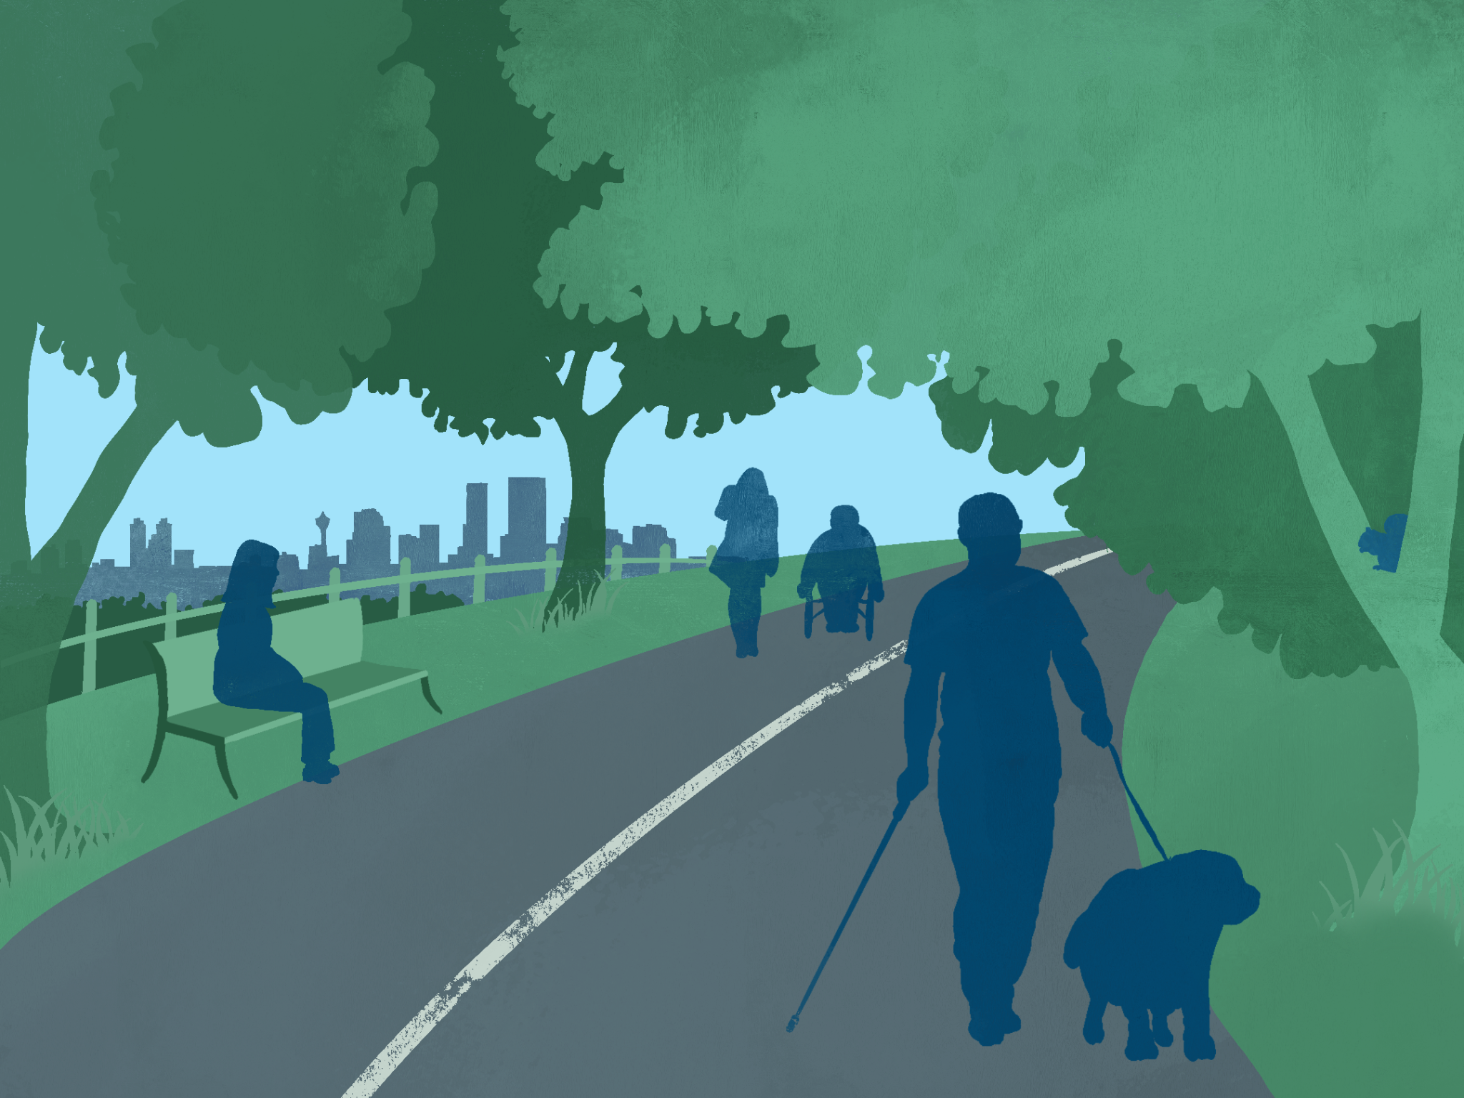

Table of Contents

Table of Contents i
List of Tables vi
List of Figures vii
Executive Summary 1
1. Introduction 3
2. Literature Review 7
2.1 Clearing Our Path Guidelines 7
2.2 North American Legislative Context 8
2.2.1 Americans with Disabilities Act & ADA Standards for Accessible Design 8
2.2.2 Accessibility for Ontarians with Disabilities Act, 2005 9
2.2.3 The Accessibility for Manitobans Act, 2013 9
2.2.4 Nova Scotia Accessibility Act, 2017 10
2.2.5 Accessible Canada Act, 2019 10
2.3 Design Guidelines 12
2.3.1 Integrated Accessibility Standards (O. Reg 191/11) 12
2.3.2 Access Recreation Guidelines 12
2.3.3 Recreational Trail Accessibility Audit and Strategy (Town of Oakville) 13
2.3.4 City of Toronto’s Accessibility Design Guidelines 13
2.3.5 Toronto Cancer Prevention Coalition Shade Guidelines 14
2.4 Trail Assessment Processes 14
2.6 Academic Studies 17
3. Multi-Use Trail Accessibility Audit (MUTAA) 19
3.1 Assessing Trails for Varied Experiences of Disability 20
3.1.1 Vision Loss 20
3.1.2 Hearing Loss 21
3.1.3 Mobility Impairment 22
3.1.4 Sensory Sensitivity 23
3.1.5 Cognitive Disability 23
3.2 Audit Variables for the MUTAA 24
3.2.1 Amenities & Features 25
3.2.2 Location 29
3.2.3 Physical Characteristics of Trails 30
3.2.4 Signage and Wayfinding 32
3.2.5 Disability Group Impact Table 35
4. Case Studies 41
4.1 Martin Goodman Waterfront Trail - Queen’s Quay West 42
4.2 Don Valley Trail 44
5. Results 45
5.1 Waterfront Trail Audit Results 46
5.2 Waterfront Trail Key Takeaways: Strengths 50
5.2.1 Amenities and Features 50
5.2.2 Location 51
5.2.3 Physical Characteristics 51
5.3 Waterfront Trail Key Takeaways: Areas of Improvement 51
5.3.1 Amenities and Features 51
5.3.2 Physical Characteristics 52
5.3.4 Signage and Wayfinding 53
5.5 Don Valley Trail Key Takeaways: Strengths 59
5.5.1 Amenities & Facilities 59
5.5.2 Location 59
5.5.3 Physical Characteristics 59
5.5.4 Signage and Wayfinding 61
5.6 Don Valley Trail Key Takeaways: Areas of Improvement 62
5.6.1 Amenities & Facilities 62
5.6.2 Location 63
5.6.3 Physical Characteristics 63
5.6.4 Signage and Wayfinding 63
6. Recommendations & Lessons Learned 64
6.1 Recommendations 64
6.2 Lessons Learned 69
7. Research Limitations 69
8. Next Steps 71
8.1 Further Research 72
8.2 Tension Points 72
9. Conclusions 73
References 74
Appendix A: Audit Criteria Justification 83
Amenities 83
Location 89
Physical Characteristics 89
Signage & Wayfinding 94
Appendix B: Justification of Disability Categories 99
Amenities 99
Location 101
Physical Characteristics 102
Signage and Wayfinding 104
Appendix C: Multi-Use Trail Accessibility Audit 107
Appendix D: Trail Audit Scan 111

List of Tables
Table 1: Scoring Values Table for Amenities & Feature Attributes 26
Table 2: Scoring Values Table for Location Attributes 30
Table 3: Scoring Values Table for Physical Characteristic Attributes 30
Table 4: Scoring Values Table for Signage and Wayfinding Attributes 33
Table 5: Disability Group Impact Table 37
Table 6: Waterfront Trail Audit Results- Amenities & Features 46
Table 7: Waterfront Trail Audit Results - Location & Physical Characteristics 47
Table 8: Waterfront Trail Audit Results - Signage & Wayfinding 48
Table 9: Lower Don Trail Audit Results-Amenities & Features 55
Table 10: Lower Don Trail Audit Results: Location & Physical Characteristics 56
Table 11: Lower Don Trail Audit Results - Signage & Wayfinding 57
Table 12: Canadian Trail Inventory 66
Table 13: Multi-Use Trail Accessibility Audit (MUTAA) - Amenities and Features 107
Table 14: MUTAA - Location & Physical Characteristics 108
Table 15: MUTAA - Signage & Wayfinding 109
Table 16: Trail Audit Comparison Scan 111

List of Figures
Figure 1: Research Process 6
Figure 2: Accessible Pedestrian Signals at Crosswalk 29
Figure 3: Toronto Waterfront Trail 43
Figure 4: Wave Decks on the Toronto Waterfront Trail 43
Figure 5: Lower Don Valley Trail 44
Figure 6: Resting Area with Benches at the Waterfront Trail 50
Figure 7: Wayfinding Signage on the Waterfront Trail 53
Figure 8: Surface of Lower Don Valley Trail 61
Figure 9: Map and Information at Lower Don Trailhead 62

Executive Summary
This report includes the Multi-Use Trail Accessibility Audit (MUTAA) tool that can be used to evaluate the accessibility of multi-use trails (MUTs) for people with various disabilities. Recommendations included in this report will guide municipalities across Canada on what elements should be prioritized when designing and upgrading MUTs. This report will supplement the “Clearing our Paths” guidelines produced by the Canadian National Institute for the Blind (CNIB), including universal design guidelines for people with vision loss. The research presented in this report takes a more holistic approach by evaluating the level of accessibility on MUTs for various disability groups including; Vision Loss, Hearing Loss, Mobility Impairment, Sensory Sensitivity, and Cognitive Disability.
Our team completed a literature review that analyzed existing legislation, design guidelines and standards, trail assessment processes, and academic studies. This analysis informed the creation of the MUTAA and a Disability Group Impact Table that compares how trails may be experienced differently by people from the five categories of disability considered in the report.
To pilot the MUTAA, two MUTs in Toronto were evaluated; the Martin Goodman Waterfront Trail, and the Lower Don Valley Trail. The strengths of the Waterfront Trail include the amenities, location, and physical characteristics. The main area of improvement, identified by MUTAA, includes the addition of accessible signage and wayfinding tools. The strengths of the Lower Don Valley Trail include the physical characteristics and signage. The main areas of improvement identified for the trail were the inclusion of amenities such as washrooms and water fountains as well as in regard to better transit accessibility . From piloting the MUTAA and compiling the results alongside the Disability Impact Table, our team identified how MUTs can be designed and upgraded to be more accessible for all users.
Seven key recommendations are included in this report to increase equitable access to MUTs. These recommendations include:
1. Prioritize increasing accessibility for attributes ranked with high significance to users in certain disability groups.
2. Collaborate with persons within various disability groups to create accessible MUTs.
3. Evaluate the accessibility of MUTs across Canada using the MUTAA.
4. Improve signage and wayfinding as a short-term goal.
5. Improve the physical characteristics as a long-term goal.
6. Expand digital and physical wayfinding tools and strategies.
7. Prioritize data acquisition by conducting accessibility audits on existing MUTS.
In following these recommendations, a more equitable approach to designing and upgrading MUTs will be achieved. Potential next steps identified in this report include conducting interviews with people with various disabilities to gain a better understanding of what attributes should be prioritized when evaluating MUTs across Canada using the MUTAA. When evaluating MUTs, it is encouraged that the results of the MUTAA are made publicly available to create an inventory of trail characteristics which will allow individuals to assess if it is accessible to them or not.
MUTs are a resource that provide many benefits to users; thus, they must be accessible for everyone. This report outlines the importance of continually evaluating MUTs, using tools like the MUTAA, to ensure that they are accessible to all types of users.

Introduction
Multi-Use Trails (MUTs) are shared outdoor trails designed to accommodate various needs and users. These trails can provide numerous benefits to users, including the social, mental, and physical health benefits of active living. However, marginalized populations in Canada, like those with disabilities, do not have access to those benefits due to inaccessibility barriers. When planning for MUTs, trails need to be accessible to all users. Our team created the Multi-Use Trail Accessibility Audit (MUTAA) for the Canadian National Institute for the Blind (CNIB) to assess the accessibility of trails. MUTAA uses universal design principles, such as equitable use, perceptible information, and flexible use, to assess MUTs for accessibility based on the needs of various users and people with varying disabilities (Centre for Universal Design, 1997).
CNIB is a non-profit organization in Canada that aims to “change what it is to be blind today.” Through various programs, campaigns, and advocacy work, CNIB empowers people impacted by vision loss to live to their fullest potential by breaking down societal and institutional barriers. Some of CNIB’s most notable work can be dated back to 1999, when the first edition of “Clearing Our Path,” a document outlining guidelines and the need for accessible environments for people who are blind, was released (CNIB, 2016). The Clearing Our Path guidelines provides ample resources for architects, planners, designers, and other stakeholders. This report and audit criteria will contribute to the Shared Spaces and Trails section of the Clearing Our Path guidelines, equipping planners and designers with the tools and resources needed to create accessible trail infrastructure in Canada.
The main objective of this report is to propose and evaluate how MUTs can become accessible for all people, regardless of ability. The main deliverable of this report is the MUTAA which can be used to assess existing trails with the unique needs and barriers for people with disabilities in mind and to identify areas of significance or improvement. To apply universal design principles to the MUTAA, we have created a framework to determine the impact of various criteria on people within different disability groups. All trail users experience space differently and have different needs. Our team applied MUTAA to two case studies in Toronto: The Martin Goodman Waterfront Trail and the Lower Don Valley Trail. This report concludes by providing an inventory of MUTs across Canada that may benefit from being evaluated by MUTAA, and finally, a series of recommendations and strategies to ensure greater accessibility for MUTs.
Our team recognizes the importance of emphasizing the voices of people with disabilities in the planning and design process, especially in the design of spaces and amenities which directly impact people with disabilities. Following CNIB guidelines, this report uses people-first language. People-first language puts the individual first and the disability second. Using this language is important as we recognize that their disabilities do not exclusively define people with disabilities. As authors of this report, we acknowledge our positionality as able-bodied people assessing the accessibility of spaces for people with disabilities. To ensure that we are accurately representing the categories of disability in our Disability Impact Table, we have undergone extensive consultation with CNIB and thoroughly looked at academic and grey literature on the topic.
This report begins with a literature review that serves as the basis for the attributes included in the MUTAA, as well as the disability groups included in the Disability Impact Table. The literature review includes the work of the Clearing Our Path Guidelines, North American legislative context, design guidelines, trail assessment processes, and academic studies. Following this section, we introduce the MUTAA, providing an overview of it’s main purpose, functions and attributes. This leads to a discussion of the Disability Impact Table to provide a more holistic view of the wide range of disabilities being represented in the MUTAA. We then piloted the tool on two different trails in the City of Toronto and evaluated their strengths and weaknesses using the MUTAA. To conclude, we outline some recommendations and lessons learned through the MUTAA pilot and discuss the next steps for future work on the MUTAA. An illustration of this research process is shown in the figure below.
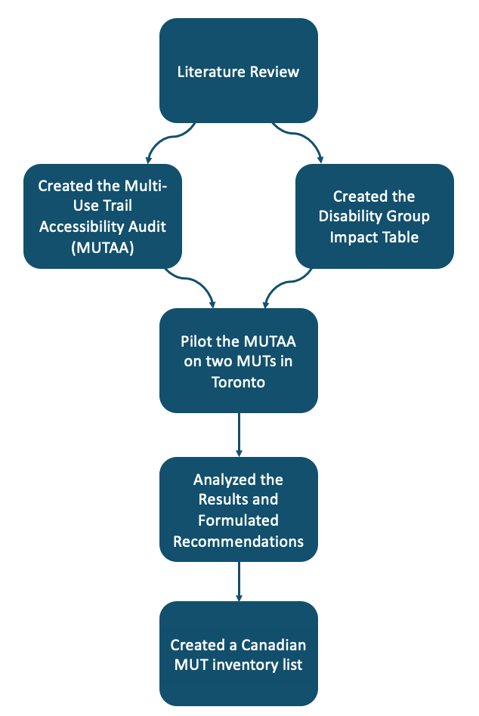
Figure 1: Research Process

Literature Review
To inform and justify the decisions we made to design our trail audit tool and recommendations, we conducted a scan of relevant legislation and design guidelines, existing trail assessment processes and academic studies related to the ways people with disabilities experience trails and the outdoors.

2.1 Clearing Our Path Guidelines
This report and trail audit aims to build upon CNIB's Clearing Our Path Guidelines to expand upon the existing design guidelines and recommendations for multi-use trails (CNIB, 2016). Given that this report builds upon CNIB guidelines, our team first reviewed guidelines content to identify how it engages (or does not engage) MUTs. While there is some existing information regarding MUTs in these guidelines, it is general and does not include any technical design recommendations. It highlights general infrastructure that should be present to help those with vision loss better navigate trails. For example, it discusses the importance of having braille on trail information boards; however, it does not discuss what specific trail information should be present to increase users' comfort levels on the trail (CNIB, 2016). Overall, many of the multi-use trail guidelines included in CNIB's report served as the basis for a more detailed trail audit and future development of design recommendations.

2.2 North American Legislative Context
A review of North American Law provided context on current national and provincial accessibility legislation that provides standards for the built environment and informed the choice of language used in this report.

2.2.1 Americans with Disabilities Act (ADA) & ADA Standards for Accessible Design
The 1990 Americans with Disabilities Act ​​(ADA) prohibits discrimination against individuals with disabilities in all areas of public life, including jobs, schools, transportation, and all public and private places open to the general public (ADA National Network, n.d.a). Amendments made in 2009 used language that focused on the discrimination experienced by an individual rather than their impairment (ADA National Network, n.d.a). The ADA and this report uses people-first language, which includes phrases such as “persons with disabilities,” which chooses words that acknowledge the person as the primary reference and not their disability. This was a departure from outdated terminology, like “handicapped”, used in the 80s and 90s, and set precedence for future legislation (ADA National Network, n.d.b). However, this type of language may not be preferred by all and remains an ongoing conversation.
The ADA has resulted in the development and implementation of design standards for trails. These standards set minimum accessibility requirements for places of public accommodation, commercial facilities, and state and local government facilities covered by the ADA (ADA National Network, n.d.c). For new trails and those undergoing redevelopment, they must comply with the 2010 ADA Standards for Accessible Design which determine trail width, surface type, slope, and other design factors (ADA National Network, n.d.c).

2.2.2 Accessibility for Ontarians with Disabilities Act, 2005
The Accessibility for Ontarians with Disabilities Act (AODA) replaced the 2001 Ontarians with Disabilities Act and mandates a series of standards for public, private, and non-profit organizations (Government of Ontario, 2019). In 2005, the AODA became law, making Ontario the first province to enact legislation of this scope and scale (AODA, 2005). The AODA’s five standards are consolidated in the Integrated Accessibility Standards Regulation (IASR). The first section covers general requirements for all standards, and the subsequent parts list the five standards (information and communication, employment, transportation, design of public spaces, and customer service) that mandate how organizations must remove and prevent barriers for people with disabilities (AODA, 2016). Within the “Design of Public Spaces Standards” of the AODA (Section 80.6), cities building or reconstructing recreational trails must make them accessible to visitors with disabilities. Accessible recreational trails are defined as paths allowing people of all abilities to move through natural environments or public spaces (AODA, 2005).

2.2.3 The Accessibility for Manitobans Act, 2013
In 2013, the Province of Manitoba passed provincial accessibility legislation, known as the Accessibility for Manitobans Act (AMA), as part of their goal to make the province accessible by 2023. Similar to the AODA’s structure, the AMA is organized into Accessibility Standards that focus on five areas of daily living; one of them being the built environment which deals with access to areas outside the jurisdiction of the Manitoba Building Code, such as pathways and parks (Government of Manitoba, 2013).

2.2.4 Nova Scotia Accessibility Act, 2017
Nova Scotia became the third province to enact accessibility legislation, after Ontario and Manitoba, when the Province passed the Nova Scotia Accessibility Act in 2017. Like the two other provinces with accessibility legislation, Nova Scotia set a goal to make the province inclusive and barrier-free by 2030 (Nova Scotia Legislature, 2017). The Government of Nova Scotia is developing six Accessibility Standards which include the same five standards in the AODA and AMA, but add on “Education” as another key area (Government of Nova Scotia, n.d.a). Standards related to the built environment and education will be the first to be developed and scheduled for implementation in 2022 (Government of Nova Scotia, n.d.a). In the initial development of the built environment standards, recommendations from their Accessibility Advisory Board have been made to address gaps within existing regulations for topics such as, wayfinding, signage, and parks and recreation (Government of Nova Scotia, n.d.b).

2.2.5 Accessible Canada Act, 2019
Consultation with Canadians led by the Government of Canada took place from July 2016 to February 2017 to determine what an accessible Canada means to them (Government of Canada, 2019). In 2018, the Accessible Canada Act was introduced to create a barrier-free Canada by 2040 and came into force in July 2019 (Government of Canada, 2019). This federal law is a culmination of years of work from disability activists and advocacy groups (McQuigge, 2019). It aims to identify, remove and prevent barriers in federal jurisdiction in key priority areas that range from the built environment to communication.
This legislation provides important terminology used throughout numerous policies and plans. Having terms defined in the ACA creates a baseline understanding across multiple sectors. Two terms of particular importance in the ACA and for this report are: ‘barriers’ and ‘disability’. Barriers are defined as "anything physical, architectural, technological or attitudinal, anything that is based on information or communications or anything that is the result of a policy or a practice—that hinders the full and equal participation in society of persons with an impairment, including a physical, mental, intellectual, cognitive, learning, communication or sensory impairment or a functional limitation (Government of Canada, 2019)." Disabilities are defined as "any impairment, including a physical, mental, intellectual, cognitive, learning, communication or sensory impairment—or a functional limitation—whether permanent, temporary or episodic in nature, or evident or not, that, in interaction with a barrier, hinders a person's full and equal participation in society (Government of Canada, 2019).” These terms demonstrate the large spectrum and diversity of experiences people with disabilities can have in their built environment. Acknowledging the extensive scope of these definitions can support the creation of more comprehensive tools and strategies that can unpack how people engage with MUTs, and inform actions to improve their experiences.

2.3 Design Guidelines

In order to develop a better understanding of existing design guidelines and standards, in regard to trail accessibility best practices, a variety of existing reports were analyzed. Below is an overview of the key takeaways from each of the design guidelines and standards documents referenced in this report.

2.3.1 Integrated Accessibility Standards (O. Reg 191/11)
Included in the AODA are the Integrated Accessibility Standards (Government of Ontario, 2016). This document provides an overview of design standards for different built environment elements. The range of built environments in these guidelines is quite broad and includes interior and exterior spaces. This document offers technical requirements and guidance regarding the dimensions and physical form of infrastructure. It provides information about proper maintenance procedures, signage, and technology to enhance accessibility, such as audible crosswalk signals. The primary information taken from these guidelines to aid in creating the trail audit was signage and wayfinding. These standards provided information in regard to what trail information is important to have on signage to increase the usability and accessibility of trails for all users.

2.3.2 Access Recreation Guidelines for Providing Trail Information to People with Disabilities
Another report utilized to aid with initial design guidelines research is the “Guidelines for Providing Trail Information to People with Disabilities” (Access Recreation, 2013). Developed by the Access Recreation Committee, which comprises representatives from federal, state, and local parks departments, this report offers guidance to individuals and park departments to improve the accessibility of natural environments for people with disabilities. This document includes specific guidelines and information about how people with vision loss may navigate recreational trails and what amenities and signage can help those with vision loss navigate spaces more easily and safely. In addition to providing general information about increasing the accessibility of outdoor recreational spaces, this report identifies what information needs to be included in signage to enhance the usability of trails and therefore was included in the trail audit.

2.3.3 Recreational Trail Accessibility Audit and Strategy (Town of Oakville)
In 2019, the Town of Oakville’s Parks and Open Space Department created its Recreational Trail Accessibility Audit Tool. Oakville completed a review of current practices from six municipalities in Ontario to create an accessibility audit for recreational trails. Design criteria from the Oakville Accessibility Audit influenced the MUTAA framework developed by our team. In particular, the physical conditions of the trail, surface slopes, location of the trail, amenities, and trail signage. The MUTAA aims to expand upon the work completed by Oakville to create a future with more accessible multi-use trails.

2.3.4 City of Toronto’s Accessibility Design Guidelines
The City of Toronto’s Accessibility Design Guidelines (2021) has a section for exterior paths of travel that outline the city’s requirements and recommendations for providing an exterior accessible path of travel. According to these guidelines, key physical factors for trail design include appropriate slopes (maximum 1:20 running slope and 1:50 cross slope), edge protection with bright colour contrast, and a 75 mm minimum curb. Signage on the trail should describe the length, width, slope, materials, amenities, and safety information with tactile communication. In addition to these parameters, the guidelines state that consultation efforts that include people with disabilities should be carried out to help define the ideal slope and the need for and location of ramps, rest areas, passing areas, viewing areas, amenities, playgrounds, service animal areas, and any other pertinent features (City of Toronto, 2021).

2.3.5 Toronto Cancer Prevention Coalition Shade Guidelines
While looking for more detailed information on the benefits and importance of shade in MUTs, the Toronto Cancer Prevention Coalition’s 2010 shade guidelines (TCPCS) stood out as a comprehensive and useful resource. There was little direct mention of the importance of shade for people experiencing disabilities. However, the TCPCS Guidelines suggested that on paths and trails, sun protection measures are important not only at rest areas but also along the trail because trails are most often used in the summer months and at times of greatest UV radiation intensity (Toronto Cancer Prevention Coalition, 2010).

2.4 Trail Assessment Processes
There have been various audits created to assess the quality of public space, but not all of them include specific consideration for accessibility. To find out which ones do, our team consulted an academic review of built environment assessment tools (Gray et al, 2012) that sought to determine which instruments included criteria relevant to disability. Through this review, we identified four appropriate tools to explore: Environmental Assessment of Public Recreation Spaces Direct Observation Tool/EAPRS (Saelens et al., 2006), Quick Pathways Accessibility Tool/Q-PAT (Rimmer et al., 2009), Path Environment Audit Tool/PEAT (Troped et al., 2006), and the Healthy Aging Research Network Environmental Audit Tool/HARNEAT (Hunter, 2015). In addition to these tools, our client suggested that we consult the Universal Trail Assessment Process/UTAP (Beneficial Design Inc, 2021). We identified the Town of Oakville’s Recreational Trail Accessibility Audit and Strategy/ORTAAS (Town of Oakville, 2019) as another recent precedent.
We compared these six audit tools to get a sense of whose accessibility is accounted for and whose accessibility needs are ignored (See Appendix D for full comparison). Taking accessibility for people with disabilities into account in these audits, five out of six of them tended to heavily focus on factors important to people with mobility impairment, especially those who use wheelchairs (Hunter, 2015; Troped et al, 2006; Saelens et al, 2006; Rimmer et al, 2009; Town of Oakville, 2019). The tool that did not show this pattern, UTAP , was designed from a more objective, quantitative, and open-ended lens, so it did not lend itself as much to applying to specific experiences of disability (Beneficial Designs Inc., 2021). In HARNEAT, there was particular mention of accessibility measures for people with vision loss, cognitive disabilities, and hearing loss. Some tools included braille or auditory signage, presence of railings, and detailed wayfinding information (Hunter, 2015); however, there was very little specific consideration for these experiences otherwise throughout the instruments. Additionally, PEAT included attributes to measure the level of odor and noise along a trail, which addresses users with sensory sensitivities (Troped et al, 2006).
When comparing all six instruments, the following patterns emerged (Hunter, 2015; Troped et al, 2006; Saelens et al, 2006; Rimmer et al, 2009; Town of Oakville, 2019; Beneficial Designs, 2021). Physical attributes related to the trail were commonly measured, including the material, width, condition, slope, cross-slope, and continuity. Signage and wayfinding were also included as attributes in EAPRS, PEAT, and HARNEAT (Saelens et al., 2006; Troped et al, 2006; Hunter et al, 2015), with consideration to the condition, type, contents, height, and visibility of these materials. The presence and condition of amenities were another common thread throughout the majority of the audits, including seating, restrooms, drinking fountains, and lighting. Finally, attributes related to location, including the trail’s relationship to and connection to automotive roads, parking facilities and transit, were included in all tools except for ORTAAS and UTAP to various degrees (Hunter, 2015; Troped et al, 2006; Saelens et al, 2006; Rimmer et al, 2009).
These patterns helped us to identify four groupings of attributes for our audit tool: (1) Amenities, (2) Location, (3) Physical characteristics, and (4) Signage and wayfinding. The individual attributes from these instruments were then weighed against academic literature that engaged with the experiences of people with specific disabilities to determine the final configuration of our audit, discussed further below.

2.6 Academic Studies
We conducted a scan of previous academic literature to understand certain experiences of persons with disabilities on MUTs. The first-hand narratives included in the academic literature provided insight for our team when scoring the magnitude and impact of each attribute for each disability group. Reading through interviews previously conducted in Canada and the United Kingdom allowed our team to create a scoring mechanism in the MUTAA.
Carruthers Den Hoed (2007) set a useful framework for creating inclusive park programming for persons with disabilities. They conducted a study which interviewed persons with disabilities to understand the artificial and natural barriers to using trail networks within Canadian parks. Their work provides general recommendations to create a more inclusive network. Most applicable to designing accessible MUTs were the recommendations to promote accessible amenities and transportation. Recommendations include the implementation of accessible washrooms, accessible surfacing and markings on trails, and adequate width for maintenance vehicles and ramps (Carruthers Den Hoed, 2007). Another suggestion provided is that having accessible public transportation that goes directly to the trail improves access for groups with no personal mode of transportation (Carruthers Den Hoed, 2007).
The research conducted by Burns, Paterson & Watson (2008) serves as an important foundation to understanding persons with disabilities' perception in outdoor environments. The extensive study interviewed multiple people with diverse types of disabilities based on first-hand experiences. The results of the study highlighted barriers experienced by people with disabilities, grouped by specific types of disabilities identified including physical, people living with a mental illness, sensory, visual, and hearing loss. This study allowed our team to determine the scoring of each attribute in the trail accessibility audit by types of disabilities.
Tuckett et al. (2004) and Tola et al. (2021) offer useful insights into how people with severe cognitive disability navigate and access the built environment. Tuckett et al. consulted with people with autism, dyspraxia, Asperger's syndrome, and learning disabilities and included discussions on how sensory sensitivities impact people's experience in a place (2004). There is also a useful discussion of how to design for people experiencing dementia or Alzheimers. However, people from this community were not consulted directly as a part of the study. Although this study examines architecture and design more broadly rather than focusing on trails, its advice on intelligibility, wayfinding, clarity of function, sensory issues, and accessible signage provided a better understanding of what types of attributes would be important to include in the MUTAA. In addition, it gives the rationale for what their impact might be to people experiencing some manner of cognitive disability. Key recommendations from these studies that shaped our audit criteria include using texture contrasts, colour as a wayfinding tool (while avoiding excessive contrast), and avoidance of loud noises, strong scents, and dead ends (Tola et al, 2021; Tuckett et al, 2004).

Multi-Use Trail Accessibility Audit (MUTAA)

Our team has created the Multi-Use Trail Accessibility Audit (MUTAA) to evaluate the accessibility of trails in order to identify what design considerations should be considered when creating MUTs for persons with disabilities (See appendix C). To test the MUTAA, our team assessed two case studies in Toronto, Ontario. The variables included in the MUTAA are based on existing literature, audit tools, and planning reports as explained in the literature review.
The MUTAA is organized into four sections to categorize the variables, including: (1) Amenities and Features, (2) Location, (3) Physical Characteristics, and (4)Signage and Wayfinding. The MUTAA considers a variety of disabilities including Vision Loss, Hearing Loss, Mobility Impairment, Sensory Sensitivity, and Cognitive Disabilities.
It is important to take into account that certain elements may create an accessible path for a person with one disability, yet create additional barriers for a person with a different disability. Due to these tensions, the MUTAA has a column indicating if the environment is accessible to each disability or not. Two case studies of the Waterfront Trail and the Don Valley Trail in Toronto were performed to evaluate the accessibility of the MUTs. The MUTAA results from these case studies are broken down into five sections that describe what variables are significant to create an accessible environment for each disability group. Additionally, an overall evaluation of each MUT was performed using the MUTAA to determine the level of accessibility.

3.1 Assessing Trails for Varied Experiences of Disability
In order to ensure that universal design principles are used in our audit criteria, we have identified five different categories of disability to assess the impact of various attributes on different types of disabilities. We recognize that this list is not exhaustive and does not fully encompass all disabilities; however, the five groups can serve as a starting point in this audit criteria and are representative of Universal Design thinking. Within each of these categories, there is a great variety of experiences and identities. The current design of many MUTs render them inaccessible to different groups for a number of different reasons, which are identified in detail in the following section.

3.1.1 Vision Loss
People who experience vision loss and blindness are one community that can be adversely impacted by inaccessible MUTs. The International Classification of Diseases classified vision impairments into two main categories: distance, and near presenting vision impairment (International Classification of Diseases, 2018). Distance vision impairment can be further categorized as mild, moderate, severe, and blind. According to CNIB, the term “blindness” covers a broad spectrum of visual disability including mild visual impairment and legal blindness (Canadian National Institute for the Blind, 2016). It is important to keep in mind that people with vision loss all have unique experiences within the spectrum. (see Appendix 2 for more detail).
Certain trail features are especially important for people experiencing vision loss since their disability impacts their ability to orient themselves. Adequate lighting, accessible pedestrian signals, guide ropes, proximity to transit, truncated domes, edge protection, and trail maintenance are all design choices that can have positive impacts on people experiencing vision loss (Rimmer, 2006). Moreover, in terms of wayfinding, information in braille or in accessible formats online can help people who experience vision loss. Wayfinding tools such as the smartphone app Blindsquare can also provide digital wayfinding opportunities for people with vision loss. Some design choices which may make MUTs inaccessible for persons experiencing vision loss include significant sound reducing measures since it may contribute to disorientation. (see Appendix 2 for more detail)

3.1.2 Hearing Loss
The experience of people with hearing loss should be considered when designing MUTs. Similar to vision loss, people who experience hearing loss have diverse experiences depending on the severity. There are many different labels that people in the community choose to identify with such as, late-deafened, hearing impaired, deaf, or hard of hearing (National Association of the Deaf, 2021). According to the National Association of the Deaf, the term people with hearing loss can be efficient and inclusive, however the terms “Deaf”, “deaf”, and “hard of hearing” are also embraced by the community (2021).
A key aspect to consider when designing MUTs for people who experience hearing difficulty are the effects of hearing loss on balance. Hearing loss has been associated with a higher risk of falls and mobility issues stemming from the hearing-balance relationship (Carpenter et al, 2020). As such, design choices can be significant for the safety of people with disabilities related to hearing. Some positive design features for people with hearing loss include adequate lighting, the separation of pedestrians and cyclists, a safe pedestrian road crossing, proximity to transit and sound reducing measures. Persons who experience hearing loss can also benefit from trail features that aid in orientation. (see Appendix 2 for more detail)

3.1.3 Mobility Impairment
People who experience mobility impairments, whether short-term or long-term, should be considered in the design choices of MUTs. Mobility impairment is a broad disability category which includes people with different types of physical impairments. Persons with physical disabilities may require assistive devices to walk and use MUTs, such as wheelchairs, canes, or other mobility devices (University of Washington, 2012).
A trail with unsuitable physical conditions or in an inaccessible location can make a trail inaccessible for this disability group. In addition, the lack of amenities, such as resting areas, accessible restrooms, and water fountains can be the difference between a trail being accessible versus inaccessible for people that are a part of this disability group. Persons with mobility impairments can face major barriers when physical elements on a MUT are not inclusive to their needs; thus, edge protection, wide trails, and the separation of uses are integral to creating accessible trails for people with mobility impairments. Having trail information available online is extremely important for all trail users, however it is of particular importance to those with mobility impairments as it allows individuals to assess the accessibility and features of a trail prior to arrival. (see Appendix 2 for more detail)

3.1.4 Sensory Sensitivity
Designing for people with sensory sensitivities typically consider strategies within four sensory categories: sight, auditory, touch/tactile and proprioceptive and vestibular senses (Gaines, et al., 2016). Many people who are on the Autism spectrum also experience some form of sensory sensitivity (Tola et al, 2021). Given this spectrum, designers of MUTs should consider how to create trails with these categories in mind. Some design choices to be considered are sound reducing measures in order to minimize the noise coming from roads, construction, or other loud activities adjacent to trails. Additionally, the material of the trails is of particular importance to people who have sensory sensitivities (Clark, et al., 2006). Some design choices which may be associated with negative experiences for people with sensory sensitivity include accessible pedestrian signals, lighting, truncated domes, and scented plants depending on the intensity of the sensitivity and the feature.

3.1.5 Cognitive Disability
Creating a MUT for people with a cognitive disability should prioritize how the trail can promote that person’s autonomy while ensuring it is safe. Cognitive Disability, also sometimes referred to as intellectual disability or cognitive impairment, can be difficult to define as it encompasses many intersecting but diverse experiences of disability. According to Health Direct Australia, cognitive impairment is a description of a person’s condition, rather than an illness, and may mean that someone has trouble with memory, attention, or recognition, or that they can find new places or situations overwhelming (Health Direct Australia, 2021). Online disability community, “Disabled World” provides a more wide reaching definition, stating that it is a “variety of medical conditions affecting cognitive ability”, including “various intellectual or cognitive deficits, including intellectual disability, deficits too mild to properly qualify as intellectual disability, various specific conditions (such as specific learning disability), and problems acquired later in life through acquired brain injuries or neurodegenerative diseases like dementia” (Disabled World, 2020).
People experience cognitive impairments in a variety of ways depending on the conditions they experience. Some examples of people impacted by cognitive disabilities may include people experiencing dementia, people on the autism spectrum, people experiencing ADHD, and people with dyslexia, among others.
People experiencing cognitive disabilities may particularly benefit from benches and resting areas to provide refuge from crowds or overwhelming conditions, and proper lighting of the trail during dark hours to provide a safe pathway and aid in orientation (Tuckett et al, 2004). Dead ends on MUTs should be avoided whenever possible to aid orientation of users, especially for persons with cognitive disabilities. When a dead end cannot be avoided, decorative features can be employed to act as unobtrusive cues for the user to better navigate the space (Tuckett et al, 2004).

3.2 Audit Variables for the MUTAA
To examine the design considerations of MUTs in greater detail, a list of 47 different attributes were included in the MUTAA and divided into four main categories; Amenities and Features, Location, Physical Characteristics, and Signage and Wayfinding. In order to evaluate how each trail performed across each variable, a scoring system of zero to three was utilized. A scoring system of 0-3 was chosen because it provided enough variation in the scoring while not over complicating the measurement criteria with too many options. Below are descriptions of each variable category as well as tables that outline the metrics behind the scoring. The rationale and sources that justify the scoring for each variable is included in Appendix A.

3.2.1 Amenities & Features
This category includes features and amenities on or adjacent to a trail that contribute to the comfort, essential needs, and safety of trail users. Although many of the amenities included in the MUTAA are important for all users, they can be especially important for the comfort and safety of trail-goers who experience disabilities. The MUTAA measures the presence and quality of features that provide shelter from sun and rain, places to rest, access to parking, presence of accessible restrooms, and access to water.
*For the rationale as to how the scoring was determined refer to Appendix A.
Table 1: Scoring Values Table for Amenities & Feature Attributes
Attribute | Scoring = 0 | Scoring = 1 | Scoring = 2 | Scoring = 3
Benches/Resting Areas/Picnic Areas  (Frequency) | No resting areas present. | Resting area is present every 1km. | Resting area is present every 500m. | Resting area is present every 250m or less.
Benches/Resting Areas/Picnic Areas  (Quality) | No resting areas present. | Small inaccessible benches like chairs /  not much space to sit / one bench. | Benches with enough space / 2-3 benches / resting areas with room. | Benches with tables / multiple benches / resting areas with room.
Benches/Resting Areas/Picnic Areas  (Accessibility) | No resting areas present. | Small inaccessible benches like chairs /  not much space to sit / one bench. | Benches with enough space / 2-3 benches / resting areas with room. | Benches with tables / multiple benches / resting areas with room.
Restrooms (Frequency) | No restrooms present. | Restroom facilities are present every 1km or more. | One restroom facility is present every 1km. | Two or more restroom facilities are present every 1km.
Restrooms (Quality) | No restrooms present. | Only porta-potties present. | Restroom facility present. | Restroom facility with accessibility measures.
Restrooms (Accessibility) | No restrooms present. | Only porta-potties present. | Restroom facility present. | Restroom facility with accessibility measures.
Water Facility (Frequency) | No water facility present. | Water facilities are present every 1km or more. | One water facility is present every 1km. | Two or more water facilities are present every 1km.
Water Facility (Quality) | No water facility present. | Unreliable water fountain present. | Water fountain is present within a facility like a restroom. | Water fountains are present with accessibility measures.
Water Facility (Accessibility) | No water facility present. | Unreliable water fountain present. | Water fountain is present within a facility like a restroom. | Water fountains are present with accessibility measures.
Parking Availability/Accessibility | No parking facility. | No wider parking space and does not have signage that identifies  the space as “van accessible” or “marked access aisle required”. | Wider parking space and has signage that identifies the space as  “van accessible”. | Wider parking spaces and has signage that identifies the space as “van accessible”. In addition, off-street spaces must include access aisles,  or space between parking spaces, so that people have enough room to enter and exit their vehicles. Access aisles on paved surfaces should have high-contrast diagonal lines painted on them to show visitors  that they should not use the aisles as extra parking spaces.
Visitor Centre | No visitor centre. | No wayfinding resources, not accessible. | Accessible to some limited wayfinding resources. | Significant accessibility features and wayfinding resources.
Frequency | No covered shelter and minimal natural shade. | Limited number of covered shelter, minimal natural shade. | Some covered shelters, some shade. | Frequent covered shelters, high levels of shade.
Covered Shelter/ Other shade measures  (Quality) | No covered shelter and minimal natural shade. | Shelters are generally in poor condition and/or not effective. | Shelters/shade structures are generally moderate quality and/or somewhat effective. | Shelters/shade structures are generally well-maintained and highly effective.
Covered Shelter/ Other shade measures  (Accessibility) | No covered shelter and minimal natural shade. | Shelters are generally not accessible. | Shelters are generally accessible to some. | Shelters are generally highly accessible.
Lighting  (Frequency) | No lighting. | Lighting present but sparse. | Lighting is present sometimes. | Lighting is present consistently throughout the trail.
Lighting (Quality) | No lighting. | Lighting doesn't offer adequate visibility. | Lighting provides some visibility. | Lighting provides full visibility of the trail consistently throughout the path.
Accessible Pedestrian Signals (only applicable where trails cross roads) | No accessible pedestrian signals. | Accessible pedestrian signals not consistently present and/or functional. | Accessible pedestrian signals are present and functional at some intersections. | Accessible pedestrian signals are present and functional at all intersections.
Sound Reducing Measures | No sound reducing measures. | Ineffective sound reducing measures. | Somewhat effective sound reducing measures. | Effective sound reducing measures.

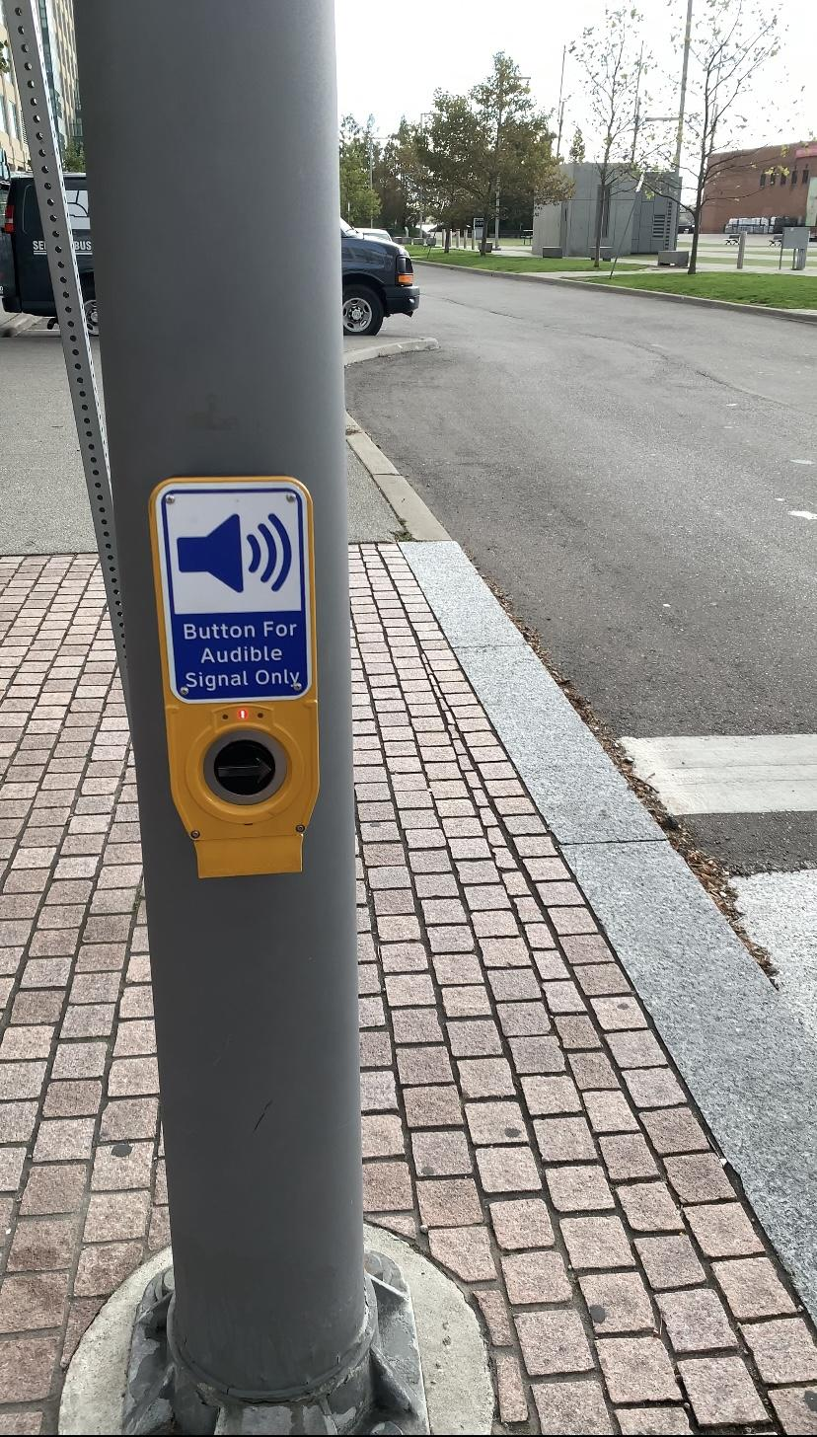
Figure 2: Accessible Pedestrian Signals at Crosswalk

3.2.2 Location
The location attributes include the distance from the trailhead to transit and the proximity to a major destination. Although many of the amenities included in our audit are important for all users, the location of the trail in proximity to transit can be especially important for persons with vision loss and a physical impairment, as these may impact a person’s ability to get to the park by other modes such as car or bike. The location attributes represent how accessible, or not accessible, it is to get to the trailhead based on distance. In this section, a major destination is defined as: downtown, major employer, mixed use corridor, and/or designated growth area.
Table 2: Scoring Values Table for Location Attributes
Attribute | Scoring = 0 | Scoring = 1 | Scoring = 2 | Scoring = 3
Proximity to Transit | Over 1km | 500m - 1km | 250m - 499m | Under 250m
Proximity to major destination (downtown, major  employer, mixed use corridor, designated growth area) | Over 1km | 500m - 1km | 250m - 499m | Under 250m

3.2.3 Physical Characteristics of Trails
An evaluation of physical attributes for MUTs is necessary in determining how the structural features comply with current design standards and reflect growing accessibility considerations. Conducting a thorough review of the physical condition of MUTs can enable municipalities to prioritize infrastructural improvements depending on its physical state and compliance to legislation accessibility standards. Furthermore, this can evaluate the effectiveness of existing maintenance to the area or may infer greater investment in such activities are needed to maintain the quality and accessibility of this public asset. Municipalities can also use this evaluation as an opportunity to integrate innovative design practices and trail features to support a barrier-free Canada by 2040 (ACA, 2019).
Table 3: Scoring Values Table for Physical Characteristic Attributes
Attribute | Scoring = 0 | Scoring = 1 | Scoring = 2 | Scoring = 3
Surface Type | n/a | Natural (informal footpath), Stairs, Woodchip. | Crushed limestone (limestone screening), Interlock, Flagstone, Bridge, and Chip, Boardwalk. | Asphalt & Concrete.
Transition Elements/ Tactile Attention Indicators | n/a | Not present. | Occasionally present where applicable. | Present at all locations where they are applicable.
Surface Stability | n/a | Not firm. | Firm in some sections. | Firm throughout the entire trail.
Trail Width | n/a | Less than 1m. | Between 1-2.1m. | More than 2.1m.
Running Slope | n/a | More than 8%. | Between 5-8%. | 5% or less.
Cross Slope | n/a | More than 5%. | Between 2-5%. | 2% or less.
Trail Crossing (Quality) | n/a | Non-marked trail crossing. | Marked trail crossing (pedestrian right-of-way). | Well-marked trail crossing with barriers/indication (ex. change in surface type).
Trail Crossing (Frequency) | 3 trail crossings per kilometer. | 2 trail crossings per kilometer. | 1 trail crossing per kilometer. | 0 trail crossings per kilometer.
Overhead Height Clearance | n/a | Non-marked trail crossing. | Marked trail crossing (pedestrian right-of-way). | Well-marked trail crossing with barriers/indication (ex. change in surface type).
Separation of Uses | n/a | Not separated. | Separated in some sections. | Separated throughout the entire trail.
Edge Protection / Guide Rope / Railing (Frequency) | No edge protection where there is water/slopes/drops. | Edge protection is partially provided where there is water/slopes/drops. | Edge protection is provided along most of the trail that is adjacent to water/slopes/drops. | Edge protection is provided along the entire length of the trail, and incorporates contrasting colours or materials.
Edge Protection / Guide Rope / Railing (Quality) | No edge protection where there is water/slopes/drops. | Edge protection is partially provided where there is water/slopes/drops, and incorporates contrasting colours or materials. | Edge protection is provided along most of the trail that is adjacent to water/slopes/drops, and incorporates contrasting colours or materials. | Edge protection is provided along the entire length of trail, and incorporates contrasting colours or materials.
Trail Condition | Informal path. | Poor. | Fair. | Good.
Trail Continuity | Many obstructions/barriers (5+). | Moderate obstructions/barriers (3-4). | Minimal obstructions/barriers (1-2). | No obstructions/barriers.
Access Point Clear Width (AODA Compliant) | Less than 850mm. | Between 850-925mm. | Between 926-1000mm. | More than 1000mm.
Paved Path to Entrance/ Trailhead | No defined path to entrance. | Unpaved path to entrance. | Partially paved path to entrance. | Paved path to entrance.
Provision or Absence of Dead Ends | More than one dead end. | Dead end exists with minimal efforts to create cues and/or turning radius for a mobility device (96in diameter). | Dead end exists with (ie. signage, markers and/or decorative features) cues and sufficient turning radius. | No dead ends.
Maintenance | No maintenance. | Servicing to remove barriers/obstacles. | Seasonal Maintenance. | All-year Maintenance.

3.2.4 Signage and Wayfinding
Signage and wayfinding are critical components of trail accessibility due to their ability to help users safely navigate a trail and identify potential hazards. Due to this, evaluating a trail's signage and wayfinding features is important in determining the overall accessibility and usability of a trail. Accessible signage and wayfinding features are especially important for those with sight-loss and those with physical impairments. For those with vision loss, the inclusion of wayfinding features such as guide ropes or audio guides can make navigating trails much easier and safer and thus are important accessibility features (American Trails, 2009). As for those with physical impairments, having signage present at the trailhead that describes the physical characteristics of a trail prior is essential as it helps individuals determine how difficult a trail may be to navigate as well as if there are any potential hazards present such as steep slopes or obstacles (Access Recreation, 2013; Government of Ontario, 2016).
Table 4: Scoring Values Table for Signage and Wayfinding Attributes
Attribute | Scoring = 0 | Scoring = 1 | Scoring = 2 | Scoring = 3
Shapes and Colour Coded Signage on Trail (Trail Markers) | Not Present. | Some trail markers but not in an easily understandable way. | Trail marker present but not fully accessible. | Fully accessible trail markers are present.
Sensory Experience (Tactile Map) | Not Present. | Present at one point along the trail. | n/a | Present at multiple locations. throughout trail
Sensory Experience (Scented Plants) | Not Present. | Present at one point along the trail. | n/a | Present at multiple locations throughout the trail.
Trail Information Available Online in a Accessible Format | No Information online. | Some information online but not in a fully accessible format. | All information available online but not in a fully accessible format. | Fully accessible trail markers are present.
Digital Tools (Wayfinding apps, QR Codes, Audio Guide) | None Present. | One digital navigation tool. | Two digital navigation tools available. | Three or more digital navigation tools available.
Guide Ropes: | Not Present. | Guide ropes are present in some sections. | Guide ropes are present along the trail. | Guide Ropes are present throughout the entire trail.
Signage has High Tonal Contrast with Background | No signage. | Signage present but difficult to read. | Some signage has high tonal contrast. | All signage has high tonal contrast.
Warning of Hazards at Trail Head (low branches, rocks, uneven terrain) | Information not present. | Information present but not in an accessible format. | Information present but only slightly accessible (high tonal contrast, large font). | Information present and fully accessible (braille, high tonal contrast, large font).
Average and Maximum Running and Cross Slope Information at Trail Head | Information not present. | Information present but not in an accessible format. | Information present but only slightly accessible (high tonal contrast, large font). | Information present and fully accessible (braille, high tonal contrast, large font).
Length of Trail Information at Trail Head | Information not present. | Information present but not in an accessible format. | Information present but only slightly accessible (high tonal contrast, large font). | Information present and fully accessible (braille, high tonal contrast, large font).
Average and Minimum Trail Information at Trail Head | Information not present. | Information present but not in an accessible format. | Information present but only slightly accessible (high tonal contrast, large font). | Information present and fully accessible (braille, high tonal contrast, large font).
Locations of Amenities Marked at Trail Head | Information not present. | Information present but not in an accessible format. | Information present but only slightly accessible (high tonal contrast, large font). | Information present and fully accessible (braille, high tonal contrast, large font).
Accessibility Information Marked at Trail Head (Is this trail accessible) | Information not present. | Information present but not in an accessible format. | Information present but only slightly accessible (high tonal contrast, large font). | Information present and fully accessible (braille, high tonal contrast, large font).
Seasonal Closures/Maintenance Information at Trail Head (Is there snow clearance, is there trail maintenance) | Information not present. | Information present but not in an accessible format. | Information present but only slightly accessible (high tonal contrast, large font). | Information present and fully accessible (braille, high tonal contrast, large font).
Accessibility of Trail Exits & Entrances Marked at Trail Head (Distance to next fully accessible trail exit marked) | Information not present. | Information present but not in an accessible format. | Information present but only slightly accessible (high tonal contrast, large font). | Information present and fully accessible (braille, high tonal contrast, large font).
Trail Rating Information at Trail Head (Easy, moderate, difficult) | Information not present. | Information present but not in an accessible format. | Information present but only slightly accessible (high tonal contrast, large font). | Information present and fully accessible (braille, high tonal contrast, large font).
Trail Surface Type Mentioned at Trailhead | Information not present. | Information present but not in an accessible format. | Information present but only slightly accessible (high tonal contrast, large font). | Information present and fully accessible (braille, high tonal contrast, large font).
Height of signage (descriptive signs at trail heads, 1m to 1.7m || user signs for when moving on trail 1.7m to 2.4m) | No signage. | Signage present but at improper heights. | Some signage is present within stated height parameters. | Signage present within stated height parameters.
Frequency of trail signage (every 4Km or at intersections) | No signage. | Signage present only at trail head. | Signage is present throughout the trail but not at every crossing. | Signage present at every crossing or every 4km (if no crossings present).
Warning signs on trail (25m from a hazard if grade is 2% or less 40m from a hazard if grade >2%) | No warning signage. | General warning signage at trailhead or along trail. | Warning signs for specific hazards but not within the stated distances. | Signage present within stated distances of hazards.

3.2.5 Disability Group Impact Table
In order to properly evaluate and synthesize the impacts and importance of different trail attributes as they relate to the five disability groups identified, a table was created (Table 5). The purpose of this table is to highlight both the magnitude of importance that certain trail attributes may have on different disability groups as well as whether the inclusion of said attribute has a positive or negative impact on members of that disability group. For example, the inclusion of a trail attribute such as accessible pedestrian signals may result in a significant positive outcome for those with vision loss as they navigate a MUT. However, the inclusion of accessible pedestrian signals on a MUT has no impact (positive or negative) on those with hearing loss as it does not make navigating the trail easier for people within that disability group. Overall, this table is able to more concisely showcase the varying levels of importance and impact that different trail attributes can have on different disability groups. By identifying these relationships, a more complete understanding of how best to adapt and redesign trails to increase their accessibility to all user groups can be achieved.

Table 5: Disability Group Impact Table
Attribute | Vision Loss | Magnitude | Impact | Hearing Loss | Magnitude | Impact | Mobility Impairment | Magnitude | Impact | Sensory Sensitivity | Magnitude | Impact | Cognitive Disability | Magnitude | Impact
Amenities & Features
Benches/Resting Areas/Picnic Areas | Vision Loss | Moderate | Positive | Hearing Loss | Moderate | Positive | Mobility Impairment | Significant | Positive | Sensory Sensitivity | Moderate | Positive | Cognitive Disability | Moderate | Positive
Restrooms | Vision Loss | Significant | Positive | Hearing Loss | Significant | Positive | Mobility Impairment | Significant | Positive | Sensory Sensitivity | Significant | Positive | Cognitive Disability | Significant | Positive
Water | Vision Loss | Moderate | Positive | Hearing Loss | Moderate | Positive | Mobility Impairment | Moderate | Positive | Sensory Sensitivity | Moderate | Positive | Cognitive Disability | Moderate | Positive
Parking Availability/Acessibility | Vision Loss | Moderate | Positive | Hearing Loss | Moderate | Positive | Mobility Impairment | Significant | Positive | Sensory Sensitivity | Moderate | Positive | Cognitive Disability | Moderate | Positive
Visitor Centre | Vision Loss | Moderate | Positive | Hearing Loss | Moderate | Positive | Mobility Impairment | Moderate | Positive | Sensory Sensitivity | Moderate | Mixed | Cognitive Disability | Moderate | Positive
Covered Shelter/ Other shade measures (tree canopy) | Vision Loss | Moderate | Positive | Hearing Loss | Moderate | Positive | Mobility Impairment | Significant | Positive | Sensory Sensitivity | Significant | Positive | Cognitive Disability | Moderate | Positive
Lighting | Vision Loss | Significant | Positive | Hearing Loss | Significant | Positive | Mobility Impairment | Significant | Positive | Sensory Sensitivity | Significant | Mixed | Cognitive Disability | Significant | Positive
Accessible Pedestrian Signals | Vision Loss | Significant | Positive | Hearing Loss | Neutral | - | Mobility Impairment | Neutral | - | Sensory Sensitivity | Moderate | Negative | Cognitive Disability | Neutral | -
Sound Reducing Measures | Vision Loss | Moderate | Mixed | Hearing Loss | Moderate | Positive | Mobility Impairment | Neutral | - | Sensory Sensitivity | Significant | Positive | Cognitive Disability | Neutral | -
Location
Proximity to Transit | Vision Loss | Significant | Positive | Hearing Loss | Moderate | Positive | Mobility Impairment | Significant | Positive | Sensory Sensitivity | Moderate | Positive | Cognitive Disability | Moderate | Positive
Proximity to Major Destination | Vision Loss | Moderate | Positive | Hearing Loss | Moderate | Positive | Mobility Impairment | Moderate | Positive | Sensory Sensitivity | Moderate | Negative | Cognitive Disability | Moderate | Positive
Physical Characteristics
Surface Type | Vision Loss | Significant | Positive | Hearing Loss | Neutral | - | Mobility Impairment | Significant | Positive | Sensory Sensitivity | Moderate | Positive | Cognitive Disability | Moderate | Positive
Tactile Attention Indicators | Vision Loss | Significant | Positive | Hearing Loss | Moderate | Positive | Mobility Impairment | Moderate | Negative | Sensory Sensitivity | Moderate | Positive | Cognitive Disability | Moderate | Positive
Surface Stability | Vision Loss | Significant | Positive | Hearing Loss | Neutral | - | Mobility Impairment | Significant | Positive | Sensory Sensitivity | Moderate | Positive | Cognitive Disability | Moderate | Positive
Trail Width | Vision Loss | Moderate | Positive | Hearing Loss | Neutral | - | Mobility Impairment | Significant | Positive | Sensory Sensitivity | Neutral | - | Cognitive Disability | Neutral | -
Running Slope | Vision Loss | Moderate | Positive | Hearing Loss | Neutral | - | Mobility Impairment | Significant | Positive | Sensory Sensitivity | Neutral | - | Cognitive Disability | Neutral | -
Cross Slope | Vision Loss | Significant | Positive | Hearing Loss | Neutral | - | Mobility Impairment | Significant | Positive | Sensory Sensitivity | Neutral | - | Cognitive Disability | Neutral | -
Trail Crossing Quality | Vision Loss | Significant | Positive | Hearing Loss | Significant | Positive | Mobility Impairment | Significant | Positive | Sensory Sensitivity | Moderate | Positive | Cognitive Disability | Moderate | Positive
Trail Crossing Frequency | Vision Loss | Significant | Negative | Hearing Loss | Significant | Negative | Mobility Impairment | Significant | Negative | Sensory Sensitivity | Moderate | Negative | Cognitive Disability | Moderate | Negative
Overhead Height | Vision Loss | Significant | Positive | Hearing Loss | Moderate | Positive | Mobility Impairment | Moderate | Positive | Sensory Sensitivity | Moderate | Positive | Cognitive Disability | Neutral | -
Separation of Uses | Vision Loss | Significant | Positive | Hearing Loss | Significant | Positive | Mobility Impairment | Significant | Positive | Sensory Sensitivity | Moderate | Positive | Cognitive Disability | Moderate | Positive
Edge Protection | Vision Loss | Significant | Positive | Hearing Loss | Moderate | Positive | Mobility Impairment | Significant | Positive | Sensory Sensitivity | Neutral | - | Cognitive Disability | Neutral | -
Trail Condition | Vision Loss | Significant | Positive | Hearing Loss | Significant | Positive | Mobility Impairment | Significant | Positive | Sensory Sensitivity | Significant | Positive | Cognitive Disability | Significant | Positive
Trail Continuity (ex of obstructions: roadways, rail lines, land parcels, natural features) | Vision Loss | Significant | Positive | Hearing Loss | Moderate | Positive | Mobility Impairment | Significant | Positive | Sensory Sensitivity | Moderate | Positive | Cognitive Disability | Moderate | Positive
Access Points (AODA compliant) | Vision Loss | Moderate | Positive | Hearing Loss | Moderate | Positive | Mobility Impairment | Significant | Positive | Sensory Sensitivity | Moderate | Positive | Cognitive Disability | Moderate | Positive
Paved Path to Entrance | Vision Loss | Significant | Positive | Hearing Loss | Neutral | - | Mobility Impairment | Significant | Positive | Sensory Sensitivity | Neutral | - | Cognitive Disability | Neutral | -
Provision /Absence of Dead Ends | Vision Loss | Moderate | Positive | Hearing Loss | Neutral | - | Mobility Impairment | Moderate | Positive | Sensory Sensitivity | Neutral | - | Cognitive Disability | Significant | Positive
Maintenance) | Vision Loss | Significant | Positive | Hearing Loss | Moderate | Positive | Mobility Impairment | Significant | Positive | Sensory Sensitivity | Moderate | Positive | Cognitive Disability | Moderate | Positive
Signage and Wayfinding
Shapes and Colour Coded Signage on trail (trail markers) | Vision Loss | Moderate | Positive | Hearing Loss | Moderate | Positive | Mobility Impairment | Moderate | Positive | Sensory Sensitivity | Moderate | Positive | Cognitive Disability | Moderate | Positive
Sensory Experience (Tactile Map) | Vision Loss | Moderate | Positive | Hearing Loss | Neutral | - | Mobility Impairment | Neutral | - | Sensory Sensitivity | Neutral | - | Cognitive Disability | Neutral | -
Sensory Experience (Scented Plants) | Vision Loss | Moderate | Positive | Hearing Loss | Neutral | - | Mobility Impairment | Neutral | - | Sensory Sensitivity | Moderate | Negative | Cognitive Disability | Neutral | -
Trail information is available online in an accesible format | Vision Loss | Significant | Positive | Hearing Loss | Moderate | Positive | Mobility Impairment | Significant | Positive | Sensory Sensitivity | Moderate | Positive | Cognitive Disability | Moderate | Positive
Digital Tools | Vision Loss | Significant | Positive | Hearing Loss | Neutral | - | Mobility Impairment | Neutral | - | Sensory Sensitivity | Neutral | - | Cognitive Disability | Moderate | Positive
Guide Ropes present | Vision Loss | Significant | Positive | Hearing Loss | Neutral | - | Mobility Impairment | Neutral | - | Sensory Sensitivity | Neutral | - | Cognitive Disability | Moderate | Positive
Signage on trail has high tonal contrast with background | Vision Loss | Significant | Positive | Hearing Loss | Moderate | Positive | Mobility Impairment | Moderate | Positive | Sensory Sensitivity | Moderate | Positive | Cognitive Disability | Moderate | Positive
Warning of Hazards at trail head (low branches, rocks, uneven terrain) | Vision Loss | Moderate | Positive | Hearing Loss | Moderate | Positive | Mobility Impairment | Significant | Positive | Sensory Sensitivity | Moderate | Positive | Cognitive Disability | Moderate | Positive
Average and maximum running and cross Slope of trail information marked at trail head | Vision Loss | Moderate | Positive | Hearing Loss | Moderate | Positive | Mobility Impairment | Significant | Positive | Sensory Sensitivity | Moderate | Positive | Cognitive Disability | Moderate | Positive
Length of Trail Information on singage at trail head | Vision Loss | Moderate | Positive | Hearing Loss | Moderate | Positive | Mobility Impairment | Significant | Positive | Sensory Sensitivity | Moderate | Positive | Cognitive Disability | Moderate | Positive
Average and Minimum Trail Width info included at trailhead | Vision Loss | Neutral | - | Hearing Loss | Neutral | - | Mobility Impairment | Significant | Positive | Sensory Sensitivity | Moderate | Positive | Cognitive Disability | Moderate | Positive
Locations of amenities marked at trailhead | Vision Loss | Moderate | Positive | Hearing Loss | Moderate | Positive | Mobility Impairment | Significant | Positive | Sensory Sensitivity | Moderate | Positive | Cognitive Disability | Moderate | Positive
Accessibility info (is this trail accessible) marked at trail head | Vision Loss | Moderate | Positive | Hearing Loss | Moderate | Positive | Mobility Impairment | Significant | Positive | Sensory Sensitivity | Moderate | Positive | Cognitive Disability | Moderate | Positive
Seasonal closures/maintenance info (is there snow clearance, etc) at trailhead | Vision Loss | Moderate | Positive | Hearing Loss | Moderate | Positive | Mobility Impairment | Significant | Positive | Sensory Sensitivity | Moderate | Positive | Cognitive Disability | Moderate | Positive
Accessibility of trail exits/entrances (distance to next fully accessible exit marked, etc) | Vision Loss | Moderate | Positive | Hearing Loss | Moderate | Positive | Mobility Impairment | Significant | Positive | Sensory Sensitivity | Moderate | Positive | Cognitive Disability | Moderate | Positive
Trail rating noted (easy, moderate, difficult) at trailhead | Vision Loss | Significant | Positive | Hearing Loss | Moderate | Positive | Mobility Impairment | Significant | Positive | Sensory Sensitivity | Moderate | Positive | Cognitive Disability | Moderate | Positive
Trail Surface type mentioned at trailhead | Vision Loss | Moderate | Positive | Hearing Loss | Moderate | Positive | Mobility Impairment | Significant | Positive | Sensory Sensitivity | Moderate | Positive | Cognitive Disability | Moderate | Positive
Height of signage | Vision Loss | Neutral | - | Hearing Loss | Neutral | - | Mobility Impairment | Moderate | Positive | Sensory Sensitivity | Neutral | - | Cognitive Disability | Neutral | -
Frequency of trail signage | Vision Loss | Moderate | Positive | Hearing Loss | Moderate | Positive | Mobility Impairment | Moderate | Positive | Sensory Sensitivity | Moderate | Positive | Cognitive Disability | Moderate | Positive
Warning signs on trail | Vision Loss | Moderate | Positive | Hearing Loss | Moderate | Positive | Mobility Impairment | Significant | Positive | Sensory Sensitivity | Moderate | Positive | Cognitive Disability | Moderate | Positive

Case Studies
We piloted MUTAA on two Toronto trails: the Queen’s Quay West segment of the Martin Goodman Waterfront Trail, and the Lower Don Valley Trail. We selected these trails due to geographic proximity and their status as urban MUTs. Due to constraints in the time frame, resources, and scope of this report, we chose to only conduct the MUTAA on portions of both trails. As such, this analysis covers a 1.5km stretch of the Martin Goodman Waterfront Trail on the Queens Quay West segment from Bay St to Spadina Ave, and a 3km stretch of the Lower Don Valley Trail from Pottery Road to Riverdale Park West. The purpose of the pilots was to assess its functionality in terms of applying criteria and recording scores to highlight which attributes may cause a barrier for people with a disability.
For both case studies, members of our research team walked along the trail to conduct the MUTAA. Each researcher was assigned an area of focus to pay attention to from the MUTAA, and recorded observations during the walk using measuring tapes to measure distances of sidewalks and benches, phone cameras to record snapshots of the trail, and notebooks, smartphones or ipads to record observations. At the end of the walk, the research team used the pictures and observational notes to rate the trail for each category included in the MUTAA. Further research and more specialized equipment to measure running slope and cross-slope may be needed for a more comprehensive analysis of the accessibility of both trails since this report only covered one part of both trails.

4.1 Martin Goodman Waterfront Trail - Queen’s Quay West
The Martin Goodman Waterfront Trail is a MUT located in the downtown core of Toronto, Ontario. This trail is busy with cyclists, runners, and walkers alike. This portion of the trail opened in 2009 and is a part of the larger 730km Waterfront Trail around Lake Ontario. Some key attractions in this trail include the Wave Decks (mainly decorative), man-made beaches, parks, and proximity to the Toronto Harbourfront. The City of Toronto describes the waterfront development initiatives as creating “beautiful, accessible, sustainable mixed-use communities and dynamic public spaces” (City of Toronto, 2017), and Waterfront Toronto describes some stretches of the Martin Goodman Trail containing similar trail design to the Queens Quay West segment as “completely barrier-free and easily accessible to everyone” (Waterfront Toronto, n. d. a). However, there is no language on accessibility on the website for the stretch that we walked (Waterfront Toronto, n. d. b). Our team evaluated this MUT because of its accessible labeling to determine if there is equitable access based on the MUTAA standards for different disability groups.
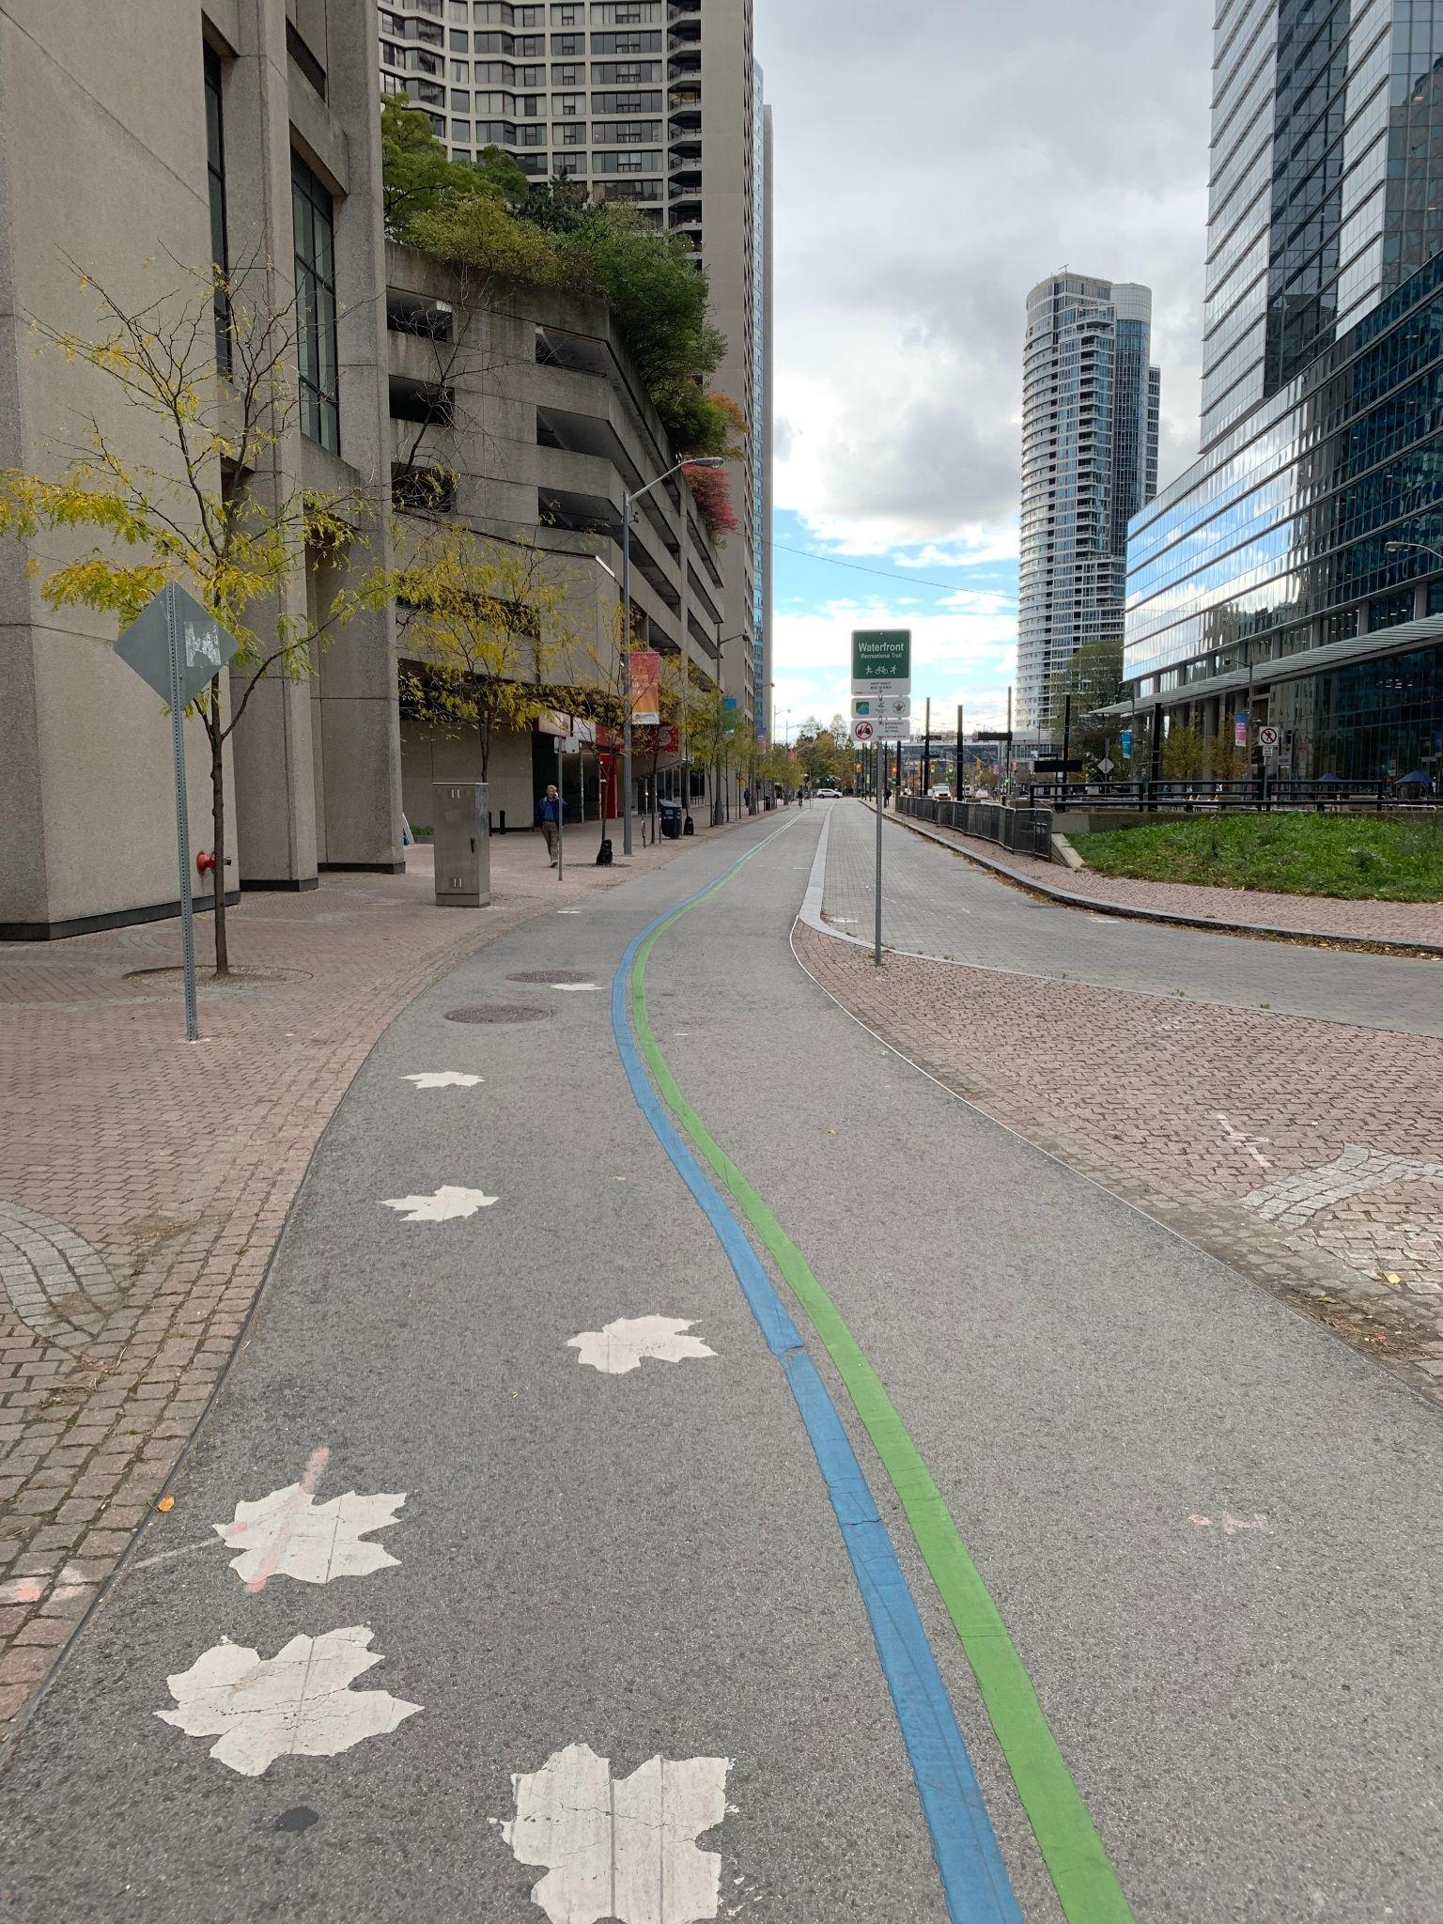
Figure 3: Toronto Waterfront Trail

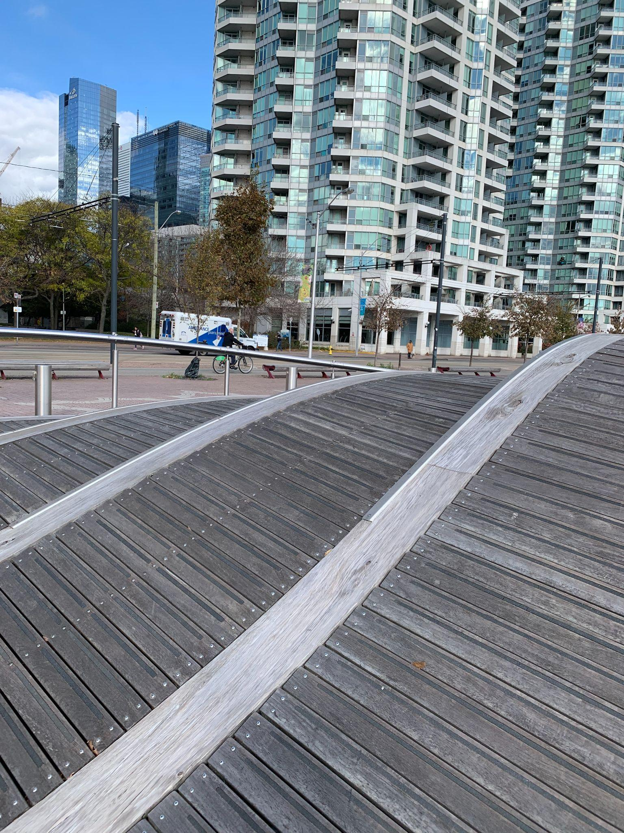
Figure 4: Wave Decks on the Toronto Waterfront Trail

4.2 Don Valley Trail
The Lower Don Valley Trail is a MUT that runs along the Don River. The trail is part of Toronto's Pan Am Path in the Ravine Trail Network, an 82 km trail across Toronto's legacy of the 1015 Pan Am and Parapan Am Games. After opening in 1961, the City of Toronto started planning improvements on the Lower Don Trail based on the Lower Don Masterplan in 2019. According to the City of Toronto, improvements are taking place to correct the fact that the trail is not fully accessible and, in some stretches, is unsafe for people belonging to certain disability groups. This trail was selected for assessment as it offers a good comparison of how the MUTAA performs when assessing more challenging trails compared to more accessible trails, such the Martin Goodman Trail, which the City of Toronto has marked as being accessible.
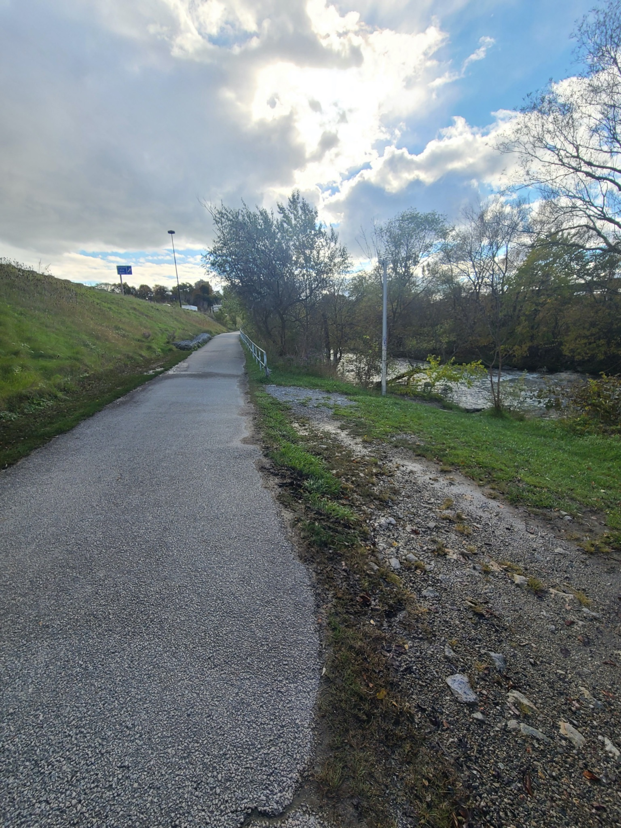
Figure 5: Lower Don Valley Trail

Results
The results section includes the completed trail audits for both the Waterfront Trail and the Don Valley Trail. These tables outline the scores each trail received for each given audit attribute on a scale of 0-3. In addition to these scores, there is also an outline of the magnitude and impact of each of these attributes on the five different disability groups identified. Finally, certain attributes have been bolded for specific disability groups to highlight trail criteria that performed either really well for that group or really poorly. For example, if a trail scored a zero for Trail Continuity and it was deemed that for those with vision loss, having good trail continuity was significantly important, then that attribute would be bolded. This is to show that improving the Trail Continuity would result in significant positive improvements for those with vision loss who are navigating the trail.

5.1 Waterfront Trail Audit Results
Table 6: Waterfront Trail Audit Results- Amenities & Features
Attribute | Sub-category | State | Group | Magnitude | Impact | Group | Magnitude | Impact | Group | Magnitude | Impact | Group | Magnitude | Impact | Group | Magnitude | Impact
Amenities & Features
Benches/Resting Areas | Frequency | 3 | Vision Loss | Moderate | Positive | Hearing Loss | Moderate | Positive | Mobility Impairment | Significant | Positive | Sensory Sensitivity | Moderate | Positive | Cognitive Disability | Moderate | Positive
Benches/Resting Areas | Quality | 3 | Vision Loss | Moderate | Positive | Hearing Loss | Moderate | Positive | Mobility Impairment | Significant | Positive | Sensory Sensitivity | Moderate | Positive | Cognitive Disability | Moderate | Positive
Benches/Resting Areas | Accessibility | 3 | Vision Loss | Moderate | Positive | Hearing Loss | Moderate | Positive | Mobility Impairment | Significant | Positive | Sensory Sensitivity | Moderate | Positive | Cognitive Disability | Moderate | Positive
Restrooms | Frequency | 1 | Vision Loss | Significant | Positive | Hearing Loss | Significant | Positive | Mobility Impairment | Significant | Positive | Sensory Sensitivity | Significant | Positive | Cognitive Disability | Significant | Positive
Restrooms | Quality | 2 | Vision Loss | Significant | Positive | Hearing Loss | Significant | Positive | Mobility Impairment | Significant | Positive | Sensory Sensitivity | Significant | Positive | Cognitive Disability | Significant | Positive
Restrooms | Accessibility | 2 | Vision Loss | Significant | Positive | Hearing Loss | Significant | Positive | Mobility Impairment | Significant | Positive | Sensory Sensitivity | Significant | Positive | Cognitive Disability | Significant | Positive
Water | Frequency | 1 | Vision Loss | Moderate | Positive | Hearing Loss | Moderate | Positive | Mobility Impairment | Moderate | Positive | Sensory Sensitivity | Moderate | Positive | Cognitive Disability | Moderate | Positive
Water | Quality | 1 | Vision Loss | Moderate | Positive | Hearing Loss | Moderate | Positive | Mobility Impairment | Moderate | Positive | Sensory Sensitivity | Moderate | Positive | Cognitive Disability | Moderate | Positive
Water | Accessibility | 3 | Vision Loss | Moderate | Positive | Hearing Loss | Moderate | Positive | Mobility Impairment | Moderate | Positive | Sensory Sensitivity | Moderate | Positive | Cognitive Disability | Moderate | Positive
Parking Availability/Accessibility |  | 2 | Vision Loss | Moderate | Positive | Hearing Loss | Moderate | Positive | Mobility Impairment | Significant | Positive | Sensory Sensitivity | Moderate | Positive | Cognitive Disability | Moderate | Positive
Visitor Centre |  | 0 | Vision Loss | Moderate | Positive | Hearing Loss | Moderate | Positive | Mobility Impairment | Moderate | Positive | Sensory Sensitivity | Moderate | Mixed | Cognitive Disability | Moderate | Positive
Covered Shelter/ Other shade measures | Frequency | 3 | Vision Loss | Moderate | Positive | Hearing Loss | Moderate | Positive | Mobility Impairment | Significant | Positive | Sensory Sensitivity | Significant | Positive | Cognitive Disability | Moderate | Positive
Covered Shelter/ Other shade measures | Quality | 2 | Vision Loss | Moderate | Positive | Hearing Loss | Moderate | Positive | Mobility Impairment | Significant | Positive | Sensory Sensitivity | Significant | Positive | Cognitive Disability | Moderate | Positive
Covered Shelter/ Other shade measures | Accessibility | 2 | Vision Loss | Moderate | Positive | Hearing Loss | Moderate | Positive | Mobility Impairment | Significant | Positive | Sensory Sensitivity | Significant | Positive | Cognitive Disability | Moderate | Positive
Lighting | Frequency | 3 | Vision Loss | Significant | Positive | Hearing Loss | Significant | Positive | Mobility Impairment | Significant | Positive | Sensory Sensitivity | Significant | Mixed | Cognitive Disability | Significant | Positive
Lighting | Quality | 3 | Vision Loss | Significant | Positive | Hearing Loss | Significant | Positive | Mobility Impairment | Significant | Positive | Sensory Sensitivity | Significant | Mixed | Cognitive Disability | Significant | Positive
Accessible Pedestrian Signals at trail crossings |  | 1 | Vision Loss | Significant | Positive | Hearing Loss | Neutral | - | Mobility Impairment | Neutral | - | Sensory Sensitivity | Moderate | Negative | Cognitive Disability | Neutral | -
Sound Reducing Measures |  | 0 | Vision Loss | Moderate | Mixed | Hearing Loss | Moderate | Positive | Mobility Impairment | Neutral | - | Sensory Sensitivity | Significant | Positive | Cognitive Disability | Neutral | -
Other Features/Services (note in comments)
Section Score (Maximum:54) |  | 35

Table 7: Waterfront Trail Audit Results - Location & Physical Characteristics
Attribute | Sub-category | State | Group | Magnitude | Impact | Group | Magnitude | Impact | Group | Magnitude | Impact | Group | Magnitude | Impact | Group | Magnitude | Impact
Location
Proximity to Transit |  | 3 | Vision Loss | Significant | Positive | Hearing Loss | Moderate | Positive | Mobility Impairment | Significant | Positive | Sensory Sensitivity | Moderate | Positive | Cognitive Disability | Moderate | Positive
Proximity to Major Destination |  | 3 | Vision Loss | Moderate | Positive | Hearing Loss | Moderate | Positive | Mobility Impairment | Moderate | Positive | Sensory Sensitivity | Moderate | Negative | Cognitive Disability | Moderate | Positive
Section Score (Maximum:6) |  | 6
Physical Characteristics
Surface Type |  | 3 | Vision Loss | Significant | Positive | Hearing Loss | Neutral | - | Mobility Impairment | Significant | Positive | Sensory Sensitivity | Moderate | Positive | Cognitive Disability | Moderate | Positive
Transition Elements/ Tactile Attention Indicators |  | 2 | Vision Loss | Significant | Positive | Hearing Loss | Moderate | Positive | Mobility Impairment | Moderate | Negative | Sensory Sensitivity | Moderate | Positive | Cognitive Disability | Moderate | Positive
Surface Stability |  | 3 | Vision Loss | Significant | Positive | Hearing Loss | Neutral | - | Mobility Impairment | Significant | Positive | Sensory Sensitivity | Moderate | Positive | Cognitive Disability | Moderate | Positive
Trail Width |  | 3 | Vision Loss | Moderate | Positive | Hearing Loss | Neutral | - | Mobility Impairment | Significant | Positive | Sensory Sensitivity | Neutral | - | Cognitive Disability | Neutral | -
Running Slope |  | 3 | Vision Loss | Moderate | Positive | Hearing Loss | Neutral | - | Mobility Impairment | Significant | Positive | Sensory Sensitivity | Neutral | - | Cognitive Disability | Neutral | -
Cross Slope |  | 3 | Vision Loss | Significant | Positive | Hearing Loss | Neutral | - | Mobility Impairment | Significant | Positive | Sensory Sensitivity | Neutral | - | Cognitive Disability | Neutral | -
Trail Crossing | Frequency | 0 | Vision Loss | Significant | Negative | Hearing Loss | Significant | Negative | Mobility Impairment | Significant | Negative | Sensory Sensitivity | Moderate | Negative | Cognitive Disability | Moderate | Negative
Trail Crossing | Quality | 2 | Vision Loss | Significant | Positive | Hearing Loss | Significant | Positive | Mobility Impairment | Significant | Positive | Sensory Sensitivity | Moderate | Positive | Cognitive Disability | Moderate | Positive
Overhead Height Clearance |  | 3 | Vision Loss | Significant | Positive | Hearing Loss | Moderate | Positive | Mobility Impairment | Moderate | Positive | Sensory Sensitivity | Moderate | Positive | Cognitive Disability | Neutral | -
Separation of Uses |  | 3 | Vision Loss | Significant | Positive | Hearing Loss | Significant | Positive | Mobility Impairment | Significant | Positive | Sensory Sensitivity | Moderate | Positive | Cognitive Disability | Moderate | Positive
Edge Protection | Frequency | 1 | Vision Loss | Significant | Positive | Hearing Loss | Moderate | Positive | Mobility Impairment | Significant | Positive | Sensory Sensitivity | Neutral | - | Cognitive Disability | Neutral | -
Edge Protection | Quality | 1 | Vision Loss | Significant | Positive | Hearing Loss | Moderate | Positive | Mobility Impairment | Significant | Positive | Sensory Sensitivity | Neutral | - | Cognitive Disability | Neutral | -
Trail Condition |  | 3 | Vision Loss | Significant | Positive | Hearing Loss | Significant | Positive | Mobility Impairment | Significant | Positive | Sensory Sensitivity | Significant | Positive | Cognitive Disability | Significant | Positive
Trail Continuity |  | 0 | Vision Loss | Significant | Positive | Hearing Loss | Moderate | Positive | Mobility Impairment | Significant | Positive | Sensory Sensitivity | Moderate | Positive | Cognitive Disability | Moderate | Positive
Access Points (AODA compliant) |  | 3 | Vision Loss | Moderate | Positive | Hearing Loss | Moderate | Positive | Mobility Impairment | Significant | Positive | Sensory Sensitivity | Moderate | Positive | Cognitive Disability | Moderate | Positive
Paved Path to Entrance |  | 3 | Vision Loss | Significant | Positive | Hearing Loss | Neutral | - | Mobility Impairment | Significant | Positive | Sensory Sensitivity | Neutral | - | Cognitive Disability | Neutral | -
Provision/Absence of Dead Ends |  | 3 | Vision Loss | Moderate | Positive | Hearing Loss | Neutral | - | Mobility Impairment | Moderate | Positive | Sensory Sensitivity | Neutral | - | Cognitive Disability | Significant | Positive
Maintenance |  | 2 | Vision Loss | Significant | Positive | Hearing Loss | Moderate | Positive | Mobility Impairment | Significant | Positive | Sensory Sensitivity | Moderate | Positive | Cognitive Disability | Moderate | Positive
Section Score (Maximum: 54) |  | 41
Table 8: Waterfront Trail Audit Results - Signage & Wayfinding
Attribute | Sub-category | State | Group | Magnitude | Impact | Group | Magnitude | Impact | Group | Magnitude | Impact | Group | Magnitude | Impact | Group | Magnitude | Impact
Signage and Wayfinding
Shapes and Colour Coded Signage on trail (trail markers) |  | 1 | Vision Loss | Moderate | Positive | Hearing Loss | Moderate | Positive | Mobility Impairment | Moderate | Positive | Sensory Sensitivity | Moderate | Positive | Cognitive Disability | Moderate | Positive
Sensory Experience (Tactile Map) |  | 0 | Vision Loss | Moderate | Positive | Hearing Loss | Neutral | - | Mobility Impairment | Neutral | - | Sensory Sensitivity | Neutral | - | Cognitive Disability | Neutral | -
Sensory Experience (Scented Plants) |  | 0 | Vision Loss | Moderate | Positive | Hearing Loss | Neutral | - | Mobility Impairment | Neutral | - | Sensory Sensitivity | Moderate | Negative | Cognitive Disability | Neutral | -
Trail information is available online in an accessible format |  | 1 | Vision Loss | Significant | Positive | Hearing Loss | Moderate | Positive | Mobility Impairment | Significant | Positive | Sensory Sensitivity | Moderate | Positive | Cognitive Disability | Moderate | Positive
Digital Tools (Applications, QR codes, audio guide) |  | 0 | Vision Loss | Significant | Positive | Hearing Loss | Neutral | - | Mobility Impairment | Neutral | - | Sensory Sensitivity | Neutral | - | Cognitive Disability | Moderate | Positive
Guide Ropes present |  | 0 | Vision Loss | Significant | Positive | Hearing Loss | Neutral | - | Mobility Impairment | Neutral | - | Sensory Sensitivity | Neutral | - | Cognitive Disability | Moderate | Positive
Signage has high tonal contrast with background |  | 0 | Vision Loss | Significant | Positive | Hearing Loss | Moderate | Positive | Mobility Impairment | Moderate | Positive | Sensory Sensitivity | Moderate | Positive | Cognitive Disability | Moderate | Positive
Warning of Hazards at trail head (low branches, rocks, uneven terrain) |  | 0 | Vision Loss | Moderate | Positive | Hearing Loss | Moderate | Positive | Mobility Impairment | Significant | Positive | Sensory Sensitivity | Moderate | Positive | Cognitive Disability | Moderate | Positive
Average and maximum running and cross slope marked at trail head |  | 0 | Vision Loss | Moderate | Positive | Hearing Loss | Moderate | Positive | Mobility Impairment | Significant | Positive | Sensory Sensitivity | Moderate | Positive | Cognitive Disability | Moderate | Positive
Length of Trail Information on singage at trail head |  | 0 | Vision Loss | Moderate | Positive | Hearing Loss | Moderate | Positive | Mobility Impairment | Significant | Positive | Sensory Sensitivity | Moderate | Positive | Cognitive Disability | Moderate | Positive
Average and Minimum Trail Width info included at trailhead |  | 0 | Vision Loss | Neutral | - | Hearing Loss | Neutral | - | Mobility Impairment | Significant | Positive | Sensory Sensitivity | Moderate | Positive | Cognitive Disability | Moderate | Positive
Locations of amenities marked at trailhead |  | 1 | Vision Loss | Moderate | Positive | Hearing Loss | Moderate | Positive | Mobility Impairment | Significant | Positive | Sensory Sensitivity | Moderate | Positive | Cognitive Disability | Moderate | Positive
Accessibility info (is this trail accessible) marked at trail head |  | 0 | Vision Loss | Moderate | Positive | Hearing Loss | Moderate | Positive | Mobility Impairment | Significant | Positive | Sensory Sensitivity | Moderate | Positive | Cognitive Disability | Moderate | Positive
Seasonal closures/maintenance info at trailhead |  | 0 | Vision Loss | Moderate | Positive | Hearing Loss | Moderate | Positive | Mobility Impairment | Significant | Positive | Sensory Sensitivity | Moderate | Positive | Cognitive Disability | Moderate | Positive
Accessibility of trail exits/entrances at trailhead (distance to next fully accessible exit marked) |  | 0 | Vision Loss | Moderate | Positive | Hearing Loss | Moderate | Positive | Mobility Impairment | Significant | Positive | Sensory Sensitivity | Moderate | Positive | Cognitive Disability | Moderate | Positive
Trail rating noted (easy, moderate, difficult) at trailhead |  | 0 | Vision Loss | Significant | Positive | Hearing Loss | Moderate | Positive | Mobility Impairment | Significant | Positive | Sensory Sensitivity | Moderate | Positive | Cognitive Disability | Moderate | Positive
Trail Surface type mentioned at trailhead |  | 0 | Vision Loss | Moderate | Positive | Hearing Loss | Moderate | Positive | Mobility Impairment | Significant | Positive | Sensory Sensitivity | Moderate | Positive | Cognitive Disability | Moderate | Positive
Height of signage (descriptive signs at trail heads, 1m to 1.7m || user signs for when moving on trail 1.7m to 2.4m) |  | 3 | Vision Loss | Neutral | - | Hearing Loss | Neutral | - | Mobility Impairment | Moderate | Positive | Sensory Sensitivity | Neutral | - | Cognitive Disability | Neutral | -
Frequency of trail signage (every 4Km or at intersections) |  | 2 | Vision Loss | Moderate | Positive | Hearing Loss | Moderate | Positive | Mobility Impairment | Moderate | Positive | Sensory Sensitivity | Moderate | Positive | Cognitive Disability | Moderate | Positive
Warning signs on trail (25m from a hazard if grade is 2% or less 40m from a hazard if grade >2%) |  | 1 | Vision Loss | Moderate | Positive | Hearing Loss | Moderate | Positive | Mobility Impairment | Significant | Positive | Sensory Sensitivity | Moderate | Positive | Cognitive Disability | Moderate | Positive
Section Score (Maximum: 60) |  | 9
Total Score (Maximum Score || 174) |  | 91

5.2 Waterfront Trail Key Takeaways: Strengths

5.2.1 Amenities and Features
The strengths of the amenities found in the MUTAA include the resting areas and lighting which scored perfectly. There is an abundance of benches, resting areas, shelter, with light posts every 25-50 metres. Figure 6 shows a resting area with multiple benches.

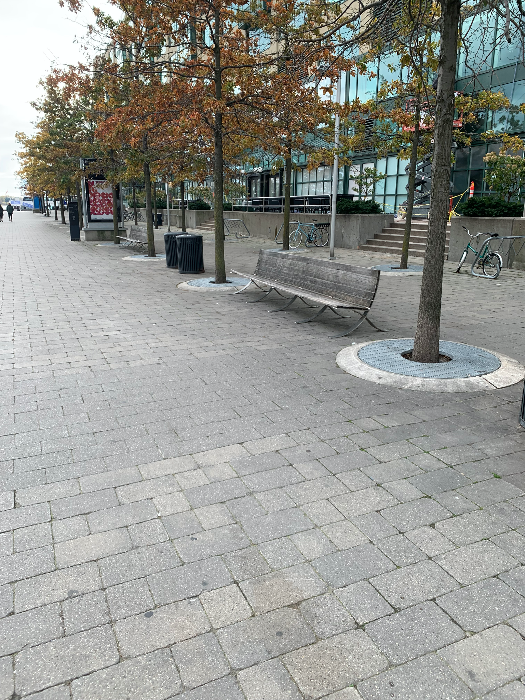
Figure 6: Resting Area with Benches at the Waterfront Trail
The waterfront trail is well-equipped to serve trail-goers who have a need for places to rest while they are visiting.

5.2.2 Location
The Martin Goodman Waterfront Trail scored perfectly due to its proximity to transit and paratransit, increasing accessibility to the trail via accessible bus routes and the Queens Quay streetcar.

5.2.3 Physical Characteristics
Overall, the physical attributes of the trail meet or exceed the minimum requirements outlined in the Design of Public Spaces Standard from the AODA. The paved surface throughout made the trail stable. There is excess trail width, overhead height clearance and access points throughout. In terms of running and cross slope, the trail is relatively flat and has no major inclines.
Chosen sections of the trail have winter maintenance. The City of Toronto provides snow clearing along Martin Goodman between Windermere Avenue and Stadium Road, and along Lakeshore Boulevard from Northern Dancer Boulevard to Lower Sherbourne Street (City of Toronto, 2020). However, an evaluation during the winter is needed to verify how well they are serviced.

5.3 Waterfront Trail Key Takeaways: Areas of Improvement

5.3.1 Amenities and Features
The amenities of the Waterfront Trail are inconsistent. Some areas of improvement include the restrooms, water, accessible pedestrian signals, and sound-reducing measures. One of the restrooms on the trail are two porta-potties, and although they are “accessible” porta-potties, this scored lower on MUTAA as they do not provide the same accessories as a restroom.
There is only one water fountain in the 1.5km stretch of the trail assessed by MUTAA. This water fountain appears appropriate for all users; however the fountain does not provide any water, rendering it useless. The lack of accessible water can be a hindrance for some users.
There are accessible pedestrian signals on each of the street crossings on the Waterfront Trail. However, the noise that emitted from the signals is extremely quiet, making them a non-factor for someone who relies on these signals to cross the street. In addition, there are no sound reducing measures as the trail was directly beside the busy downtown street of Queens Quay. This added to the signal's inaudibility as the sound of cars drowned the signal out. This could also be a deterrent for those with a sensory sensitivity.
There is a higher demand on amenities as this trail is situated on the edge of the downtown core. To improve upon the existing amenities, the Waterfront trail should focus on improving the accessibility of its restrooms, including more functional water stations, increasing the sound of the accessible pedestrian signals, and creating sound reducing measures.

5.3.2 Physical Characteristics
Given this trail is situated along the edge of Downtown Toronto, 10 trail crossings (2 unmarked and 8 marked) were noted within our 1.5km segment. The presence of unmarked crossings is a major hazard for any user and the frequency of these crossings poses an increased safety risk for those with impairments.
Sections of the trail indicated that there is no winter maintenance. Therefore, at certain times of the year for long periods of time, parts of the trail can be unusable for certain groups. Improving existing maintenance of the trail can help create a trail that is accessible for all people regardless of the time of year.

5.3.4 Signage and Wayfinding
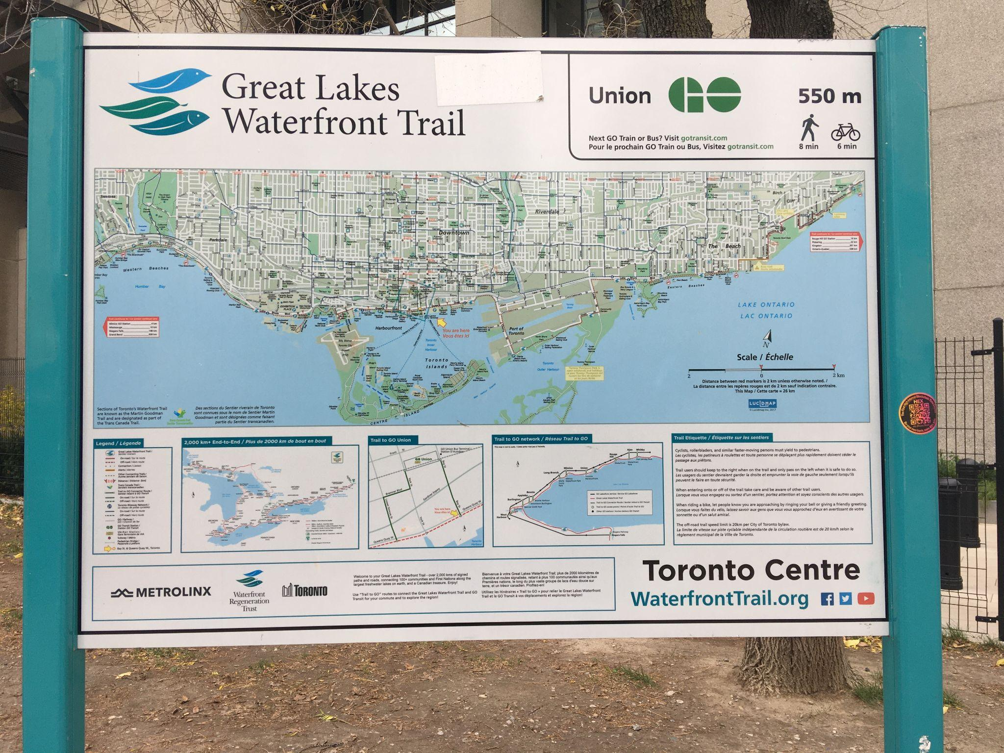
Figure 7: Wayfinding Signage on the Waterfront Trail
Wayfinding map signage was present at the beginning and end of the segment we assessed (spaced approximately 1.5 km apart). There is no information about hazards, slopes, surface type, or accessibility. The signs are also not designed in a very accessible way. Though they were colour-coded, not all symbols are present in the legend. The map is extremely busy, and images and text were small with no tactile elements, accessible pedestrian signals, or braille included. Information on the maps is outdated. The first sign, located at Queen’s Quay and Bay, is installed on a grassy area separated from the path by a curb, making it difficult for some trail users to use, especially those using a mobility aid such as a wheelchair.
The City of Toronto has a web page available for this trail that lists the access points and redirects the user to the Waterfront Trail website to access downloadable maps for different trail segments. The website is not very intuitive or accessible, and it did not include information about the accessibility measures or conditions present on the trail itself.

Table 9: Lower Don Trail Audit Results-Amenities & Features
Attribute | Sub-category | State | Group | Magnitude | Impact | Group | Magnitude | Impact | Group | Magnitude | Impact | Group | Magnitude | Impact | Group | Magnitude | Impact
Amenities & Features
Benches/Resting Areas | Frequency | 1 | Vision Loss | Moderate | Positive | Hearing Loss | Moderate | Positive | Mobility Impairment | Significant | Positive | Sensory Sensitivity | Moderate | Positive | Cognitive Disability | Moderate | Positive
Benches/Resting Areas | Quality | 2 | Vision Loss | Moderate | Positive | Hearing Loss | Moderate | Positive | Mobility Impairment | Significant | Positive | Sensory Sensitivity | Moderate | Positive | Cognitive Disability | Moderate | Positive
Benches/Resting Areas | Accessibility | 2 | Vision Loss | Moderate | Positive | Hearing Loss | Moderate | Positive | Mobility Impairment | Significant | Positive | Sensory Sensitivity | Moderate | Positive | Cognitive Disability | Moderate | Positive
Restrooms | Frequency | 0 | Vision Loss | Significant | Positive | Hearing Loss | Significant | Positive | Mobility Impairment | Significant | Positive | Sensory Sensitivity | Significant | Positive | Cognitive Disability | Significant | Positive
Restrooms | Quality | 0 | Vision Loss | Significant | Positive | Hearing Loss | Significant | Positive | Mobility Impairment | Significant | Positive | Sensory Sensitivity | Significant | Positive | Cognitive Disability | Significant | Positive
Restrooms | Accessibility | 0 | Vision Loss | Significant | Positive | Hearing Loss | Significant | Positive | Mobility Impairment | Significant | Positive | Sensory Sensitivity | Significant | Positive | Cognitive Disability | Significant | Positive
Water | Frequency | 0 | Vision Loss | Moderate | Positive | Hearing Loss | Moderate | Positive | Mobility Impairment | Moderate | Positive | Sensory Sensitivity | Moderate | Positive | Cognitive Disability | Moderate | Positive
Water | Quality | 0 | Vision Loss | Moderate | Positive | Hearing Loss | Moderate | Positive | Mobility Impairment | Moderate | Positive | Sensory Sensitivity | Moderate | Positive | Cognitive Disability | Moderate | Positive
Water | Accessibility | 0 | Vision Loss | Moderate | Positive | Hearing Loss | Moderate | Positive | Mobility Impairment | Moderate | Positive | Sensory Sensitivity | Moderate | Positive | Cognitive Disability | Moderate | Positive
Parking Availability/Accessibility |  | 1 | Vision Loss | Moderate | Positive | Hearing Loss | Moderate | Positive | Mobility Impairment | Significant | Positive | Sensory Sensitivity | Moderate | Positive | Cognitive Disability | Moderate | Positive
Visitor Centre |  | 0 | Vision Loss | Moderate | Positive | Hearing Loss | Moderate | Positive | Mobility Impairment | Moderate | Positive | Sensory Sensitivity | Moderate | Mixed | Cognitive Disability | Moderate | Positive
Covered Shelter/ Other shade measures | Frequency | 0 | Vision Loss | Moderate | Positive | Hearing Loss | Moderate | Positive | Mobility Impairment | Significant | Positive | Sensory Sensitivity | Significant | Positive | Cognitive Disability | Moderate | Positive
Covered Shelter/ Other shade measures | Quality | 0 | Vision Loss | Moderate | Positive | Hearing Loss | Moderate | Positive | Mobility Impairment | Significant | Positive | Sensory Sensitivity | Significant | Positive | Cognitive Disability | Moderate | Positive
Covered Shelter/ Other shade measures | Accessibility | 0 | Vision Loss | Moderate | Positive | Hearing Loss | Moderate | Positive | Mobility Impairment | Significant | Positive | Sensory Sensitivity | Significant | Positive | Cognitive Disability | Moderate | Positive
Lighting | Frequency | 0 | Vision Loss | Significant | Positive | Hearing Loss | Significant | Positive | Mobility Impairment | Significant | Positive | Sensory Sensitivity | Significant | Mixed | Cognitive Disability | Significant | Positive
Lighting | Quality | 0 | Vision Loss | Significant | Positive | Hearing Loss | Significant | Positive | Mobility Impairment | Significant | Positive | Sensory Sensitivity | Significant | Mixed | Cognitive Disability | Significant | Positive
Accessible pedestrian signals at trail crossings |  | 0 | Vision Loss | Significant | Positive | Hearing Loss | Neutral | - | Mobility Impairment | Neutral | - | Sensory Sensitivity | Moderate | Negative | Cognitive Disability | Neutral | -
Sound Reducing Measures |  | 2 | Vision Loss | Moderate | Mixed | Hearing Loss | Moderate | Positive | Mobility Impairment | Neutral | - | Sensory Sensitivity | Significant | Positive | Cognitive Disability | Neutral | -
Other Features/Services (note in comments)
Section Score (Maximum:54) |  | 8

Table 10: Lower Don Trail Audit Results: Location & Physical Characteristics
Attribute | Sub-category | State | Group | Magnitude | Impact | Group | Magnitude | Impact | Group | Magnitude | Impact | Group | Magnitude | Impact | Group | Magnitude | Impact
Location
Proximity to Transit |  | 1 | Vision Loss | Significant | Positive | Hearing Loss | Moderate | Positive | Mobility Impairment | Significant | Positive | Sensory Sensitivity | Moderate | Positive | Cognitive Disability | Moderate | Positive
Proximity to Major Destination |  | 1 | Vision Loss | Moderate | Positive | Hearing Loss | Moderate | Positive | Mobility Impairment | Moderate | Positive | Sensory Sensitivity | Moderate | Negative | Cognitive Disability | Moderate | Positive
Section Score (Maximum:6) |  | 2
Physical Characteristics
Surface Type |  | 3 | Vision Loss | Significant | Positive | Hearing Loss | Neutral | - | Mobility Impairment | Significant | Positive | Sensory Sensitivity | Moderate | Positive | Cognitive Disability | Moderate | Positive
Transition Elements/ Tactile Attention Indicators |  | 0 | Vision Loss | Significant | Positive | Hearing Loss | Moderate | Positive | Mobility Impairment | Moderate | Negative | Sensory Sensitivity | Moderate | Positive | Cognitive Disability | Moderate | Positive
Surface Stability |  | 3 | Vision Loss | Significant | Positive | Hearing Loss | Neutral | - | Mobility Impairment | Significant | Positive | Sensory Sensitivity | Moderate | Positive | Cognitive Disability | Moderate | Positive
Trail Width |  | 3 | Vision Loss | Moderate | Positive | Hearing Loss | Neutral | - | Mobility Impairment | Significant | Positive | Sensory Sensitivity | Neutral | - | Cognitive Disability | Neutral | -
Running Slope |  | 3 | Vision Loss | Moderate | Positive | Hearing Loss | Neutral | - | Mobility Impairment | Significant | Positive | Sensory Sensitivity | Neutral | - | Cognitive Disability | Neutral | -
Cross Slope |  | 2 | Vision Loss | Significant | Positive | Hearing Loss | Neutral | - | Mobility Impairment | Significant | Positive | Sensory Sensitivity | Neutral | - | Cognitive Disability | Neutral | -
Trail Crossing | Frequency | 2 | Vision Loss | Significant | Negative | Hearing Loss | Significant | Negative | Mobility Impairment | Significant | Negative | Sensory Sensitivity | Moderate | Negative | Cognitive Disability | Moderate | Negative
Trail Crossing | Quality | 1 | Vision Loss | Significant | Positive | Hearing Loss | Significant | Positive | Mobility Impairment | Significant | Positive | Sensory Sensitivity | Moderate | Positive | Cognitive Disability | Moderate | Positive
Overhead Height Clearance |  | 3 | Vision Loss | Significant | Positive | Hearing Loss | Moderate | Positive | Mobility Impairment | Moderate | Positive | Sensory Sensitivity | Moderate | Positive | Cognitive Disability | Neutral | -
Separation of Uses |  | 1 | Vision Loss | Significant | Positive | Hearing Loss | Significant | Positive | Mobility Impairment | Significant | Positive | Sensory Sensitivity | Moderate | Positive | Cognitive Disability | Moderate | Positive
Edge Protection | Frequency | 2 | Vision Loss | Significant | Positive | Hearing Loss | Moderate | Positive | Mobility Impairment | Significant | Positive | Sensory Sensitivity | Neutral | - | Cognitive Disability | Neutral | -
Edge Protection | Quality | 1 | Vision Loss | Significant | Positive | Hearing Loss | Moderate | Positive | Mobility Impairment | Significant | Positive | Sensory Sensitivity | Neutral | - | Cognitive Disability | Neutral | -
Trail Condition |  | 2 | Vision Loss | Significant | Positive | Hearing Loss | Significant | Positive | Mobility Impairment | Significant | Positive | Sensory Sensitivity | Significant | Positive | Cognitive Disability | Significant | Positive
Trail Continuity |  | 3 | Vision Loss | Significant | Positive | Hearing Loss | Moderate | Positive | Mobility Impairment | Significant | Positive | Sensory Sensitivity | Moderate | Positive | Cognitive Disability | Moderate | Positive
Access Points (AODA compliant) |  | 3 | Vision Loss | Moderate | Positive | Hearing Loss | Moderate | Positive | Mobility Impairment | Significant | Positive | Sensory Sensitivity | Moderate | Positive | Cognitive Disability | Moderate | Positive
Paved Path to Entrance |  | 3 | Vision Loss | Significant | Positive | Hearing Loss | Neutral | - | Mobility Impairment | Significant | Positive | Sensory Sensitivity | Neutral | - | Cognitive Disability | Neutral | -
Provision/Absence of Dead Ends |  | 3 | Vision Loss | Moderate | Positive | Hearing Loss | Neutral | - | Mobility Impairment | Moderate | Positive | Sensory Sensitivity | Neutral | - | Cognitive Disability | Significant | Positive
Maintenance |  | 2 | Vision Loss | Significant | Positive | Hearing Loss | Moderate | Positive | Mobility Impairment | Significant | Positive | Sensory Sensitivity | Moderate | Positive | Cognitive Disability | Moderate | Positive
Section Score (Maximum: 54) |  | 40

Table 11: Lower Don Trail Audit Results - Signage & Wayfinding
Attribute | Sub-category | State | Group | Magnitude | Impact | Group | Magnitude | Impact | Group | Magnitude | Impact | Group | Magnitude | Impact | Group | Magnitude | Impact
Signage and Wayfinding
Shapes and Colour Coded Signage on trail (trail markers) |  | 1 | Vision Loss | Moderate | Positive | Hearing Loss | Moderate | Positive | Mobility Impairment | Moderate | Positive | Sensory Sensitivity | Moderate | Positive | Cognitive Disability | Moderate | Positive
Sensory Experience (Tactile Map) |  | 0 | Vision Loss | Moderate | Positive | Hearing Loss | Neutral | - | Mobility Impairment | Neutral | - | Sensory Sensitivity | Neutral | - | Cognitive Disability | Neutral | -
Sensory Experience (Scented Plants) |  | 0 | Vision Loss | Moderate | Positive | Hearing Loss | Neutral | - | Mobility Impairment | Neutral | - | Sensory Sensitivity | Moderate | Negative | Cognitive Disability | Neutral | -
Trail information is available online in an accessible format |  | 1 | Vision Loss | Significant | Positive | Hearing Loss | Moderate | Positive | Mobility Impairment | Significant | Positive | Sensory Sensitivity | Moderate | Positive | Cognitive Disability | Moderate | Positive
Digital Tools (Applications, QR codes, audio guide) |  | 0 | Vision Loss | Significant | Positive | Hearing Loss | Neutral | - | Mobility Impairment | Neutral | - | Sensory Sensitivity | Neutral | - | Cognitive Disability | Moderate | Positive
Guide Ropes present |  | 0 | Vision Loss | Significant | Positive | Hearing Loss | Neutral | - | Mobility Impairment | Neutral | - | Sensory Sensitivity | Neutral | - | Cognitive Disability | Moderate | Positive
Signage has high tonal contrast with background |  | 3 | Vision Loss | Significant | Positive | Hearing Loss | Moderate | Positive | Mobility Impairment | Moderate | Positive | Sensory Sensitivity | Moderate | Positive | Cognitive Disability | Moderate | Positive
Warning of Hazards at trail head (low branches, rocks, uneven terrain) |  | 0 | Vision Loss | Moderate | Positive | Hearing Loss | Moderate | Positive | Mobility Impairment | Significant | Positive | Sensory Sensitivity | Moderate | Positive | Cognitive Disability | Moderate | Positive
Average and maximum running and cross slope marked at trail head |  | 2 | Vision Loss | Moderate | Positive | Hearing Loss | Moderate | Positive | Mobility Impairment | Significant | Positive | Sensory Sensitivity | Moderate | Positive | Cognitive Disability | Moderate | Positive
Length of Trail Information on signage at trail head |  | 2 | Vision Loss | Moderate | Positive | Hearing Loss | Moderate | Positive | Mobility Impairment | Significant | Positive | Sensory Sensitivity | Moderate | Positive | Cognitive Disability | Moderate | Positive
Average and Minimum Trail Width info included at trailhead |  | 2 | Vision Loss | Neutral | - | Hearing Loss | Neutral | - | Mobility Impairment | Significant | Positive | Sensory Sensitivity | Moderate | Positive | Cognitive Disability | Moderate | Positive
Locations of amenities marked at trailhead |  | 2 | Vision Loss | Moderate | Positive | Hearing Loss | Moderate | Positive | Mobility Impairment | Significant | Positive | Sensory Sensitivity | Moderate | Positive | Cognitive Disability | Moderate | Positive
Accessibility info (is this trail accessible) marked at trail head |  | 2 | Vision Loss | Moderate | Positive | Hearing Loss | Moderate | Positive | Mobility Impairment | Significant | Positive | Sensory Sensitivity | Moderate | Positive | Cognitive Disability | Moderate | Positive
Seasonal closures/maintenance info at trailhead |  | 2 | Vision Loss | Moderate | Positive | Hearing Loss | Moderate | Positive | Mobility Impairment | Significant | Positive | Sensory Sensitivity | Moderate | Positive | Cognitive Disability | Moderate | Positive
Accessibility of trail exits/entrances at trailhead (distance to next fully accessible exit marked) |  | 1 | Vision Loss | Moderate | Positive | Hearing Loss | Moderate | Positive | Mobility Impairment | Significant | Positive | Sensory Sensitivity | Moderate | Positive | Cognitive Disability | Moderate | Positive
Trail rating noted (easy, moderate, difficult) at trailhead |  | 0 | Vision Loss | Significant | Positive | Hearing Loss | Moderate | Positive | Mobility Impairment | Significant | Positive | Sensory Sensitivity | Moderate | Positive | Cognitive Disability | Moderate | Positive
Trail Surface type mentioned at trailhead |  | 2 | Vision Loss | Moderate | Positive | Hearing Loss | Moderate | Positive | Mobility Impairment | Significant | Positive | Sensory Sensitivity | Moderate | Positive | Cognitive Disability | Moderate | Positive
Height of signage (descriptive signs at trail heads, 1m to 1.7m || user signs for when moving on trail 1.7m to 2.4m) |  | 3 | Vision Loss | Neutral | - | Hearing Loss | Neutral | - | Mobility Impairment | Moderate | Positive | Sensory Sensitivity | Neutral | - | Cognitive Disability | Neutral | -
Frequency of trail signage (every 4Km or at intersections) |  | 3 | Vision Loss | Moderate | Positive | Hearing Loss | Moderate | Positive | Mobility Impairment | Moderate | Positive | Sensory Sensitivity | Moderate | Positive | Cognitive Disability | Moderate | Positive
Warning signs on trail (25m from a hazard if grade is 2% or less 40m from a hazard if grade >2%) |  | 1 | Vision Loss | Moderate | Positive | Hearing Loss | Moderate | Positive | Mobility Impairment | Significant | Positive | Sensory Sensitivity | Moderate | Positive | Cognitive Disability | Moderate | Positive
Section Score (Maximum: 60) |  | 26
Total Score (Maximum Score || 174) |  | 77

5.5 Don Valley Trail Key Takeaways: Strengths

5.5.1 Amenities & Facilities
The lower Don Valley Trail included benches and areas to rest alongside the trail every kilometre. Sound reducing measures were also incorporated along the trail, creating better accessibility for persons with sensory impairments specifically. Natural plants and foliage line the side of the trail to provide sound reducing measures, shade and shelter from the elements which is helpful for people with vision loss and sensory sensitivity. Additionally, there is a wall located throughout the segment where the Don Valley Parkway is located next to the trail, which works to mitigate the sound of traffic.

5.5.2 Location
When accessing the lower Don Valley from the Pottery Road access point, the trail is within 800m of the Evergreen Brickworks. The Evergreen Brickworks is a greenspace which has a farmers market on weekends, and has an arts centre that offers sustainable education programs. The proximity to the Evergreen Brickworks has a positive impact since there is a bus service to the facility and it attracts visitors. Another MUT connects the lower Don Valley to the Evergreen Brickworks; however, it is next to a major road which can be a deterrent for some users.

5.5.3 Physical Characteristics
The most accessible components of the Don Valley trail are the physical characteristics. The surface of the trail was asphalt, making for a firm and stable trail. The trail width and access points were ranked well, with widths above the minimum AODA requirements. The trail was relatively flat with an average running slope of 1.8%. One section of the trail was steep with an incline of 25.5% however, this section was marked as a hazard on the map located at the trailhead. When a steep slope is unavoidable, it is best practice to indicate a warning at the beginning of the trail to allow people with a disability, especially with a mobility impairment, to evaluate if the trail meets their needs. Additionally, the Don Valley trail had limited street crossing, making it accessible for persons with disabilities. Throughout the 3km section, there is one street crossing, and thus, users are safely protected from traffic. The Don Valley trail is most accessible during the spring, summer and fall since there is 3-season maintenance, where natural debris is removed from the path. During the winter there is no snow removal, making the trail challenging to navigate, especially for people with vision loss and mobility impairments.
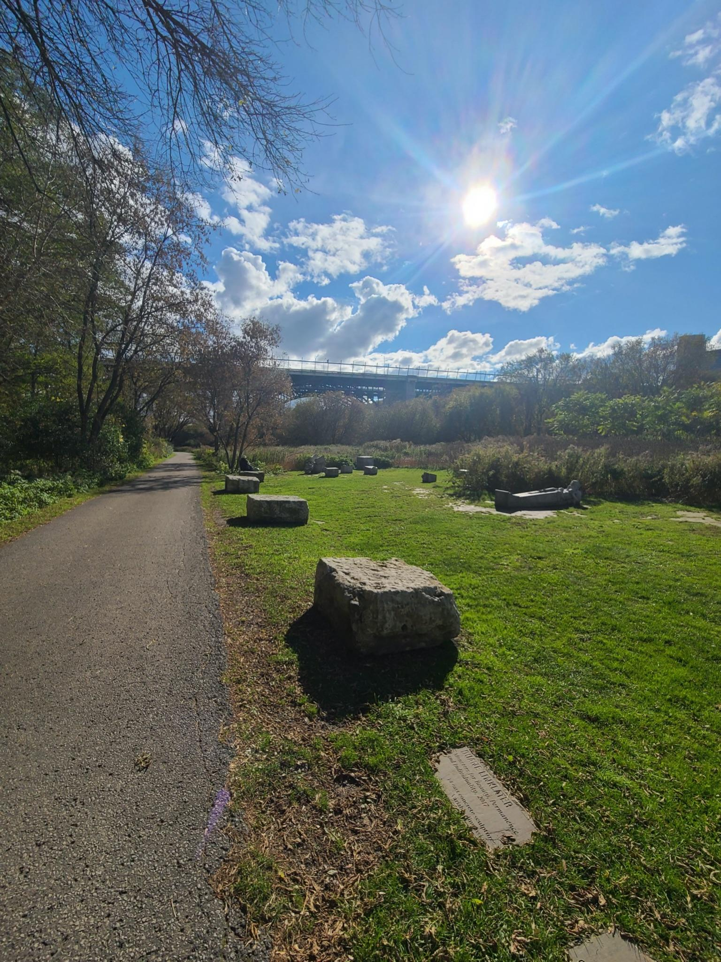
Figure 8: Surface of Lower Don Valley Trail

5.5.4 Signage and Wayfinding
Overall, there was good signage located at the lower Don Valley trailhead. A map and accessibility information is present at the Pottery Road trailhead regarding the width of the trail, the average and maximum slope, and the trail surface. The map and textual information was displayed in a high tonal contrast, providing an accessible format for persons who have partial vision impairment; however there is no braille for users who have complete vision loss. Additionally, no guide ropes were found on the trail to help users with vision impairments. Providing online information in an accessible format can improve the signage and wayfinding of this MUT.
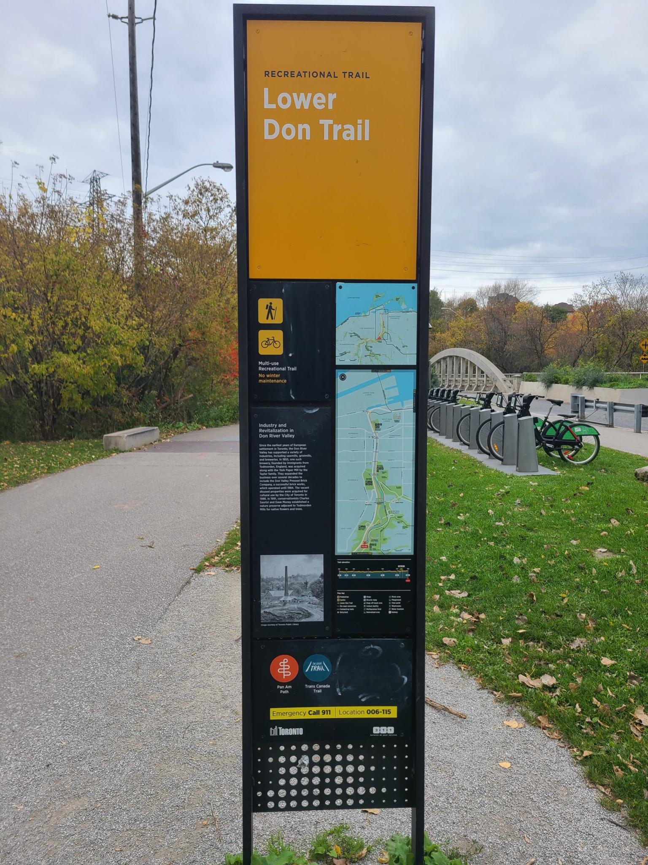
Figure 9: Map and Information at Lower Don Trailhead

5.6 Don Valley Trail Key Takeaways: Areas of Improvement

5.6.1 Amenities & Facilities
This section of the Don Valley Trail was missing many key components when assessing the Amenities and Features of the trail. Some of the critical components missing from the trail include restrooms, water facilities, and covered shelters, negatively impacting trail users. Additionally, the frequency of benches and rest areas throughout the trail is quite poor, which negatively impacts those with mobility impairments. The trail also lacks proper lighting making it difficult to use at night. There is also a lack of accessible pedestrian signals at trail crossings, leading to challenging and dangerous infrastructure for those with vision loss as they may rely on accessible pedestrian signals to cross trail intersections safely.

5.6.2 Location
While this section of the Don Valley trail is within 800m of public transit connections, that distance may still be a barrier to some individuals, especially those with mobility impairments or vision loss. Additionally, the lack of parking at the trailhead or near the trail entrance may also result in difficulties accessing the trail for some users.

5.6.3 Physical Characteristics
There are several key infrastructure features missing from this trail, such as proper edge protection. While there is a transition in surface types between the paved trail and grassy side areas along some trail sections, there is no clear edge protection, which can potentially lead to difficulties navigating sections of the trail for individuals with vision loss. There is also a lack of transitional elements on the trail such as tactile attention indicators at trail crossings, which is a critical piece of infrastructure for increasing the safety of those with vision loss. Additionally, there is also no physical separation between trail users such as cyclists and pedestrians, which can lead to safety issues for all trail users but especially for those with vision loss, hearing loss, and mobility impairments.

5.6.4 Signage and Wayfinding
Despite the Don Valley trail including most trail information outlined in the MUTAA, none of the physical signage on site was available in braille and thus is unreadable to those with vision loss. There is also a lack of digital wayfinding tools such as Blind Square or other audio guides, which can aid those with vision loss in navigating MUTs. Additionally, there were no guide ropes or sensory experiences present on the trail, both of which can help increase the safety and enjoyment of a trail for those with vision loss.

Recommendations & Lessons Learned

6.1 Recommendations

1. Prioritize increasing accessibility for attributes ranked with a high significance.
The MUTAA covers a wide range of attributes, some of which are more significant than others in creating accessible MUTs. It is recommended that stakeholders take a holistic approach when designing MUTs that improves attributes that will significantly create equitable access to various disability groups. The disability group impact table our team has created states which attributes are “significant” to each disability group. The attributes ranked as “significant” for multiple disability groups should be a priority when designing MUTs. For example; lighting, presence of restrooms, and overall trail condition are ranked as significant attributes across all five impairment types and therefore should be prioritised. Attributes that received a “significant” ranking across multiple disability groups (three or more groups) should also be a main consideration when designing MUTs. These attributes include; trail crossing quality and quantity, the separation of uses, the maintenance of trails, and accessible online trail information. Although the listed attributes are recommended as a priority, when designing MUTs, it is encouraged that stakeholders understand how each attribute impacts each disability group and meaningfully work towards creating equitable access.

2. Collaborate with persons within various disability groups to create quality MUTs.
Municipalities should take a targeted approach when improving the accessibility of MUTs by investing in quality instead of the number of trails. Using the MUTAA as a baseline, municipalities can identify which trails within their jurisdiction have the potential for being the most accessible for persons with varying disabilities. During the planning process for new trails or rehabilitation of existing ones, municipalities should consult with persons within various disability groups. In doing so, staff will better understand what attributes need prioritisation. The consultation will help develop a long-term strategy to improve equitable access for the targeted MUTs.

3. Canadian Trail Inventory
Our team recommends evaluating trails across Canada using the MUTAA to begin building an inventory of accessible MUTs. The evaluation should be publicly available to ensure that all persons can access the information required to evaluate if a MUT meets their needs. A list of trails across Canada (“Canadian trail inventory”) has been created and it is recommended that municipalities evaluate these trails. In doing so, the MUTAA will showcase what attributes of the MUTs are not accessible and highlight areas for improvement.
The Canadian trail inventory includes at least one MUT from every Province and one from the Territories. A set of criteria was developed in creating the Canadian trail inventory to ensure that it is feasible that the selected trails are accessible to various disability groups. Firstly, trails were selected if they were advertised in some regard as being accessible, for example on a City’s website or an online application. Next, only trails that fell within a Census Metropolitan Area were selected since this correlated to a larger user potential, as opposed to rural trails where transportation to the trail head is a large barrier. Thirdly, trails were selected if they had high potential usage, such as being a tourist attraction. In meeting the criteria, majority of the MUTs selected are located close to a downtown area or along a City’s waterfront.
Table 12: Canadian Trail Inventory
Name | City | Province
Confederation Trail (segment A) | Charlottetown | Prince Edward Island
Dartmouth waterfront trail (Trans Canada Trail) | Halifax | Nova Scotia
Harbour Passage Trail | St. John | New Brunswick
Quidi Vidi Lake Trail | St. Johns | Newfoundland
Mont Royal (Olmsted Path) | Montreal | Quebec
Parc Jean-Drapeau | Montreal | Quebec
Waterfront trail (Martin Goodman trail) | Toronto | Ontario
Rouge Beach Waterfront Trail | Pickering | Ontario
Lower Don Valley Trail | Toronto | Ontario
Ottawa River Pathway (Trans Canada Trail) | Ottawa | Ontario
Bishop Grandin Trail | Winnipeg | Manitoba
Wascana Lake Trail | Regina | Saskatchewan
Stream Changes Trail | Calgary | Alberta
Stanley Park Seawall | Vancouver | British Columbia
Arbutus Greenway | Vancouver | British Columbia
Millenium Trail | Whitehorse | Yukon

Our team recommends municipalities to facilitate the evaluation of the trails in the inventory to highlight what MUT trail attributes may or may not be accessible for each disability group and to make this information publicly available. If the MUTAA indicates the trail is not inclusive of all persons, we recommend that municipalities identify which attributes are the most significant barriers to achieving accessibility and plan for improvement.

4. Improve Signage and Wayfinding as a Short-Term Goal
Short-term and long-term strategies are encouraged to enhance the accessibility of MUTs. As a short-term solution with relatively low financial investment, stakeholders should include more inclusive signage and information both on the trail and online. A map and trail information should be present in accessible formats, such as a high contrast sign and braille, to communicate with users the trail’s condition. Information such as the service maintenance, the surface type, the slope, the overall difficulty of the trail, any potential hazards, accessible entrances/exits, the location of amenities, and the length of the trail is recommended. This information will allow persons with disabilities to assess what segments of the trail meet their needs. Additionally, making this information publicly available online in an AODA compliant document will allow potential users to assess if the trail is accessible to their needs before arrival.

5. Improve Physical Characteristics as a Long-Term Goal
A long-term strategy to create equitable access to MUTs is to improve the trails' physical characteristics, and amenities & features. After a MUT is evaluated, the low scoring attributes in the MUTAA should be the priority of improvement. Creating equitable access to MUTs is likely to involve construction to improve the physical state and the addition of amenities, which can be done using a phased approach.

6. Prioritize Data Acquisition
Our capacity to navigate the city and its public spaces is heavily reliant on wayfinding tools that are available to us. Innovative GPS applications, like Blindsquare, have been used to assist those who are visually impaired by providing audible information as they traverse the space. It can alert them to trail surface changes, proximity to facilities and trail features, and more. However, these navigational applications require site-specific information that we argue is still lacking. As a result, there is still limited information to assess the accessibility of MUTs across Canada for different impairments. Nationwide application of an audit, like MUTAA, can support data acquisition to develop a trail inventory that would act as a publicly available database from which these tools can draw. Also, making this data public could reduce the cost of providing these tools and for the end consumer.

7. Expand Wayfinding Tools and Strategies.
Digital wayfinding will require access to a device and the technical literacy to download and use it; therefore, it is equally important to invest in wayfinding situated outside the private digital realm. Regarding physical improvements, design standards should consider the inclusion of guide ropes and braille signage to improve the experience of those with visual impairments.

6.2 Lessons Learned
From the research conducted to create the MUTAA, it has become clear that there is a need for a more holistic approach to trail design and an evaluation that accounts for the needs of a range of disability groups. Design standards and audit instruments related to MUTs in Canada tend to focus on accessibility for people experiencing physical mobility impairments.
Standards for those who experience vision loss, hearing loss, sensory sensitivities, or cognitive disabilties are currently limited, and they do not discuss how these needs may overlap or compete with each other. Our proposed audit tool first integrates more inclusive and diverse accessibility considerations. Essential to this work will be community outreach and further research that seeks contributions from people within these communities themselves.

Research Limitations
This section outlines some of the key limitations of this research and the MUTAA. Our team created the MUTAA in accordance with CNIB guidelines on accessible trails, key research, and precedence from existing MUTs; however, due to time and resource constraints, our research methodology did not include interviewing people with disabilities to inform our research. For a more comprehensive study, our team recommends consultation with members of each disability group or researchers with first-hand experience with disabilities. Although it was beyond the scope of this report, MUTAA could benefit from including information from first-hand experiences of how people belonging to different disability groups experience and use MUTS, and what they feel is necessary to include to increase the accessibility of trails. The MUTAA’s scoring in our pilot run was limited by a lack of precise measurement tools, which if used would provide more accurate measurements of running slope, cross slope, and trail width. Within our audit criteria, there was also no weighting given to the different trail attributes based on importance or impact - and since some of the attributes had multiple parts (for instance signage), those will be weighted disproportionally in the final score.
In addition to time constraints, another resource limitation that hindered our ability to conduct interviews was ethics protocols. Ethics related to this project was particularly challenging since disability research is related to vulnerable groups. Ethics protocols related to informed consent, confidentiality, respect, and equity must be given the utmost importance, especially when dealing with vulnerable populations. This research was conducted over three months, and therefore we did not have sufficient time or resources to accurately and thoughtfully conduct interviews with people in different disability groups. As authors of this report, we recognize our positionality as able-bodied people creating a tool to assess the accessibility of spaces representing groups we do not belong to, which is a key limitation of this report.
Another limitation of this research is that the main disability groups identified in the MUTAA are not exhaustive and do not fully represent the wide spectrum of disability. Not only are there unique experiences among each disability group, but also within each group. For example, cognitive impairments cover a wide spectrum of disabilities such as dementia, autism, dyslexia, and more. Although these disabilities were grouped into one category, the way that those people with those disabilities experience space is unique to one another. This principle is the same for the four other disability groups identified in the MUTAA. In addition to this, there are other experiences of disability that may not be covered by our categories, for instance, the diverse impacts that chronic illness can have on people’s lives. While we believe the five disability groups are a sufficient starting point, we recognize that a more inclusive and exhaustive list of disability groups and experiences is needed for a more thorough and representative study.

Next Steps
The purpose of the MUTAA is to have a tool that can evaluate the accessibility of MUTs across Canada. The case studies serve as a starting point in testing the MUTAA and provide information on the accessibility status of MUTs. MUTAA can numerically evaluate the physical state of MUTs and highlight how it impacts each disability group. Having this information publicly available for multiple MUTs will allow persons with disabilities to plan their activities on MUTs adequately.

8.1 Further Research
One of the next steps is to refine the MUTAA in order to gain a greater understanding of the barriers each disability group faces. Due to limited time and resources, interviews were not conducted. To score the magnitude and impact of each attribute for each disability group, our team relied on existing literature and information. To enhance the MUTAA, it is recommended that interviews and focus groups are conducted with persons with varying disabilities to provide a first-hand perspective of barriers faced on MUTs. This information will help adjust the MUTAA by ensuring the magnitude and impact are allocated appropriately for each attribute and will allow the opportunity to add in attributes to the MUTAA that should be assessed if needed.

8.2 Tension Points
Depending on the impairment, different aspects of the trail can be considered more accessible to one group but a hindrance to another. Some of the tension points noted in this research include accessible pedestrian signals (sensory sensitivity), sound-reducing measures (vision loss), proximity to major destination (sensory sensitivity), transition elements/ tactile attention indicators (mobility impairments), and the use of sensory experiences for wayfinding (sensory sensitivity). Although a trail can be labelled as “accessible”, its accessibility may very well not support the inclusion of all disability groups. Knowing what these points of contention for different groups are can inform those with different abilities on which trails are appropriate for them. Understanding these points of contention and minimizing their impact is important for creating accessible MUTs for all. There is no specific MUT design that will be perfectly accessible for all people; however, conducting focus-groups with various disability groups can help in understanding what attributes are most important to serve their needs. Further research should be done to determine how to minimize the impacts of potential tension points between different disability groups.

Conclusions
Multi-Use Trails (MUTs) are a resource that provides many benefits to users; thus, they must be accessible for everyone. This report outlines the importance of continually evaluating MUTs, using tools like the Multi-Use Trails Accessibility Audit (MUTAA) to ensure that they are accessible to all types of users. Currently, trail accessibility initiatives focus on creating accessible trails for people with mobility impairments; however, to create MUTs that are truly accessible to all users, universal design principles should be applied to create MUTs that everyone can use and enjoy. The attributes within the four categories identified in the MUTAA are a starting point of features to be considered in the pursuit of making MUTs fully accessible.
The two case studies conducted in this report revealed two key patterns related to accessibility and MUTs. Although both had adequate physical characteristics, such as wide trail widths, smooth surface types, and high surface stability, both trails could improve their signage and wayfinding. Having information related to trail accessibility before arriving at the trail and while using the trail is of the utmost importance for users with disabilities. A lack of information could result in unsafe and undesirable situations for various disability groups. Some innovative tools that may help signage and wayfinding include digital apps, such as Blindsquare, which help people experiencing vision loss efficiently and safely navigate spaces. Other solutions include high-contrast and braille signage, as well as including guide ropes for certain trail sections. Information availability and wayfinding tools are key aspects of trail accessibility that must be improved for MUTs to be deemed accessible.
Results from the MUTAA can inform the decision-making processes and/or a case for allocating resources and capital funding towards improving trail systems. Furthermore, in conjunction with public consultation, it can aid in prioritizing which trails to focus on and identifying the attributes that play a significant role in making the trail accessible for different disability groups.
The MUTAA is a living tool, and this project has produced a prototype from which to build from. Refining this tool will require an iterative feedback loop with various stakeholder groups who can share first-hand experiences about the barriers they face when using MUTs and identify the essential attributes that would make MUTs accessible for them. This will allow the MUTAA to become more accurate and precise in determining the degree to which a trail can be deemed accessible, and for who.

References
Access Recreation. (2013). Guidelines for Providing Trail Information to People with Disabilities. https://www.accessrecreation.org/home/Access_Recreation_Home_files/Trail%20Guidelines%20in%20PDF%202020.pdf
ADA National Network. (n.d.a) What is the Americans with Disabilities Act (ADA)?. ADA National Network. https://adata.org/learn-about-ada
ADA National Network. (n.d.b) Guidelines for Writing About People With Disabilities. ADA National Network.https://adata.org/factsheet/ADANN-writing
ADA National Network. (n.d.c) ADA Standards for Accessible Design. ADA National Network. https://www.ada.gov/2010ADAstandards_index.htm
AllAccess. (2020). AllAccess Toolkit: A collection of resources to support the understanding and application of PoPS. Canadian Urban Institute & Human Space.
American Trails. (2009). Braille Trail Building and Renovating. https://www.americantrails.org/resources/faq-braille-trails#.YZxL6DapCg0.link
Anthun, K. S., Maass, R. E. K., Hope, S., Espnes, G. A., Bell, R., Khan, M., & Lillefjell, M. (2019). Addressing inequity: Evaluation of an intervention to improve accessibility and quality of a green space. International Journal of Environmental Research and Public Health, 16(24), 5015–. https://doi.org/10.3390/ijerph16245015
AODA. (2005). The Act (AODA). Accessibility for Ontarians with Disabilities Act. https://www.aoda.ca/the-act/
AODA. (2016). O. Reg. 191/11: INTEGRATED ACCESSIBILITY STANDARDS. https://www.ontario.ca/laws/regulation/110191
Beneficial Designs Inc. (2021). trail assessment tools: UTAP. Beneficial Designs Inc. https://www.beneficialdesigns.com/assessment/trails/tools/utap/
Burns, N., Paterson, K., & Watson, N. (2008). Exploring disabled people’s perceptions and use of forest recreation goods, facilities and services in Scotland, England and Wales. Glasgow: Strathclyde Centre for Disability Research, Department of Sociology, Anthropology and Applied Social Sciences, University of Glasgow.
Canadian National Institute for the Blind (CNIB). (2016, January 9). Design Needs. Clearing Our Path.https://www.clearingourpath.ca/8.0.0-design-needs_e.php
Carpenter, M. G., & Campos, J. L. (2020). The Effects of Hearing Loss on Balance: A Critical Review. Ear and Hearing, 41. https://journals.lww.com/ear-hearing/Fulltext/2020/11001/The_Effects_of_Hearing_Loss_on_Balance__A_Critical.12.aspx
Carruthers Den Hoed, D. & Parks Canada (2008). Planning with (not for) persons with disabilities: Insights and opportunities. In Paper presented at the Canada Parks for Tomorrow Conference.
City of Brampton (2015). City of Brampton Accessibility Technical Standards. https://www.brampton.ca/en/City-Hall/Accessibility/Documents/technical-standards.pdf
City of Kitchener. (2012). Multi-Use Pathways and Trails Master Plan. City of Kitchener. https://www.ontariotrails.on.ca/assets/files/pdf/Masterplans/Kitchener_MasterPlan_March282012_website.pdf
City of Markham. (2009). Pathway and Trail Design Guidelines. In Pathways and Trails Master Plan: Report and Design Guidelines. https://www.markham.ca/wps/wcm/connect/markham/240b88a2-44bc-47ce-931f-cf26d3afa5ad/5.0-pathways+design.pdf?MOD=AJPERES&CONVERT_TO=url&CACHEID=ROOTWORKSPACE.Z18_2QD4H901OGV160QC8BLCRJ1001-240b88a2-44bc-47ce-931f-cf26d3afa5ad-msjGm5n
City of Mississauga. (2015, December). City of Mississauga Facility Accessibility Design Standards. http://www7.mississauga.ca/Departments/Marketing/Websites/Accessibility/Mississauga_FADS.html
City of Toronto. (2021). Toronto Accessibility Design Guidelines. City of Toronto. https://www.toronto.ca/wp-content/uploads/2021/08/8ee5-Revised-TADG.pdf
City of Toronto. (2020). Bike Path - recreational pathway - multi-use trails - Martin Goodman Trail - Humber Bay Shore Trail - snow clearing. City of Toronto.
https://www.toronto.ca/311/knowledgebase/kb/docs/articles/transportation-services/district-transportation-services/road-operations/Bike-Path-recreational-pathway-multi-use-trails-Martin-Goodman-Trail-Humber-Bay-Shore-Trail-snow-clearing.html
City of Toronto. (2015). Toronto Multi-Use Trail Guidelines. Toronto: Transportation Services, Parks, Forestry & Recreation.
https://www.toronto.ca/wp-content/uploads/2017/11/96a5-TORONTO_TRAIL_DESIGN_GUIDELINES.pdf
City of Toronto (2017, August 25). Waterfront Toronto (Toronto, Ontario, Canada). City of Toronto. https://www.toronto.ca/city-government/accountability-operations-customer-service/city-administration/city-managers-office/agencies-corporations/corporations/waterfront-toronto/
Clark, C., & Uzzell, D. L. (2006). The socio-environmental affordances of adolescents’ environments. In C. Spencer & M. Blades (Eds.), Children and their Environments (pp. 176–196). Cambridge University Press. https://www.cambridge.org/core/product/identifier/CBO9780511521232A021/type/book_part
Connnell, B, Jones, M, Mace, R, Mueller, J, Mullick, A, Ostroff, E, Sanford, J, Steinfeld, E, Story, M, & Vanderheiden, G (1997). The principles of universal design: Version 2.0. Raleigh, NC: The Center for Universal Design.
Coulter, R. (2009). Understanding the Visual Symptoms of Individuals with Autism Spectrum Disorder (ASD). 40(3). https://cdn.ymaws.com/www.covd.org/resource/resmgr/certification_study_guide/understanding_visual_symptom.pdf
Disabled World. (2014, January 1). Cognitive Disability: Information on Intellectual Disabilities. Disabled World. https://www.disabled-world.com/disability/types/cognitive/
Gaines, K., Bourne, A., Pearson, M., & Kleibrink, M. (2016). Designing for Autism Spectrum Disorders. Routledge. https://www.routledge.com/rsc/downloads/9780415725279_chapter_1.pdf
Gilson, D., Lo, T. (2021). GPS app BlindSquare helps visually impaired navigate trails of Calgary's Fish Creek Park. CBC News. https://www.cbc.ca/news/canada/calgary/blindsquare-app-visually-impaired-fish-creek-park-1.6200757
Government of Canada. (2019). Accessible Canada Act. https://www.canada.ca/en/employment-social-development/programs/accessible-people-disabilities/act-summary.html#h2.01
Government of Manitoba. (2013). Accessibility Standards. The Accessibility for Manitobans Act. https://accessibilitymb.ca/index.html
Government of Ontario. (2016). O. Reg. 191/11: INTEGRATED ACCESSIBILITY STANDARDS. Accessibility for Ontarians with Disabilities Act, 2005. https://www.ontario.ca/laws/regulation/110191#BK99
Government of Ontario. (2019). 2019 Legislative Review of the Accessibility for Ontarians with Disabilities Act, 2005. https://www.ontario.ca/page/2019-legislative-review-accessibility-ontarians-disabilities-act-2005
Government of Nova Scotia. (n.d.a). Standards Development. Access by Design 2030: Achieving an Accessible Nova Scotia. https://novascotia.ca/accessibility/access-by-design/
Government of Nova Scotia. (n.d.b). Built Environment Standard Development Committee. Standard Development Committees.
https://novascotia.ca/accessibility/built-environment/
Gray, J. A., Zimmerman, J. L., & Rimmer, J. H. (2012). Built environment instruments for walkability, bikeability, and recreation: Disability and universal design relevant? Disability and Health Journal, 5(2), 87–101. https://doi.org/10.1016/j.dhjo.2011.12.002
Health Direct Australia. (2021, May 14). Cognitive impairment [Text/html]. Healthdirect Australia. https://www.healthdirect.gov.au/cognitive-impairment
Hunter, R. (2015). Healthy Aging Research Network Environmental Audit Tool. University of Washington Health Promotion Research Center. https://depts.washington.edu/hprc/programs-tools/tools-guides/environmental-audit-tools-protocols/
International Classification of Diseases. (2018). International Statistical Classification of Diseases and Related Health Problems 10th Revision. (ICD-10)-WHO. https://www.who.int/news-room/fact-sheets/detail/blindness-and-visual-impairment
Lid, I. M., & Solvang, P. K. (2016). (Dis)ability and the experience of accessibility in the urban environment. Interroger Les Sociétés Contemporaines à La Lumière Du Handicap. Quatrième Conférence d’Alter 2015 / Questioning Contemporary Societies through the Lens of Disability. Fourth Alter Conference 2015. Éditeurs / Guest Editors : Noémie Rapegno, Isabelle Ville., 10(2), 181–194. https://doi.org/10.1016/j.alter.2015.11.003
Low Vision Design Committee. (2015). Design Guidelines for the Visual Environment. National Institute of Building Sciences. https://www.nibs.org/files/pdfs/NIBS_LVDP_Guidelines_2015.pdf
Mackenstadt. (n.d.). Audible Street Signals are Barriers to the Blind. Retrieved November 1, 2021, from https://nfb.org//sites/default/files/images/nfb/publications/fr/fr02/issue3/f020305.html
McAdam, K. (2017). Dementia Friendly Design Features for Walking Paths—A Focused Practice Question. Region of Peel Public Health. https://www.peelregion.ca/health/library/pdf/dementia-friendly-design-walking-paths.pdf
McQuigge, M. (2019). Canada's First Accessibility Bill could become law next month: Minister. Canadian Architect. The Canadian Press. Retrieved November 2021, from https://www.canadianarchitect.com/canadas-first-accessibility-bill-could-become-law-next-month-minister/.
Metro Mobility. (2021, January 6). Are Mobility Scooters Waterproof? What Happens if It Gets Wet? Metro Mobility USA. https://metromobilityusa.com/are-mobility-scooters-waterproof-what-happens-if-it-gets-wet/
MIG Inc. (2006). Park and Trail Accessibility Design Guidelines. In Malibu Parks and Public Access Enhancement Plan. https://www.americantrails.org/resources/park-and-trail-accessibility-design-guidelines
National Association of the Deaf. (2021). Community and Culture—Frequently Asked Questions. National Association of the Deaf. https://www.nad.org/resources/american-sign-language/community-and-culture-frequently-asked-questions/
Nova Scotia Legislature. (2017). An Act Respecting Accessibility in Nova Scotia. Bill No. 59. https://nslegislature.ca/legc/bills/62nd_3rd/3rd_read/b059.htm
Parkin, J. (Director). (2020). Why we need walk bike separation, not sharing [Motion Picture].
Parks and Recreation Ontario. (2014). Pathways to Recreation: Learning about Ontario’s Accessibility Standard for the Design of Public Spaces. https://accessibilitycanada.ca/wp-content/uploads/2016/01/Pathways-to-Recreation.pdf
Parks Victoria. (2013). Park Accessibility Evaluation Manual. State Government of Victoria.
Province of Ontario. (2012, December 12). AODA. https://www.ontario.ca/laws/regulation/r12413
Rimmer, J., Eisenberg, Y., Graham, B., Lullo, C., & Madrigal, J. (2009). Q-PAT, The health empowerment zone environmental assessment tool. The Health Disparities and Social Jusitice Conference 2009: A Focus on Families, Depaul University, Chicago IL.
Rimmer, J. H. (2006). Building inclusive physical activity communities for people with vision loss. Journal of Visual Impairment & Blindness, 100(1_suppl), 863-865.
Saelens, Frank, Auffrey, Whitaker, & Burdette. (2006). Environmental Assessment of Public Recreation Spaces (EAPRS) Tool. Active Living Research Program of the Robert Wood Johnson Foundation. https://www.midss.org/content/environmental-assessment-public-recreation-spaces-eaprs-tool
Setola, N., Marzi, L., & Torricelli, M. C. (2018). Accessibility indicator for a trails network in a Nature Park as part of the environmental assessment framework. Environmental Impact Assessment Review, 69, 1–15. https://doi.org/10.1016/j.eiar.2017.11.003
Shevchuk, A., McIntosh, S., Henry, R., Strickland, W., Goodwin, H., Reinders, K., Palmer, P., & Taber, C. (n.d.). TECHNICAL ADVISORY COMMITTEE. 59.
Thomson, G. (2019). Accessible Parking in Ontario. Accessibility for Ontarians with Disabilities Act (AODA); AODA.ca. https://aoda.ca/accessible-parking-in-ontario/
Tola, G., Talu, V., Congiu, T., Bain, P., & Lindert, J. (2021). Built Environment Design and People with Autism Spectrum Disorder (ASD): A Scoping Review. International Journal of Environmental Research and Public Health, 18(6), 3203. PubMed. https://doi.org/10.3390/ijerph18063203
Toronto Cancer Prevention Coalition. (2010). Shade Guidelines. Toronto Public HEalth. www.toronto.ca/health/resources/tcpc/shade_guidelines.htm
Town of Oakville. (2019). Recreational Trail Accessibility Audit and Strategy. Town of Oakville Parks and Open Space Department, Paradigm Transportation Solutions Limited. https://www.oakville.ca/assets/general%20-%20residents/recreational-trail-accessibility-audit-april-2019.pdf
Troped, P. J., Cromley, E. K., & Fragala, M. S. (2006). Development and reliability and validity testing of an audit tool for trail/path characteristics: The Path Environmental Audit Tool (PEAT). J Phys Act Health, 3, S158–S175.
Tuckett, P., Marchant, R., Jones, M., & Adams, K. (2004). Close to the Wall: Cognitive Impairment, Access and the Built Environment. Arts Council England. https://projectartworks.org/wp-content/uploads/2015/08/close-to-the-wall.pdf
United States Access Board. (2014). Accessibility Standards for Federal Outdoor Developed Areas. United States Access Board. https://www.access-board.gov/files/aba/guides/outdoor-guide.pdf
University of Washington. (2012). Glossary of Disability-Related Terms. https://www.washington.edu/accesscomputing/what-mobility-impairment
Waterfront Toronto. (n.d. a). Martin goodman trail at ontario place. Retrieved November 23, 2021, from https://waterfrontoronto.ca/nbe/portal/waterfront/Home/waterfronthome/projects/martin+goodman+trail+at+ontario+place

Waterfront Toronto. (n.d. b ). Queens quay (west). Waterfront Toronto. Retrieved November 23, 2021, from https://waterfrontoronto.ca/nbe/portal/waterfront/Home/waterfronthome/projects/queens+quay+west/queens+quay+west

Appendix A: Audit Criteria Justification

Amenities

Benches/Resting Areas/Picnic Areas:
Based on existing precedence/audit tools these areas can be a spot for resting for those who have mobility impairments and limited physical stamina. (Recreational Trail Accessibility Audit and Strategy, 2018; How to Make Public Places Accessible, 2021). Benches attract users of different capabilities with different purposes. As one woman, aged 68 states, ‘I like the benches. I can rest there and, therefore, I can walk the whole path’ (Anthun et al., 2019).

Restrooms:
Are restrooms easy to access and accessible to go inside? Are toilet stalls large enough to allow for wheelchairs/other mobility aids to enter? MUTs with only porta-potties could deter certain groups of people from going to the trail. An accessible restroom can be a necessity for some users who may spend an extended period of time on the trail depending on their ability. (Guidelines for Providing Trail Information to People with Disabilities, 2020; Penny, 2018).

Access to Water:
Are water drinking sources reliable, frequent, and in an easily accessible location? Dehydration can be a constant danger for some people depending on ability (Guidelines for Providing Trail Information to People with Disabilities). Water stations should:
1) Be located on an accessible route for mobility devices;
2) Have an appropriate angle for the water spout and water stream;
3) Have an appropriate height of water flow to drink from; and
4) Have controls that can be easily operated using one hand with minimal force (City of Brampton Accessibility Technical Standards, 2015).

Parking Facility:
Parking spaces should be van accessible (with signage to indicate as much) and should have space for people using larger mobility devices like wheelchairs and scooters who require more space to enter and exit vehicles, as well as walk to and from the trail. This extra space is more important for those with mobility impairments. Parking spaces should also contain signage for its accessible spaces. The signage should extend to the paved surface of the parking lot for both cars and people walking in the space (Thomson, 2019). Off-street spaces must include access aisles, or space between parking spaces, so that people have enough room to enter and exit their vehicles. Access aisles on paved surfaces should have high-contrast diagonal lines painted on them to show visitors that they should not use the aisles as extra parking spaces.

Visitor Centre:
Is the building designed with accessibility measures that make it easy to enter and navigate for people with different disabilities? Are there features and resources inside that can help the person navigate the trail itself? A well designed Visitor centre would have significant accessibility measures including most or all of the following:
- The entrance and indoor space is accessible to people using mobility devices
  - There is a ramp with a 1:12 slope gradient, with a level landing area at the top and bottom, or the front entrance is flush with the sidewalk and has no need for one. (Welage et al, 2011)
  - The entrance should be at least 32 inches wide. (Welage et al, 2011)
  - There are designated accessible restrooms. (Welage et al, 2011)
- The space is navigable to people with vision loss
  - Tactile and visual signals around stairways and tripping hazards (Low Vision Design Committee, 2015)
  - Colour contrast to help distinguish between features, levels, etc (Low Vision Design Committee, 2015)
  - All staircases have railings (Low Vision Design Committee, 2015)
  - Tactile signage (Low Vision Design Committee, 2015)
  - Well-lit space without glare (Low Vision Design Committee, 2015)
  - Any glass barriers include visual indicators such as stickers, glazing, or etching (Low Vision Design Committee, 2015)
- The space is navigable to people with hearing loss
- The space is sensory friendly (e.g. no loud noises or bright lights). (Tola et al, 2021)
- There are accessible wayfinding resources available (see wayfinding and signage section)

Covered Shelters/ Protection from the elements:
Are there areas to take shelter from the sun, rain, or snow while on the trail? This may include natural sources of shade or protection from the elements, such as tree canopies, or constructed shade structures. Shade provides benefits to protect trail all users from UV radiation and glare (Toronto Cancer Prevention Coalition, 2010; Parks and Recreation Ontario, 2014). Opportunities for protection from rain or snow is also important for users of electric mobility devices as getting caught in an unexpected downpour can damage their devices (Metro Mobility, 2021; United States Access Board, 2014). People experiencing vision loss and limited mobility also benefit from protective structures, as being caught in the rain or snow without a place to take shelter and wait out the worst of the storm can make it much harder to navigate a trail safely due to loss of visibility. Shelters should contain accessibility measures including:
- Roll-in access, with a clear ground space of at least 36 by 48 inches on firm and stable ground alongside the open side of the shelter, and directly adjacent to the trail (United States Access Board, 2014).
  - Shelter floor at entrance no higher than 19 inches and floor inside shelter is firm and stable with a slope no greater than 1:48 if asphalt, concrete, or board, or 1:20 if made of other material (United States Access Board, 2014).
  - Width of sheltered area: can it fit a person using a mobility device
  - Presence of seating
  - Protection from elements including sun, rain, wind, and snow

Artificial Light Presence:
Is there sufficient lighting to illuminate a trail after sundown is important for people experiencing partial vision loss, people with cognitive challenges, people with mobility challenges, and people with hearing loss, because it allows the trail to remain legible and assists in people’s ability to orient themselves and navigate safely (Carpenter et al, 2020; Tuckett 2004; Lid et al, 2016). However, if the lighting is too bright, it could present challenges for people with sensory sensitivities (Tola et al, 2021). Bright lighting may also impact wildlife activities and cause light pollution (City of Toronto, 2015).

Accessible Pedestrian Signals:
This will only be applicable where a trail intersects a road - If a trail intersects a road used by motor vehicles, are there accessible pedestrian signals or vibro-tactile signals? These are useful to provide cues to help people with low to no vision know when they are able to cross (City of Toronto, 2021). Note that there has been some disagreement that such measures are helpful, and some say that accessible pedestrian signals are harmful because people who are blind contribute to false societal attitudes that people who are blind can’t cross the street without these signals, when listening to the flow of traffic can also be a safe way to cross (Mackenstadt, 1983).

Sound Reducing Measures:
This will only be applicable if the trail is close to a high-noise area: If the trail is close to a high-noise area such as a major destination or road, are there measures to reduce this sound? This is of particular benefit for people who experience sensory sensitivities (Tola et al., 2021).

Transition Elements/ Tactile Attention Indicators:
Are there tactile attention indicators on the ground to signal transition between functions? This can be important for people with vision loss, especially when there is a potential hazard present (City of Toronto, 2021).

Other: (ex. Special services)
Are there other services or resources that are available when using a trail system? For instance a shuttle service or specific types of assistive technology not mentioned here. Make note of any other factors observed that may impact accessibility.

Location

Proximity to Transit:
This can make it easy for anyone to access the trail without a vehicle. The closer to the transit station the better (Recreational Trail Accessibility Audit and Strategy, 2018). The distances used mirrored the distances provided by the Oakville Recreational Trail Accessibility Audit (2018). The distance to the trail is important for those with mobility impairments who may have limited physical stamina - having the distance to the trail be longer than they can travel makes the trail inaccessible.
Proximity to Major Destination: The closer to a major destination like Downtown Centre, Major Employer, Mixed-Use Corridor can make it more accessible to other services and activities around the MUT (Recreational Trail Accessibility Audit and Strategy, 2018).

Physical Characteristics Justification

Surface Type:
The surface type can either improve mobility or can prohibit mobility for all persons. Asphalt and concrete surfaces create a smooth surface that allow persons to travel with limited barriers (Oakville, 2019). The scoring follows the Oakville Recreational Trail Accessibility Audit (2018) where the surface types with the highest ratings have the smoothest surface and the lowest rating is designated to surface types with non-consistent textures.

Surface Stability:
The surface stability variable reflects the firmness of a path which allows or prohibits travel along a path. Technical requirements are set out by the Accessibility for Ontarians with Disabilities Act (AODA), Ontario Regulation 191/11 Integrated Accessibility Standards. To be AODA compliant, the recreational trail must be firm and stable (O.Reg. 191/11, 2016).

Trail Width:
The minimum width of a trail has been regulated by Ontario Regulation 191/11 to ensure all persons can travel on a recreational trail, including persons with mobility aids. The minimum trail width is 1m (O.Reg. 191/11, 2016). According to the North Oakville Trails Plan (2013) the ideal width of a trail is 2.1m since it allows for maintenance vehicles, this is therefore used as the ideal trail width given a scoring of 3.

Running Slope:
A continuous flat trail allows trail users to travel easily, resulting in multiple municipalities specifying an accepted standard for recreational trails. The Town of Oakville has identified a 5% maximum running slope design standard for new trail developments (Oakville, 2019). Trails greater than 8% average in slope are not appropriate for new trail developments (Oakville, 2019).

Cross Slope:
The slope across the trail should be minimal to allow for ease of movement for all persons. Multiple municipalities have provided guidelines for cross slope to be under 2%, including the Town of Oakville (Oakville, 2019). For new trail developments guidelines indicate trails should be under 5% and ideally, less than 2% (Oakville, 2019).

Trail Crossing:
Where trails cross roads, they should be directed to existing intersections that provide a right-of-way for pedestrians and cyclists (Toronto, 2015). To ensure safety of trail users, visible signage should be present to mark the trail crossing.

Overhead Height Clearance:
To mitigate barriers that may not be anticipated, the trail must meet the minimum AODA overhead height clearance requirement. Under Ontario Regulation 191/11 the minimum overhead height clearance requirement is 2.1m (O.Reg. 191/11, 2016). Maintenance that ensures an overhead height clearance of more than 2.1m is ideal since it reduces the likelihood of persons running into physical barriers.

Separation of Uses:
The separation of pedestrians and cyclists is important to reduce the likelihood of collisions. On average, pedestrians travel at an average of 4km/hr and cyclists travel at an average of 20km/hr (Parkin, 2020). Due to this difference in speed it is important to separate uses on MUTs to avoid collision whenever possible. This is especially important for people with vision loss and hearing loss, because they may not have as much visual or audible signals when a different type of trail user is approaching. It is also important for people with mobility impairment and some types of cognitive disability, as they may not be able to react as quickly to avoid close calls.

Edge Protection / Guide Rope / Railing:
Edge protections are required for any trail that is situated next to water and/or a slope for safety reasons (Province of Ontario, 2012). They can take the form of curbs, ropes, railing, and walls located immediately adjacent to paved surfaces. However, some types of edge protection can be hazardous for cyclists, particularly raised surface elements located next to paved surfaces (MIG, 2006). For those who are visually impaired, the incorporation of contrasting colours or materials can be used at edges to clearly delineate the pathway edge (City of Markham, 2009)

Trail Condition:
The overall condition of the trail is important to get a general sense of which trails and/or sections of trails will require capital improvements and rehabilitation. The physical trail condition is determined through visual inspection based on the precedence of the 2019 Oakville Recreational Trail Accessibility Audit and Strategy.

Trail Continuity:
An accessible route is defined as a continuous, unobstructed path connecting all accessible elements and spaces of a building or facility that meets the requirements of ADA Accessibility Guidelines (Access Recreation, 2013). “Barriers to multi-use pathway and trail continuity result from natural and constructed features that create a physical impediment to the development of an interconnected trail system” (City of Kitchener, 2012). Physical barriers could include roadways, railway lines, natural land and waterscapes, and land parcels (City of Kitchener, 2012).

Access Points (AODA Compliant):
The entrance to a recreational trail must provide a clear opening of between 850 mm and 1,000 mm, whether the entrance includes a gate, bollard or other entrance design (Province of Ontario, 2005). The scoring is differentiated on the acceptable range outlined in the AODA standards.

Paved Path to Entrance/Trailhead:
As a key access point to the trail, the state of the trailhead should also be evaluated to assess the accessibility to the trail. Paved surfaces like asphalt or concrete can allow people to access the trail with limited barriers (Oakville, 2019). The scoring range is therefore based on the presence of paved surfaces at the trailhead.

Provision/Absence of Dead Ends:
Across guidelines and academic literature, dead ends are avoided if possible, however if they are unavoidable markers, decorative features to provide visual cues and a sufficient turning radius should be considered (Tuckett et al, 2004; City of Mississauga, 2015; Access Recreation, 2013). The City of Mississauga 2015 Facility Accessibility Design Standards indicate a minimum 96 inch turn radius for mobility aids which informs the state of the dead end if present.

Maintenance:
Maintenance is critical to year-round accessibility of public spaces. Proper maintenance can ensure the quality and condition of the trails is kept to a standard that allows all user groups to enjoy the trail. Greater investment in maintenance relies on how municipalities allocate resources to their operational budget.

Signage & Wayfinding

Shapes and Colour Coded Signage on Trail (Trail Markers):
The inclusion of trail markers aides with navigation for all groups as it helps in verifying if an individual is navigating along the correct section of trail (City of Toronto, 2015)

Sensory Experience (Tactile Map) & Sensory Experience (Scented Plants):
Both of these trail features can act as aided ways for individuals to gain information about a trail as well as enhance the overall experience. These are especially important for those with vision loss as they may rely on other senses such as touch and smell to experience the trail. (American Trails, 2019)

Trail Information Available Online in an Accessible Format:
It is important to have trail information available online in an accessible format so that individuals of all abilities can access this information and make a judgement on if they would feel comfortable going and using certain recreational trails prior to arriving at the trail itself. (Government of Ontario, 2016)

Digital Tools (Wayfinding apps, QR Codes, Audio Guide):
There is a variety of new wayfinding technology that can help individuals more easily navigate spaces. These technologies are especially helpful for those with vision loss and they can make it much easier for individuals to know where there are in relation to certain physical elements and thus make it easier to navigate areas independently (Gilson & Lo, 2021)

Guide Ropes:
Guide ropes can be a critical navigation tool for those with vision loss as it makes it much safer and easier to navigate trail when guide ropes are present, especially when there is uneven terrain or steeper sections. (American Trails, 2009)

Signage has High Tonal Contrast with Background:
In order to increase the readability of information and trail signage, it is important to ensure that the text and background color have a high tonal contrast such as white text on a black sign (Government of Ontario, 2016).

Warning of Hazards at Trail Head (low branches, rocks, uneven terrain):
Having information and signage outlining any potentials hazards that may be on the trail is important to ensure that individuals can properly assess a trail prior to entering it (City of Toronto, 2015)

Average and Maximum Running and Cross Slope Information at Trail Head:
Including information on the running and cross slope of a trail is important for someone's ability to assess the safety of a trail, especially for those with mobility impairments (Government of Ontario, 2016).

Length of Trail Information at Trail Head || Average and Minimum Trail Width Information at Trail Head ||Locations of Amenities Marked at Trail Head:
All of this information is important to include at trail entrances as it provides critical information outlining the difficulty, potential accessibility, as well as what amenities are included on the trail. (Government of Ontario, 2016)

Accessibility Information Marked at Trail Head (Is this trail accessible):
Including basic information on a trail’s accessibility at trail entrances can make it easier for certain individuals to quickly gauge if they are comfortable navigating a certain path. While the definition of what constitutes accessible can be varied between different disability groups, it can still be helpful to some individuals (City of Toronto, 2015).

Seasonal Closures/Maintenance Information at Trail Head (Is there snow clearance, is there trail maintenance):
Understanding what kind of maintenance is performed on a trail is important for all trails users as the maintenance level of a trail can act as a proxy for what potential hazards may be present on the trail, such as fallen branches or snow. This information is especially important for those with mobility impairments or vision loss (City of Toronto, 2015)

Accessibility of Trail Exits & Entrances Marked at Trail Head (Distance to next fully accessible trail exit marked):
Information on what trail entrances and exits are accessible is critical information, especially for those with mobility impairments as having an understanding of the distance until the next exit can determine if an individual feels comfortable entering a trail (City of Toronto, 2015)

Trail Rating Information at Trail Head (Easy, moderate, difficult):
While a general trail rating can be quite broad and non-specific, it can still act as a good indicator for individuals to assess whether or not they feel comfortable navigating a trail prior to entering it (Access Recreation, 2013)

Trail Surface Type Mentioned at Trailhead:
Inclusion of information on a trails surface type is very important information as it can greatly impact the difficulty of a trail for some individuals, especially for those with mobility impairments. (Access Recreation, 2013)

Height of signage (descriptive signs at trail heads, 1m to 1.7m || user signs for when moving on trail 1.7m to 2.4m):
Guidelines for the placement of signage is important for ensuring the accessibility and readability of information, especially for those with vision loss as they may need to physically touch signage to see if there is braille. It is also important for those with mobility impairments as they may be in a mobility device and thus be lower to the ground (City of Toronto, 2015)

Frequency of trail signage (every 4Km or at intersections):
Ensuring that trail information is present at each intersection as well as along a trail with some frequency is important for ensuring that anyone entering the trail has access to the trail information. (City of Toronto, 2015)

Warning signs on trail (25m from a hazard if grade is 2% or less 40m from a hazard if grade >2%):
Including signage about potential upcoming hazards is helpful to ensure the safety of trail users as they can prepare for potential hazards or turn around if needed. (City of Toronto, 2015)

Appendix B: Justification of Disability Categories

Amenities

Vision Loss:
Certain amenities can be especially important for people experiencing vision loss, especially those which impact their ability to orient themselves. For those with partial vision loss, good lighting may be important to ensure proper legibility of the path. In cases where a trail intersects with an automotive road, accessible pedestrian signals can also be a useful tool to warn of the approaching intersection and aid in crossing safely. If significant sound reducing measures are taken on the trail, it is possible that this could have a negative impact on some people experiencing vision loss as it may contribute to disorientation.

Hearing Loss:
Members of the deaf and hard of hearing community can also particularly benefit from trail features that aid in orientation. With a limited or absent sense of hearing, lighting and visibility becomes particularly important, so that trail users can get visual warning of any hazards on or near the trail, especially if they are walking at night. Full visibility is also important in allowing people to communicate with each other in sign language. Hearing loss has also been associated with difficulties in balance (Carpenter et al, 2020), so a well-lit trail to provide full visibility of the path and its boundaries can also be important to prevent falls. For those who are hard of hearing, measures to reduce sound from adjacent roadways or sources of ambient noise may also be beneficial in allowing them to communicate with others on the trail verbally or hear what is going on around them better.

Mobility Impairment:
The presence of amenities on trails for people with mobility impairments can be the difference between it being an accessible trail versus an inaccessible trail. Based on existing precedence/audit tools, certain amenities can be a place for resting for those who have mobility impairments and limited physical stamina. If someone with a mobility impairment uses a mobility device, it is important that the trail contains amenities that can be easily accessible via their device. The presence of accessible restrooms, water fountains, a visitor centre, and tactile attention indicators can improve the overall accessibility of the trail for this group. Covered shelters that protect trail users from the rain and snow are also particularly important for people using electric mobility devices, as some of these devices can be seriously damaged if they get wet.

Sensory Sensitivity:
Sound reducing measures to minimize the noise coming from roads, construction, or other loud activities adjacent to trails are of particular importance to people who have sensory sensitivities (Tola et al, 2021; Tuckett et al, 2004). If a trail has accessible pedestrian signals, however, this might be a source of discomfort for people with such sensitivities. Lighting on the trail, while it is still important for visibility at night, may also have a negative impact if it is too bright or if fluorescent lighting is used (Coulter, 2009).

Cognitive Disability:
People experiencing cognitive disabilities may particularly benefit from benches and resting areas to provide refuge from crowds or overwhelming conditions, and proper lighting of the trail during dark hours to provide a safe pathway and aid in orientation (McAdam, 2017).

Location

Vision Loss:
The closer to the trail, the fewer obstacles that may be encountered by someone with vision loss on the way to the trail that may hinder their ability to reach the trail. The closer the trail is to a major destination the more likely the path to the trail is accessible; however, there could also be more barriers due to the major destination like cars and people.

Hearing Loss:
The closer to the trail, the fewer obstacles that may be encountered by someone with hearing loss on the way to the trail that may hinder their ability to reach the trail. The closer the trail is to a major destination the more likely the path to the trail is accessible.

Mobility Impairment:
The distance to the trail is important for those with mobility impairments who have limited physical stamina - having the distance to the trail be longer than they can travel makes the trail inaccessible.

Sensory Sensitivity:
The closer to the trail, the fewer obstacles that may be encountered by someone with sensory sensitivities on the way to the trail that may hinder their ability to reach the trail. The proximity to a major destination could be a hindrance however as there may be more stimuli within the area.

Cognitive Disability:
The closer to the trail, less potential obstacles may be encountered by someone with a cognitive disability on route to the trail that may hinder their ability to reach the trail.

Physical Characteristics

Vision Loss:
For persons with vision loss, creating an accessible MUT requires certain physical characteristics. The following elements have been highlighted in previous studies and therefore are scored with significant magnitude for persons who are visually impaired. According to Rimmer (2006) walking paths should include warning textures (such as truncated domes) to alert the user that they are approaching an intersection. Additionally, trails should have year-round maintenance to avoid temporary obstructions such as snow and natural debris (Rimmer, 2006). Multiple design guidelines highlight the importance that trails are firm and stable (for example, made of asphalt or concrete) and they should be continuous with edge protection (Oakville, 2019; Parks Victoria, 2013; AllAccess, 2020). Ensuring these physical characteristics are included in the development of new MUTs will create a more inclusive environment for persons with vision loss.

Hearing Loss:
Planning an accessible MUT for persons with hearing loss should include the separation of pedestrians and cyclists and well-marked trail crossings. Emphasis on the separation of uses is displayed in the first-hand experiences documented by Burns et al., (2008). Persons with hearing impairments indicated that cyclists coming up from behind can be disorienting, with little or no understanding of deaf people’s needs (Burns et al., 2008). Additionally, when crossing an intersection, well-marked signage with pedestrian right-of-way is encouraged to ensure user safety. The physical separation of uses as well as well-marked trail crossings is most significant for persons with hearing loss.

Mobility Impairment:
Persons with mobility impairments can face major barriers when physical elements on a MUT are not inclusive to their needs. Under Ontario Regulation 191/11 enacted under the AODA, the technical requirements of a minimum clear width, a firm and stable surface, maximum surface openings, and edge protection are outlined to promote an inclusive environment. In a study by Burns et al., (2008) it was found that persons who require mobility aids (for example, a wheelchair or cane) faced difficulties on trails with a steep slope and trails with no maintenance. The stated physical characteristics are therefore deemed significant for persons with mobility impairments.

Sensory Sensitivity:
Designing for people with sensory sensitivities typically consider strategies within four sensory categories: sight, auditory, touch/tactile and proprioceptive and vestibular senses (Gaines, et al., 2016). Given this spectrum, designers of MUTs should consider how to design with these categories in mind. For example, this could inform what materials would be suitable for the trail to aid in navigating the space for those with tactile sensitivities. Physical attributes form the basic functional affordances in which an individual will interact with such as surfaces, greenery, and terrain (Clark, et al., 2006). The designed elements of our built environment play a significant role in providing conditions that will produce positive responses and experiences, and limit the chance of producing potentially harmful environments that negatively impact user groups.

Cognitive Disability:
Creating a space for people with cognitive disabilities should prioritize how the environment can promote that person’s autonomy while ensuring it is safe (Tuckett, et al., 2004); the physical components and nature of a space are integral to ensuring these priorities are met. Tuckett, et al. (2004) note that dead ends should be avoided at all times, therefore trail continuity is important for people with cognitive disabilities to safely traverse the trail (McAdam, 2017). However, if they are unavoidable, decorative features can be employed to act as unobtrusive cues for the user to better navigate the space.

Signage and Wayfinding

Vision Loss:
The most important aspects of signage and wayfinding are in regard to having information in accessible formats. Having information available in braille or in accessible formats online is critical for ensuring that those with vision loss are able to understand the features of a trail prior to navigating it. Other trail wayfinding features that are especially important for those with vision loss are the inclusion of guide ropes on the trail as well as the availability of digital wayfinding tools such as Blindsquare (Gilson & Lo, 2021). Both of these features make it much easier and less stressful for those with vision loss to navigate trails by themselves (American Trails, 2009)

Hearing Loss:
For those with hearing loss, trail signage and wayfinding needs are similar to that to that of able bodied people. This is primarily due to most signage and wayfinding materials being visual rather than audible and thus both groups may experience these trail features similarly.

Mobility Impairment:
Having trail information available online is extremely important for all trail users, however it is of particular importance to those with mobility impairments as it allows individuals to assess the accessibility and features of a trail prior to navigating it (Government of Ontario, 2016). In addition to having trail information available online, having specific information about the design and potential hazards on a trail is important for individuals with mobility impairments. Information about trail features such as the cross slope and running slope, surface type, minimum trail width, and potential hazards are critical information for someone to assess the safety and usability of a trail.

Sensory Sensitivity:
In regards to wayfinding and signage, some critical components for trail navigation that those with sensory sensitivities may need are in regard to knowing the amenities present throughout the trail as well as knowing the locations and distances to trail crossings and exits.

Cognitive Disabilities:
Some ways in which signage can affect those with cognitive disability is in regard to the positioning, colour, and symbology of signage as it can have therapeutic effects for some individuals (McAdam 2017). Having clear trail markings and other navigation tools can also make wayfinding easier for individuals.

Appendix C: Multi-Use Trail Accessibility Audit
Table 13: Multi-Use Trail Accessibility Audit (MUTAA) - Amenities and Features
Attribute | State | Sub-category | Scoring |  |  |  | Comments
Amenities & Features |  |  | 0 | 1 | 2 | 3
Benches/Resting Areas/Picnic Areas |  | Frequency | No resting areas present. | Resting area present every 1km. | Resting area present every 500m. | Resting area present every 250m or less.
Benches/Resting Areas/Picnic Areas |  | Quality | No resting areas present. | Small inaccessible benches like chairs /  not much space to sit / one bench. | Benches with enough space / 2-3 benches / resting areas with room | Benches with tables / multiple benches / resting areas with room
Benches/Resting Areas/Picnic Areas |  | Accessibility | No resting areas present. | Small inaccessible benches like chairs /  not much space to sit / one bench. | Benches with enough space / 2-3 benches / resting areas with room | Benches with tables / multiple benches / resting areas with room
Restrooms |  | Frequency | No restrooms present. | Restroom facility present every 1km or more. | One restroom facility present every 1km. | Two of more restroom facility present every 1km.
Restrooms |  | Quality | No restrooms present. | Only porta-potties present | Restroom facility present | Restroom facility with accessibility measures
Restrooms |  | Accessibility | No restrooms present. | Only porta-potties present | Restroom facility present | Restroom facility with accessibility measures
Water |  | Frequency | No water facility present | Water facility present every 1km or more. | One water facility present every 1km. | Two or more water facilties present every 1km.
Water |  | Quality | No water facility present | Unreliable water fountain present | Water fountain present within a facility like a restroom | Water fountain present with accessibility measures
Water |  | Accessibility | No water facility present | Unreliable water fountain present | Water fountain present within a facility like a restroom | Water fountain present with accessibility measures
Parking Availability/Accessibility |  |  | No parking facility | No wider parking space and has signage that identifies  the space as “van accessible”. | Wider parking space and has signage that identifies the space as  “van accessible”. | Wider parking space and has signage that identifies the space as  “van accessible”. In addition, off-street spaces must include access aisles,  or space between parking spaces, so that people have enough room to  enter and exit their vehicles. Access aisles on paved surfaces should  have high-contrast diagonal lines painted on them to show visitors  that they should not use the aisles as extra parking spaces.
Visitor Centre |  |  | No visitor centre | No wayfinding resources, not accessible | accessible to some, limited wayfinding resources | Significant accessibility measures and wayfinding resources
Covered Shelter/ Other shade measures (tree canopy) |  | Frequency | No covered shelter and minimal natural shade | limited number of covered shelter, minimal natural shade | some covered shelters, some shade | frequent covered shelters, high levels of shade
Covered Shelter/ Other shade measures (tree canopy) |  | Quality | No covered shelter and minimal natural shade | shelters generally poor condition and/or not effective | shelters/shade structures generally moderate quality and/or somewhat effective | shelters/shade structures are generally well-maintained and highly effective
Covered Shelter/ Other shade measures (tree canopy) |  | Accessibility | No covered shelter and minimal natural shade | shelters generally not accessible | shelters generally accessible to some | shelters are generally highly accessible
Lighting |  | Frequency | No lighting | lighting present but sparse | lighting present sometimes | lighting present consistently throughout trail
Lighting |  | Quality | No lighting | lighting doesn't offer adequate visibility | lighting provides some visibility | lighting provides full visibility of trail consistently throughout path
Accessible Pedestrian Signals (where trails cross roads) |  |  | No accessible pedestrian signals | Accessible pedestrian signals not consistently present and/or functional | Accessible pedestrian signals present and functional at some intersections | Accessible pedestrian signals present and functional at all intersections
Sound Reducing Measures (to limit loud noises, if quiet then "-") |  |  | No sound reducing measures | ineffective sound reducing measures | somewhat effective sound reducing measures | effective sound reducing measures
Other Features/Services (note in comments)
Section Score (Maximum:54)

Table 14: MUTAA - Location & Physical Characteristics
Attribute | State | Sub-category | Scoring |  |  |  | Comments
Location |  |  | 0 | 1 | 2 | 3
Proximity to Transit |  |  | 1km and above | 500m – 1km | 250m –500m | Under 250m
Proximity to Major Destination |  |  | 1km and above | 500m – 1km | 250m-500m | Under 250m
Section Score (Maximum:6)
Physical Characteristics
Surface Type |  |  | n/a | Informal footpath, stairs, woodchip | Crushed limestone, interlock, flagstone, bridge, tar and chip, boardwalk | Asphalt, concrete
Tactile Attention Indicators |  |  | n/a | Not present. | Occasionally present where applicable. | Present at all locations where they are applicable.
Surface Stability |  |  | n/a | Not firm | Firm in some sections | Firm throughout entire trail
Trail Width |  |  | n/a | Less than 1m | 1m - 2.1m | More than 2.1m
Running Slope |  |  | n/a | More than 8% | 5% - 8% | 5% or less
Cross Slope |  |  | n/a | More than 5% | 2% - 5% | 2% or less
Trail Crossing |  | Frequency | 3 trail crossing per kilometer | 2 trail crossings per kilometer | 1 trail crossing per kilometer | 0 trail crossings per kilometer
Trail Crossing |  | Quality | n/a | Non-marked trail crossing | Marked trail crossing | Well marked trail crossing with pedestrian right-of-way
Overhead Height Clearance |  |  | n/a | Less than 2.1m | 2.1 - 2.5m | More than 2.5m
Separation of Uses |  |  | n/a | Walking/cycling not separated | Walking/cycling separated | Walk path at least 1.8m wide and cycle path at least 3m wide
Edge Protection |  | Frequency | No edge protection | Edge protection partially provided | Edge protection along most of trail | Edge protection along entire length
Edge Protection |  | Quality | No edge protection | Edge protection partially provided, + contrasting colours or materials | Edge protection along most of trail + contrasting colours or materials | Edge protection along entire length + contrasting colours or materials
Trail Condition |  |  | Informal path | Poor | Fair | Good
Trail Continuity (ex of obstructions: roadways, rail lines, land parcels, natural features) |  |  | Many obstructions/barriers (5+) | Moderate obstructions/barriers (3-4) | Minimal obstructions/barriers (1-2) | No obstructions/barriers
Access Points Clear Width (AODA compliant) |  |  | Less than 850mm | Between 850-925mm | Between 926-1000mm | More than 1000mm
Paved Path to Entrance |  |  | No defined path to entrance | Unpaved path to entrance | Partially paved path to entrance | Paved path to entrance
Provision/Absence of Dead Ends (measure diameter of dead end if present) |  |  | More than one dead end | Dead end w/ cues (ie. signs, decorative features) and/or turning radius for a mobility device (96in diameter) | Dead end w/ cues and sufficient turning radius | No dead ends
Maintenance |  |  | No Maintenance | Servicing to remove barriers/obstacles | Seasonal Maintenance | All-year Maintenance
Section Score (Maximum: 54)

Table 15: MUTAA - Signage & Wayfinding
Attributes | State | Sub-Category | Scoring |  |  |  | Comments
Signage and Wayfinding |  |  | 0 | 1 | 2 | 3
Shapes and Colour Coded Signage on trail (trail markers) |  |  | Not present | Some trail markers but not in a easily understandable way | Trail marker present but not fully accessible | Fully accessible trail markers present
Sensory Experience (Tactile Map) |  |  | Not present | Present at one point along the trail | n/a | Present at multiple locations throughout the trail
Sensory Experience (Scented Plants) |  |  | Not present | Present at one point along the trail | n/a | Present at multiple locations throughout the trail
Trail information is available online in an accessible format |  |  | No info online | Some info online but not fully accessible | All info online but not fully accessible | All info online and full accessible
Digital Tools (Applications, QR codes, audio guide) |  |  | None present | Some digital tools present | Not in a fully accessible format. | Accessible audio guide like blind square present
Guide Ropes present |  |  | Not present | Guides ropes present at some sections | Guide ropes are present along the trail. | Guide ropes present throughout trail
Signage on trail has high tonal contrast with background |  |  | No signage | Signage present but difficult to read | Some signage has high tonal contrast. | High tonal contrast
Warning of Hazards at trail head (low branches, rocks, uneven terrain) |  |  | Information not present | Information present but not in an accessible format | Information present but only slightly accessible (high tonal contrast, large font) | Information present and fully accessible (braille, high tonal contrast, etc)
Average and maximum running and cross Slope of trail information marked at trail head |  |  | Information not present | Information present but not in an accessible format | Information present but only slightly accessible (high tonal contrast, large font) | Information present and fully accessible (braille, high tonal contrast, etc)
Length of Trail Information on signage at trail head |  |  | Information not present | Information present but not in an accessible format | Information present but only slightly accessible (high tonal contrast, large font) | Information present and fully accessible (braille, high tonal contrast, etc)
Average and Minimum Trail Width info included at trailhead |  |  | Information not present | Information present but not in an accessible format | Information present but only slightly accessible (high tonal contrast, large font) | Information present and fully accessible (braille, high tonal contrast, etc)
Locations of amenities marked at trailhead |  |  | Information not present | Information present but not in an accessible format | Information present but only slightly accessible (high tonal contrast, large font) | Information present and fully accessible (braille, high tonal contrast, etc)
Accessibility info (is this trail accessible) marked at trail head |  |  | Information not present | Information present but not in an accessible format | Information present but only slightly accessible (high tonal contrast, large font) | Information present and fully accessible (braille, high tonal contrast, etc)
Seasonal closures/maintenance info (is there snow clearance, etc) at trailhead |  |  | Information not present | Information present but not in an accessible format | Information present but only slightly accessible (high tonal contrast, large font) | Information present and fully accessible (braille, high tonal contrast, etc)
Accessibility of trail exits/entrances (distance to next fully accessible exit marked, etc) |  |  | Information not present | Information present but not in an accessible format | Information present but only slightly accessible (high tonal contrast, large font) | Information present and fully accessible (braille, high tonal contrast, etc)
Trail rating noted (easy, moderate, difficult) at trailhead |  |  | Information not present | Information present but not in an accessible format | Information present but only slightly accessible (high tonal contrast, large font) | Information present and fully accessible (braille, high tonal contrast, etc)
Trail Surface type mentioned at trailhead |  |  | Information not present | Information present but not in an accessible format | Information present but only slightly accessible (high tonal contrast, large font) | Information present and fully accessible (braille, high tonal contrast, etc)
Height of signage (descriptive signs at trail heads, 1m to 1.7m || user signs for when moving on trail 1.7m to 2.4m) |  |  | No signage | Signage present but at improper heights | Some signage is present within stated height parameters. | Signage present within stated heigh parameters
Frequency of trail signage (every 4Km or at intersections) |  |  | No signage | Some signage present | Signage present throughout trail but not at every crossing | Signage present at every crossing or every 4km
Warning signs on trail (25m from a hazard if grade is 2% or less 40m from a hazard if grade >2%) |  |  | No signage | General warning signs at trailhead or along trail | Warning signs for specific hazards but not within the stated distances | Signage present within stated distances
Section Score (Maximum: 60)
Total Score (Maximum Score || 174)

Appendix D: Trail Audit Scan
Table 16: Trail Audit Comparison Scan
Name | EAPRS | Q-PAT | PEAT | HAN EAT | Oakville | UTAP
Trail Specific? | No | Yes | Yes | No | Yes | Yes
Focus on accessibility/ disability | No | Yes | No | Yes | Yes | Yes
Disabilities addressed | Mobility impairment (some)  Vision loss (little) | Mobility Impairment | Mobility impairment (wheelchair)  Sensory sensitivity (some) | Mobility impairment  Vision loss (little)  Hearing loss (little) | Mobility impairment | None specified
Notes | Very comprehensive |  |  | More related to urban paths, sidewalks | For gathering data to be spatially analysed | Limited info available (proprietary), open-ended entry of features in tool
Material of trail | Yes | Yes | No | Yes | Yes | Yes
Stable surface | No | No | No | No | Yes | Yes
Length | No | No | No | Yes | Yes | Yes
Width | Yes | Yes | No | Yes | Yes | No
Vertical Clearance | No | No | Yes | No | Yes | No
Condition | Yes | Yes | Yes | Yes | Yes | No
Under construction | No | No | Yes | No | No | No
Running Slope | Yes | Yes | Yes | Yes | Yes | Yes
Cross Slope | No | Yes | Yes | Yes | Yes | Yes
Presence of buffer | No | No | Yes | Yes | No | No
Width of Buffer | No | No | Yes | No | No | No
Level Changes | No | Yes | No | No | No | No
Continuity | Yes | Yes | No | Yes | Yes | No
Edge Protection | No | No | No | No | Yes | No
Railing | No | No | No | Yes | Yes | No
Obstruction of path | Yes | No | Yes | Yes | No | No
Dividing Line Stripe | Yes | No | No | No | No | No
Slipping hazards | No | No | No | Yes | No | No
Curb Cuts/ Curb Ramps Presence | No | Yes | Yes | Yes | No | No
Curb Cuts/ Curb Ramps Slope | No | Yes | No | No | No | No
Curb Cuts / Curb Ramp continuity | No | Yes | No | Yes | No | No
Stairs Present | Yes | No | No | No | Yes | No
Openness (visibility for safety) | Yes | No | Yes | Yes | No | No
Animal waste cleanup | Yes | No | Yes | No | No | No
Signage present | Yes | No | Yes | Yes | No | No
Visibility of signage | Yes | No | No | Yes | No | No
Signage condition | Yes | No | No | Yes | No | No
Signage accessible route | No | Yes | No | No | No | No
Signage - Directional | No | No | Yes | Yes | No | No
Signage - regulations | No | No | Yes | No | No | No
Signage - Audible or braille | No | No | No | Yes | No | No
Signage - Interpretation | No | No | Yes | No | No | No
Signage for uses of trail | Yes | No | No | No | No | No
Signage hazards | Yes | No | Yes | No | No | No
Signage trail name | Yes | No | No | No | No | No
Signage colourful | Yes | No | No | No | No | No
Signage map | Yes | No | No | Yes | No | No
Signage distance markings | Yes | No | No | No | No | No
Signage marks trail convergence | Yes | No | No | No | No | No
Coverage/ Shade | Yes | No | No | Yes | No | No
Seating present | Yes | No | Yes | Yes | Yes | Yes
Seating accessible | No | No | Yes | No | No | No
Seating material | Yes | No | No | No | No | No
Seating condition | Yes | No | Yes | No | No | No
Seating comfort | Yes | No | No | No | No | No
Seating width | Yes | No | No | No | No | No
Seating coverage / shade | Yes | No | No | No | No | No
Picnic table presence | Yes | No | Yes | No | No | Yes
Picnic table accessibility | No | No | Yes | No | No | No
Picnic table condition | No | No | Yes | No | No | No
Playground presence | Yes | No | Yes | No | No | Yes
Presence of restrooms | Yes | No | Yes | Yes | No | Yes
Accessible Restrooms | No | No | Yes | No | No | No
Condition of restrooms | No | No | Yes | No | No | No
Proximity of restrooms | Yes | No | No | No | No | No
Drinking fountain present | Yes | No | Yes | Yes | Yes | Yes
Drinking fountain functional | Yes | No | Yes | No | No | No
Drinking fountain accessible | No | No | Yes | No | No | No
Drinking fountain proximity | Yes | No | No | No | No | No
Drinking fountain condition | No | No | Yes | No | No | No
Lighting presence | Yes | No | Yes | Yes | No | Yes
Lighting level | Yes | No | No | Yes | No | No
Call boxes present and functional | Yes | No | Yes | Yes | No | Yes
Call boxes condition | No | No | Yes | No | No | No
Call boxes accessible height to wheelchair | No | No | Yes | No | No | No
Presence of scenic viewpoints | No | No | Yes | No | No | Yes
Presence of services (shops) | No | No | Yes | No | No | Yes
Information centre or trail service | No | No | Yes | No | No | Yes
Presence of cultural or civic institutions | No | No | Yes | No | No | No
Level of odor | No | No | Yes | No | No | No
Level of noise | No | No | Yes | No | No | No
Presence of dogs | No | No | Yes | No | No | No
Number of access points | Yes | No | Yes | No | No | No
Entrance points accessible to wheelchairs | No | No | Yes | No | No | No
Proximity to parking | Yes | Yes | Yes | No | No | No
Parking lot surface material | No | No | Yes | No | No | No
Parking lot # of spaces | No | No | Yes | No | No | No
Accessible Parking Presence | No | Yes | No | No | No | No
Accessible Parking adequacy | No | Yes | No | No | No | No
Bike parking | No | No | Yes | Yes | Yes | Yes
Bike rack condition | No | No | Yes | No | No | No
Barriers at entrance | Yes | No | No | No | No | No
Paved path to trail from entrance | Yes | No | No | No | No | No
Openness (visibility for safety) | Yes | No | No | Yes | No | No
Automotive Road adjecent | No | No | Yes | No | No | No
Automotive Road Audible | No | No | Yes | No | No | No
Automotive crossing Presence | Yes | No | Yes | No | No | No
Crosswalk signal presence | No | No | Yes | No | No | No
Crosswalk signal timing | No | Yes | No | No | No | No
Stop sign or traffic signal at crossing for vehicles | No | No | Yes | No | No | No
Crosswalk presence | No | No | Yes | No | No | No
Raised Crosswalk Presence | No | No | Yes | No | No | No
Presence of transit stop | No | Yes | Yes | Yes | No | No
Accessibility of transit stop | No | No | No | Yes | No | No

