Interior Spaces

Amenities, Washrooms and Meeting Rooms

1. Introduction

This discussion paper provides details on where to position building amenities such as seating areas and vending machines in order to create an accessible path of travel within a building. This paper will also present requirements to enhance the overall accessibility of common interior spaces focusing on washrooms, lecture halls and theaters and meeting rooms.

2. Amenities

In order to create a barrier free interior environment, building amenities, such as seating areas, planters, garbage cans, signs, displays, vending machines and art (including sculptures), should not be placed in the path of travel.

A path of travel is defined as any space in a public facility where people might be expected to move from one point to another. Paying attention to the design of a path of travel is essential as an accessible route will significantly help those impacted by blindness and low vision to navigate public spaces safely and independently. Therefore, a path of travel in interior spaces should be kept clear of any obstructions.

To help with the identification of amenities, consider locating them in amenity zones that are differentiated from adjacent paths of travel using floor finishes with different colour and tactile characteristics. Amenity zones can help to define and reinforce the intended path of travel through an area.
Fire extinguishers, drinking fountains and telephone booths in hallways should be recessed into corridor walls. If this isn’t possible, these fixtures should be detectable by a long cane user at floor level. They should contrast in colour and brightness to surrounding surfaces.

Amenities should be placed in an amenity zone. Amenity zones can help to define and reinforce the intended path of travel through an area. The amenity zone must be differentiated from adjacent paths of travel using floor finishes with different colour and tactile characteristics to help those with low vision and people impacted by blindness to identify amenities.

Furthermore, amenities should be detectable by long cane users at floor level wherever possible. Strong colour and brightness contrast should also be used to help differentiate amenities from floors and walls.

Other common building amenities such as fire extinguishers, drinking fountains and telephone booths in hallways should be recessed into corridor walls. If this isn’t possible, these fixtures should be detectable by a long cane user at floor level. It is best to use contrast in colour and brightness to surrounding surfaces for common building amenities.

3. Washrooms

Washrooms in any interior space must be accessible for all users. To support those impacted by blindness and low vision, washrooms and shower stalls should incorporate floor finishes made of non-slip, non-glare material. Where washrooms include floor tiles, whether ceramic, linoleum or vinyl composite, floor tiles should have a matte finish to cut down on glare. Loose carpeting should be backed with a rubber-like material to prevent slippage. Glossy finish on wall tiles should be avoided as it may also produce glare.
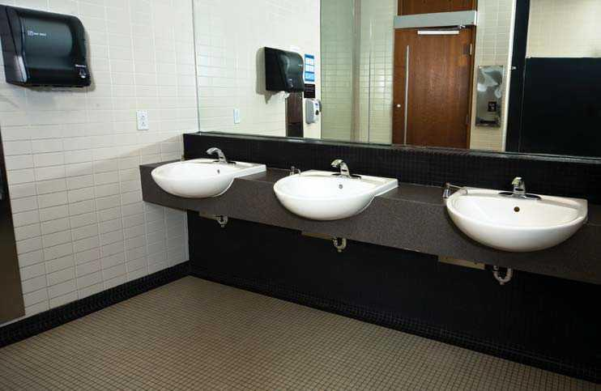
Use colour and brightness contrast to highlight toilet stalls or enclosures, accessories and fixtures in a public washroom or bathing facility. For example, plumbing fixtures should be colour/brightness contrasted to the walls and floors to prevent someone impacted by blindness from accidentally bumping into them. Toilet paper dispensers, soap trays and light switches can be enhanced with borders that are colour/brightness contrasted to the surrounding surface. Other essential items like faucets, grab bars and towel rails should also contrast in colour and brightness to their background surfaces.
An example of good colour contrast in a washroom.

Washroom stalls and urinals should be located logically in relation to washbasins and should not protrude into paths of travel. Wall-mounted accessories and equipment should not project out from the wall by more than 100 mm. A soap dispenser should be attached to each washbasin with paper towel dispensers or hand dryers located at either end of a line of washbasins. Accessories that are normally placed at a high wall level, such as coat hooks, should be placed above head level, so that they are not a hazard to people with vision loss.

If possible, towel dispensers, waste cans and drinking fountains should be recessed into the wall. Towel dispensers that use motion detectors are a good choice because they are universally accessible.
Light fixtures should not be placed around a mirror, because this will create glare. Instead, arrange soft, diffuse lighting to illuminate the user’s face. The level of lighting in the area of the washbasin should be at least 200 lux.
Flush controls are ideally electronically or automatically activated. These controls should contrast in colour and brightness to their surrounding surface. In washroom stalls, there should be at least 900 mm by 900 mm of open space between the toilet and the stall door with grab rails on both sides of the toilet.
Urinal centre lines should be identified by vertical piping or a tactile raised marker, directly above the urinal. This should be in colour and brightness contrast from the surrounding surface.
Seats in shower stalls should be colour and brightness contrasted to their surroundings and detectable by people using a long cane. Shower heads should be colour and brightness contrasted to their background.

Avoid designing curbs at shower stalls, which are a tripping hazard for everyone. If there are curbs, they should contrast in colour and brightness to the surrounding floor surface to reduce the possibility of tripping. Seats in shower stalls should be colour/brightness contrasted to their surroundings and detectable by people using a long cane. Shower heads should be colour/brightness contrasted to their background.
In buildings where it’s possible to provide assistance, single user washrooms should be equipped with a colour-contrasted emergency call switch that activates an alarm.

4. Theatres, Performance Spaces and Lecture Halls

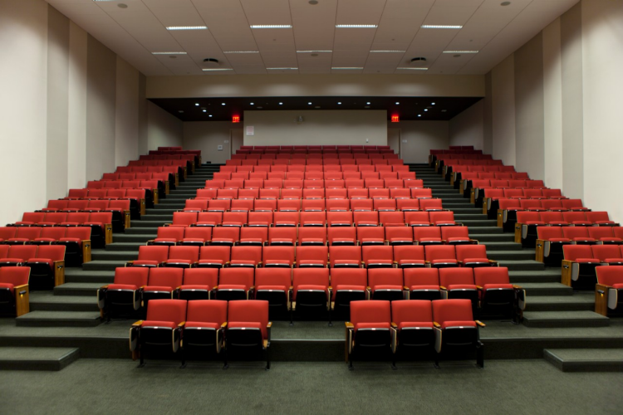
Seating in interior spaces such a lecture hall or theatre should be oriented so that the occupants sit facing the focal point of the room. Furniture and fixtures in a room should be positioned in order to ensure a clear view of the focal point is still maintained. Sloping or “raking” the floor so that the back of the room is higher than the front also helps keep the focal point unobstructed. Even a gentle slope (such as 1:30) helps.

Example of a “sloping” lecture hall or theater with good colour contrast.
Source: NYC, 2021

The path of travel to the seating area should not cross the line of sight to the focal point. For example,
in most theatres the entrances are at the back or
sides, out of the patrons’ line of sight to the stage.

Spaces to accommodate guide dogs and seat their handlers should be provided close to the path of travel. They should be clearly marked to keep them reserved for people who need them.

Removable seats help to create safe, comfortable seating for guests with guide dogs. These seats should be located next to an aisle. Avoid designated seating for guide dog handlers at the at the back or off to the side of an auditorium.

Public address messages should include the location of emergency exits, for example: “There are emergency exits on either side of the stage at the front of the auditorium.” Many people impacted by blindness regularly attend public events independently, so it’s not appropriate to assume that a sighted companion will always be present.

Lighting can be used to accentuate key areas in an assembly or meeting place. For example, a lecture hall may have a combination of lighting levels and lighting patterns that draws attention to the lecturer.

Take care to maintain adequate light levels, and gradually change levels where appropriate. For instance, the difference in lighting between the lobby of a theatre and the seating area should be gradual to accommodate people with difficulties adapting to sudden changes in light levels. One approach is to provide the brightest lighting at the entrance and ticket sales counter and then slightly reduced lighting at the concession stands and restrooms. The inside of the theatre would have the lowest level of lighting. Before the event starts, lights in the room should be dimmed gradually.

Colour contrast on furniture and room fixtures can facilitate better use of a room. For example, in a theatre with dark-coloured seating, a dark-coloured stage set against a light background will direct the audience’s attention to the stage. Colour-coded seating can make it easier to find a specific section (e.g., rows A to D are dark blue, rows E to H are dark yellow, etc.).

Stages and platforms should have their perimeters identified by a tactile material that is colour contrasted from the surrounding stage or platform floor surface.

5. Meeting Rooms

In a meeting room such as a municipal council chamber, the colour of seating can be used to distinguish different types of participants: council members, city administrators, members of the media, members of the public and so on.

Colour schemes should be kept simple and avoid complex patterns. Review the section Colour and Brightness Contrast for information on using colour appropriately to benefit people impacted by blindness.

Meeting rooms must be kept free from obstacles that can be tripping hazards for those impacted by blindness and low vision. Equipment such as extension cords and bags can be hazardous. Protruding objects can also cause accessibility issues. Ensure a barrier-free path throughout the meeting room.

