Path of Travel and Restaurant Patios

1. Introduction

To help people impacted by blindness and low vision navigate in outdoor environments safely and independently, a clear path of travel is crucial, one free of obstruction such as common outdoor elements (e.g. park benches and garbage cans). The path of travel must also be separated from restaurant patios.

This discussion paper will present guidelines for a path of travel, as well as present good and bad examples of patio barriers.

2. Path of Travel

Paths of travel is defined as any space in a public facility where people might be expected to move from one point to another. It’s essential to pay attention to the design of paths of travel when considering people impacted by blindness as an accessible route will allow them to navigate public spaces safely and independently. Paths of travel should be wide enough to allow an individual with a guide dog to pass a person using a wheelchair who is travelling in the opposite direction. Since an individual with a guide dog needs approximately 1,100 mm and a wheelchair requires approximately 1,200 mm the width of a path of travel should be a minimum of 1,800 mm but up to 2,300 mm if possible.

An accessible path of travel should ideally be straight, with turns as equal to 90 degrees as possible. A straight path is easier to follow for people impacted by blindness. Curved or winding paths are more difficult to detect, more difficult to describe when giving verbal directions and more difficult for frequent users to memorize. Primary paths of travel that are clearly differentiated from the surrounding area are much easier to navigate. In large open outdoor areas, using textured surfaces to differentiate paths of travel from adjacent areas makes the path easier to navigate. The path’s surfaces should be firm, stable, slip resistant and free of glare. Busy and heavily patterned surfaces should be avoided as they can result in visual confusion and disorientation.

Streetscape elements such as benches, garbage cans, planters, signs and bus stop shelters should be placed outside the path of travel – ideally in an amenity zone that is clearly differentiated from the path of travel using ground finishes that contrast in colour and texture.

Elements of use to pedestrians (e.g., benches and waste receptacles) located near the path of travel should be within 600 mm of the edge of the pathway so that a person using a long cane can easily detect them.

Sandwich boards or temporary signs should be avoided wherever possible. These can create major obstacles for people impacted by blindness, making independent travel unnecessarily difficult. If deemed necessary, they should be placed well outside the path of travel.

Gratings should be positioned so that their long openings are perpendicular to the path of travel. To prevent canes and high-heeled shoes from becoming entrapped in gratings, the spacing between the openings should be 13 mm or less, measured edge-to-edge.

3. Restaurant Patios and Sidewalk Extensions

To ensure outdoor patios do not hinder the ability for people with vision impairment to navigate safely, the path of travel around restaurant patios, located in the typical path of travel, should be separated from the patio by a cane detectable barrier. The route around it should be clearly marked using cane-detectable guidance TWSIs, or it should have textural contrasts in ground materials that are detectable by a long cane and underfoot.

Cane detectable means that objects in the line of travel below 680mm (I.e., waist level) are detected by cane.

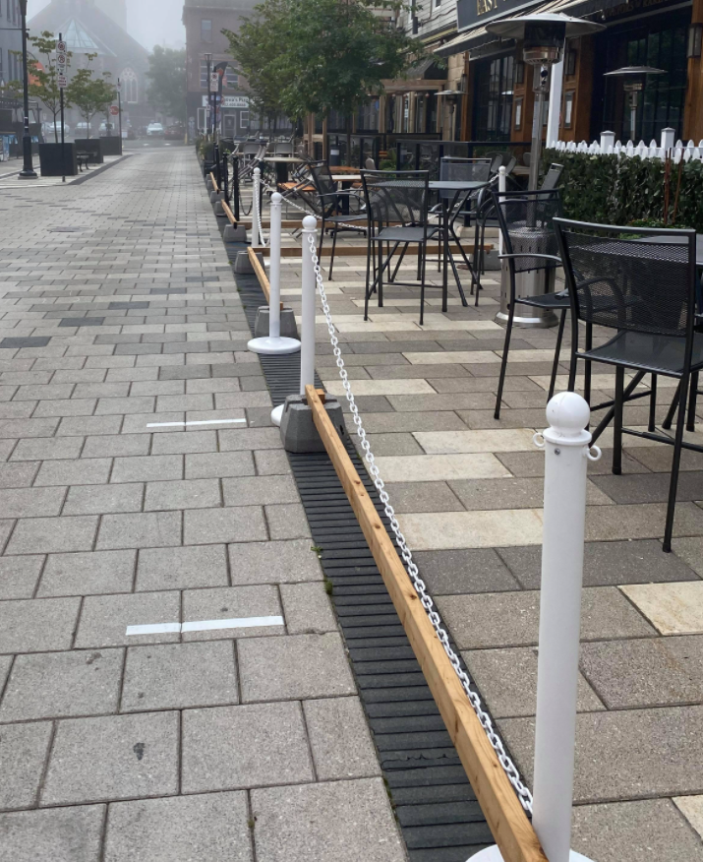
Image 1 depicts a wooden, near ground level barrier, that is cane detectable. Typically, those who travel using a cane rely on their cane to detect objects below 680 mm. Therefore, it is important for patios and other temporary facilities to include ground level barriers to ensure the patio is cane detectable for people impacted by blindness or low vision navigating a path with a cane.
Image 1: Example of a wooden, near ground level barrier.
- To be cane detectable by an adult, a protruding object must be located with its leading edge no higher than 680 mm above the walking surface.
- To be cane detectable by a child, the lowest leading edge of objects should be lower than 680 mm. The exact height will depend on the child’s size/age.

3.1 Types of Barriers

Outdoor patios are often separated from the path of travel by rope to post, chain to post, planter boxes, metal and steel and wood fencing to define the patio.

Businesses must ensure their patio is designated using cane detectable material such as continuous fencing and delineation elements. Cane detectable barriers must also have a strong contrasting color to the sidewalk. Where the sidewalk is gray, the barrier should be a dark colour such as brown or black to provide a strong contrast (Guidelines from CaféTO, 2021).

For a barrier to be cane detectable, it must be continuous and easy to identify. Furthermore, it is important that restaurant owners do not change the configuration of their patio regularly as people who are blind and those with low vision typically rely on familiar routes when travelling.

This section provides images of examples of both good and bad patio barriers and recommendations for enhancement, thus making patios more accessible for all users.

3.2 Chain to Post Barrier
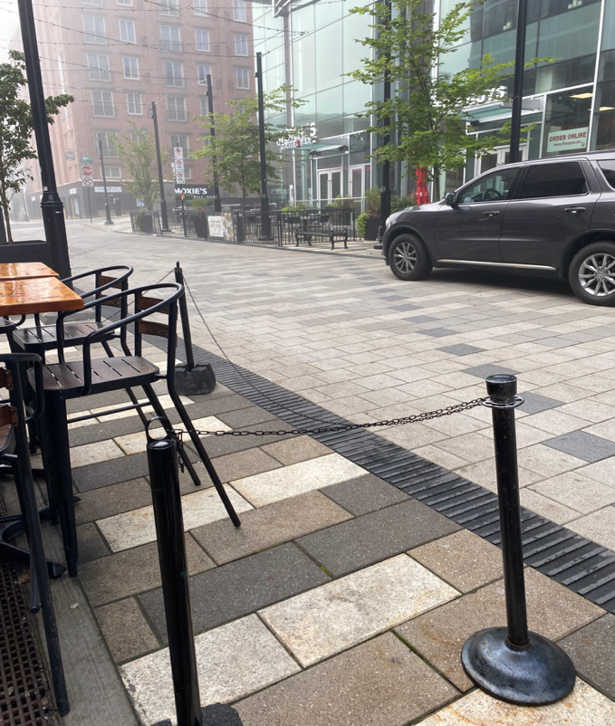
Image 2: Example of chain to post without a continuous ground level barrier.
Chain to post is a common and popular barrier typically used for semi- permanent patios as it is a cost-effective method to separate the outdoor restaurant from the path of travel.

It is best for chain to post barriers to be avoided as they do not provide adequate guidance and are not typically cane detectable due to the open space between the posts.

A consistent ground level barrier must be included to ensure that the barrier is cane detectible,
Image 2 is an example of a chain to post barrier that is not cane detectable due to large open space between the posts, thus creating a potential risk. When the barrier is not continuous such as posts connected by hanging chains/ropes, these types of barriers should be accompanied by a ground level barrier (toe rail) as depicted in Image 3. The toe rail must be a maximum of 0.6 meters from the ground. Image 3 does have a continuous ground level barrier thus making it cane detectible.

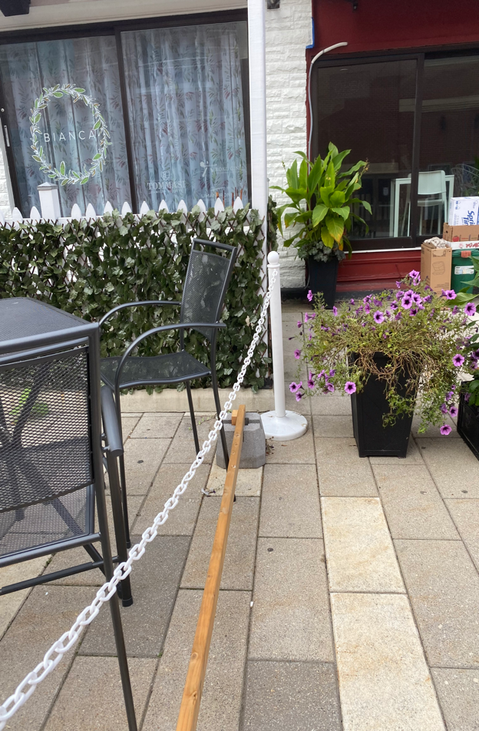
Where chain to post barriers are present, the chain should the same height as the post so an individual can trail the chain by hand. Both images depict a small, low hanging chain. Since the chain is situated near ground level, tripping hazards can occur. Image 3 depicts just how low hanging the chain is, practically low enough to touch the toe rail. Chain and post barriers are not recommended because they are wobbly making them susceptible to being knocked over by strong winds. The barrier could easily be dislodged causing it to fall into an adjacent path of travel; there by creating a tripping hazard. Wind could easily knock over the barrier causing the post to go into the path of travel thus creating a tripping hazard. The chain must be thicker, and the posts must also be made of a more sturdy, solid material other than plastic.
Image 3: Example of chain to post with a continuous ground level barrier.

The use of color contrast to differentiate between the path of travel and the amenity zone is very important. Image 2 depicts a patio with different colored paving than the path of travel thus designating the patio through colour contrast. Both examples also have a black tactile strip to create a separation from the path of travel. Although the barrier in image 2 does have good color contrast to its surrounding area, the chain is so small it is not easily visible.

3.3 Rope to Post

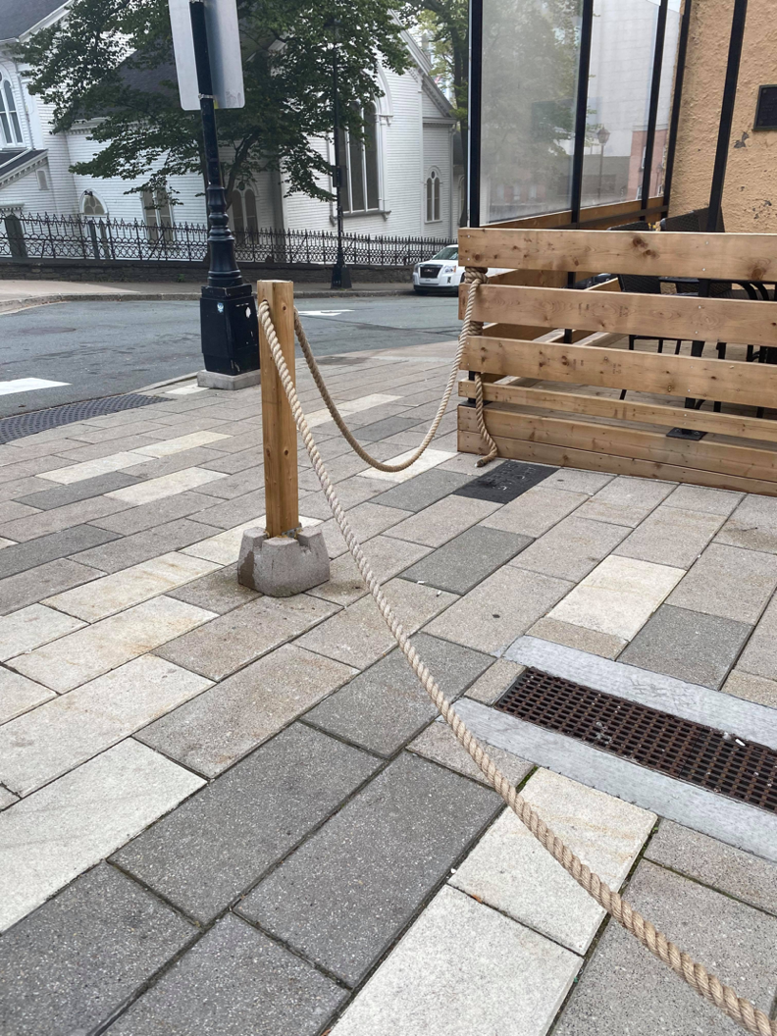
Similarly, to chain to post barriers, many patios also use a hanging rope connected by posts. Image 4 depicts a thick and solid rope, however this barrier used to designate the patio is not cane detectable. The low hanging rope also presents a tripping hazard.
Image 4: Example of rope to post without a continuous ground level barrier. The rope hangs low to the ground thus presenting tripping hazards.

These types of barriers are not the best guidance for service dogs to follow. For example, in the summer of 2020, a man in Sudbury Ontario who is visually impaired, walked into the middle of traffic due to his cane and guide dog being unable to navigate the path around the patio. The path had no curve or edge that he could feel with his cane and nothing for his guide dog to trail. This type of barrier creates accessibility concerns and should be avoided.

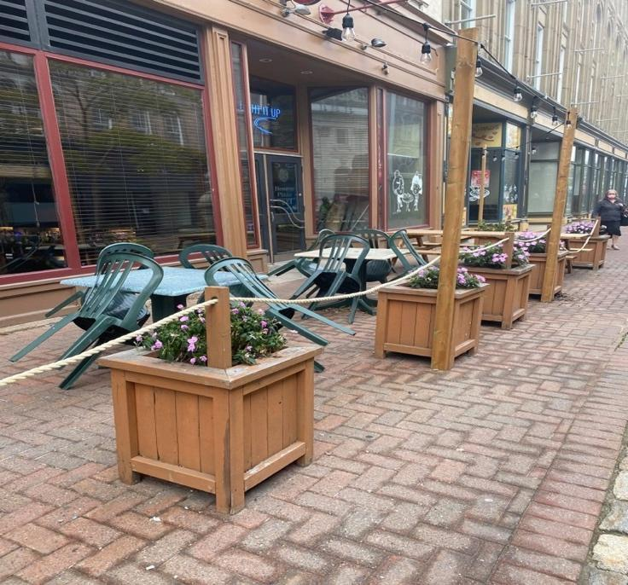
Image 5: Example of planter boxes connected by hanging rope to designate the patio.

3.4 Planter boxes

Many establishments have implemented planter boxes connected by hanging ropes to designate the patio. Placement of planter boxes is particularly important when used as a barrier. If there is too much space between each planter box, the patio would not be cane detectable.

To support people using a long cane to navigate, planter boxes should not be spaced out more than 0.3 meters apart if a toe rail is not present. Planters must also be approximately 0.9 meters in height and have a detectable base so that they are cane detectable.(measurement guidelines come from CaféTO Café Guidelines 2021).
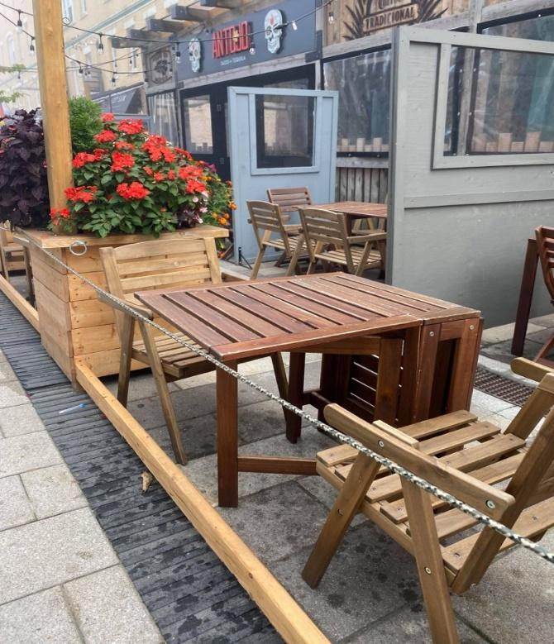
Image 6: Example of planter boxes that are distanced from one another but are accompanied by a toe rail.
The patio in Image 5 uses planter boxes to designate the patio, however each planter box is farther apart than the recommended 0.3 meters making the patio not detectable by cane.

To make the patio accessible, a toe rail should be a
maximum of 680 mm from the ground and must be implemented to create a continuous cane detectable barrier. Image 6 is an example of planter boxes that are distanced from one another but are accompanied by a toe rail thus creating a more detectable barrier.

Both examples do include hanging ropes that are placed at an appropriate height (I.e., not too low, not too high) to minimize safety hazards.

Image 5 depicts a different colored paving than the path of travel, using brick paving which provides color and texture contrast. Image 6 has a black tactile strip that is detected by cane in front of the patio to separate the patio from the path of travel.

Image 7: Example of a sidewalk extension with a wooden fence. The sidewalk is slightly slanted.

3.5 Sidewalk Extensions
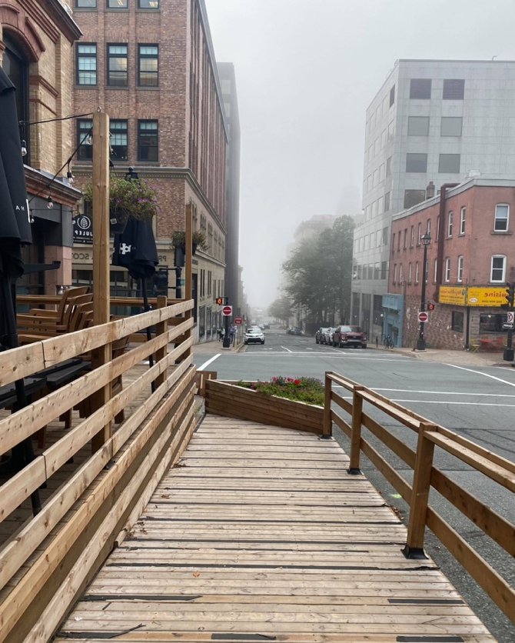
Due to businesses expanding to outdoor dining, many restaurants have also built sidewalk extensions.

The sidewalks shown in Image 7, Image 8 and Image 9 are wide enough to accommodate an individual with a guide dog to move past a person using a wheelchair who is travelling in the opposite direction.

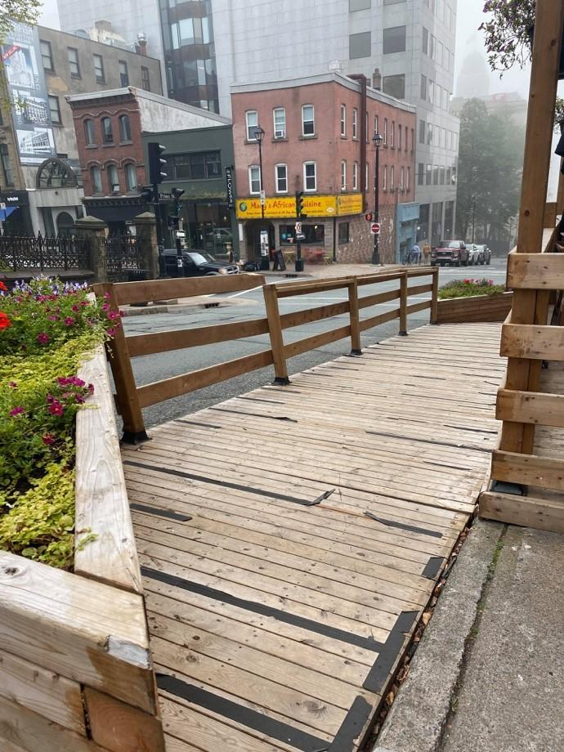
Image 7 has a wooden fence to separate the sidewalk from the traffic. The fence includes a toe rail and a middle continuous firm barrier that runs along the fence to safely separate pedestrians from the road. Entering and exiting the sidewalk extension is made easier due to the rotated planter box guiding pedestrians on and off the sidewalk. The fence also contrasts well with the sidewalk extension and the road.
Image 8: Example of skid resistant tape peeling off on the sidewalk.

The sidewalks however, could be enhanced by regular maintenance practices. The skid resistant tape on the sidewalk extensions can pose accessibility issues especially for wheelchair users. The pieces of tape peeling off the wood can reduce grip for those navigating with a wheelchair and may be a tripping hazard for pedestrians of all abilities.

Image 9 has a rope to post barrier to separate from the road. The sidewalk extension is slightly elevated; therefore, cane users can detect the edge. The rope is also at an appropriate height making it easy to trail the rope by hand. Furthermore, the posts contrast well with the sidewalk extension and the road. The sidewalk is also very wide, free of obstructions and has a smooth, well-maintained surface.

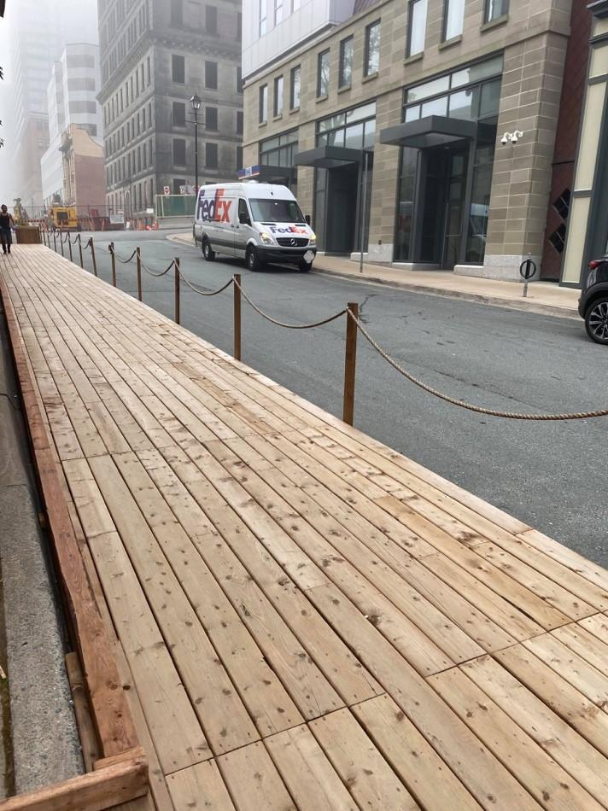
Image 9: Example of an elevated sidewalk extension with a rope to post barrier.
Image 9: Example of an elevated sidewalk extension with a rope to post barrier.

3.6 Metal Fencing
Image 11: Closer look of the metal fence barrier.
Image 10: Example of a metal fence barrier.
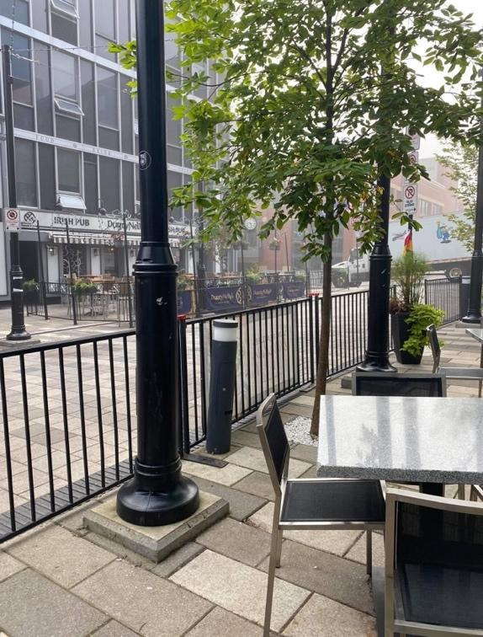
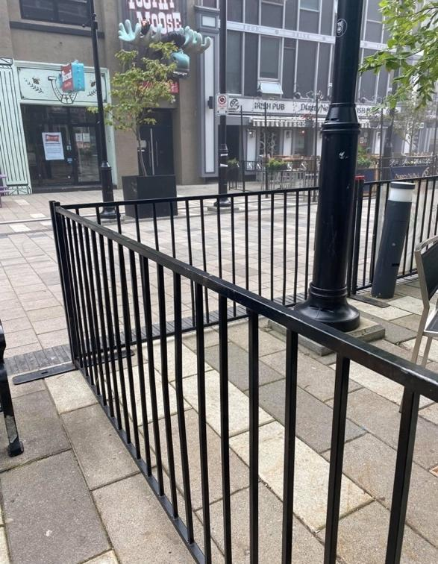
Metal fencing is a common barrier to designate a patio. The black color of the fence contrasts well with the ground. The fence is tall enough to use as a guide and the fence is solid and sturdy. The fence is cane detectable.

It is important to note that many metal fences such as shown in Images 10, 11 and 12 typically have openings between the poles. For people travelling with a cane, the cane can potentially get stuck in between the openings.

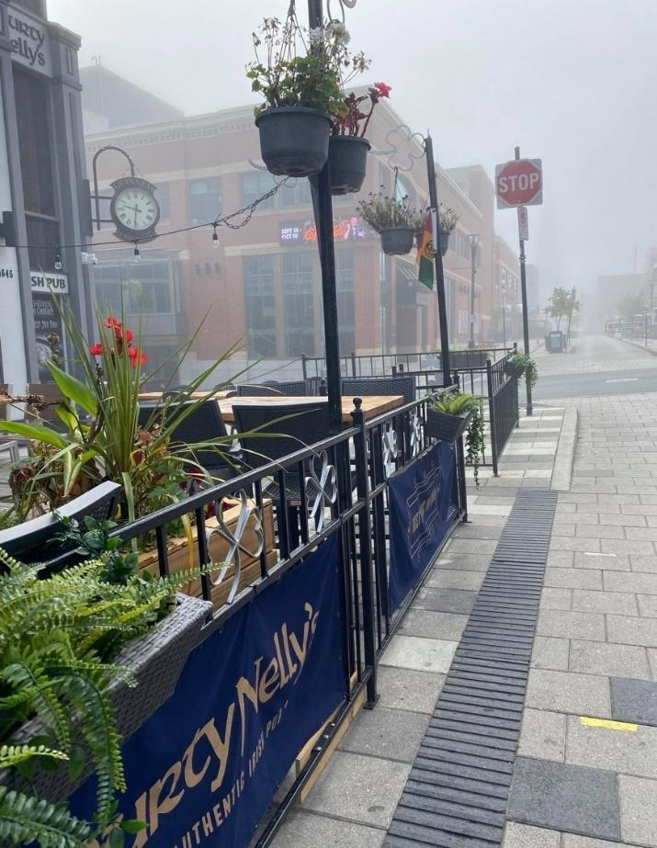
Some patios also include beautification elements such as enhancing their fence with hanging flower pots as shown in Image 12.
Image 12: Example of fence with decoration elements (hanging flowerpots on fence and overhead plants).

Overhanging objects and plantings within building landscapes should be no lower than 2,030 mm (2.03m) along walking routes. Elements that are lower than 2,030 mm such as greenery on fences should not protrude more than 100 mm (0.1m).

Image 12 depicts a patio that has been enhanced using greenery. The use of elements adheres to the measurement guidelines stated above.

3.7 Wood and Steel Fencing

The patio barrier includes both wood and steel fencing. The patio is cane detectable due to the ground level continuous barrier. The fence is enclosed with no open spaces except for the entrance and exist paths. Furthermore, the patio is much easier to identify and navigate compared to a typical chain/rope to post barrier due to its large size and adequate color contrast to its surrounding areas. There is a wide path of travel directly in front of the patio with no obstacles or obstructions, thus making entry to the patio and walking past the patio easy to navigate.

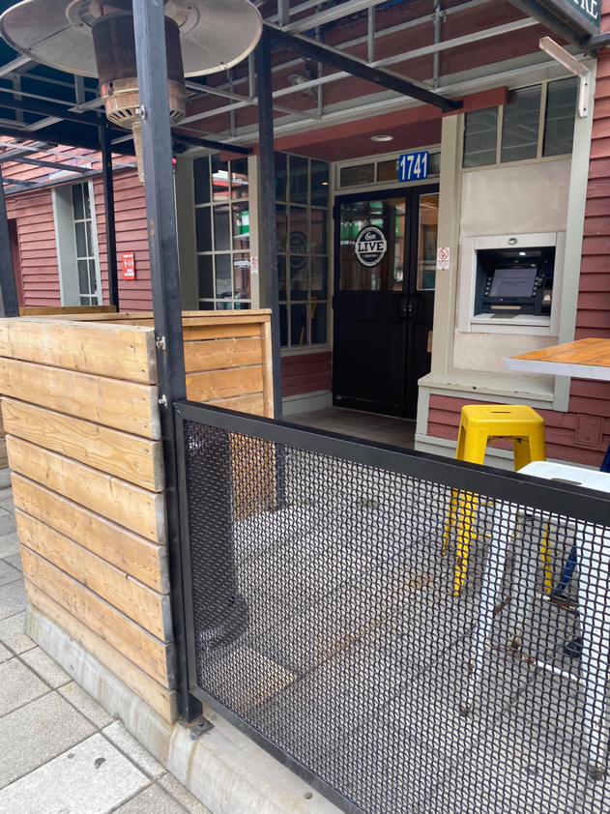
Image 13: Example of a patio barrier that is separated by a wood and steel fence.
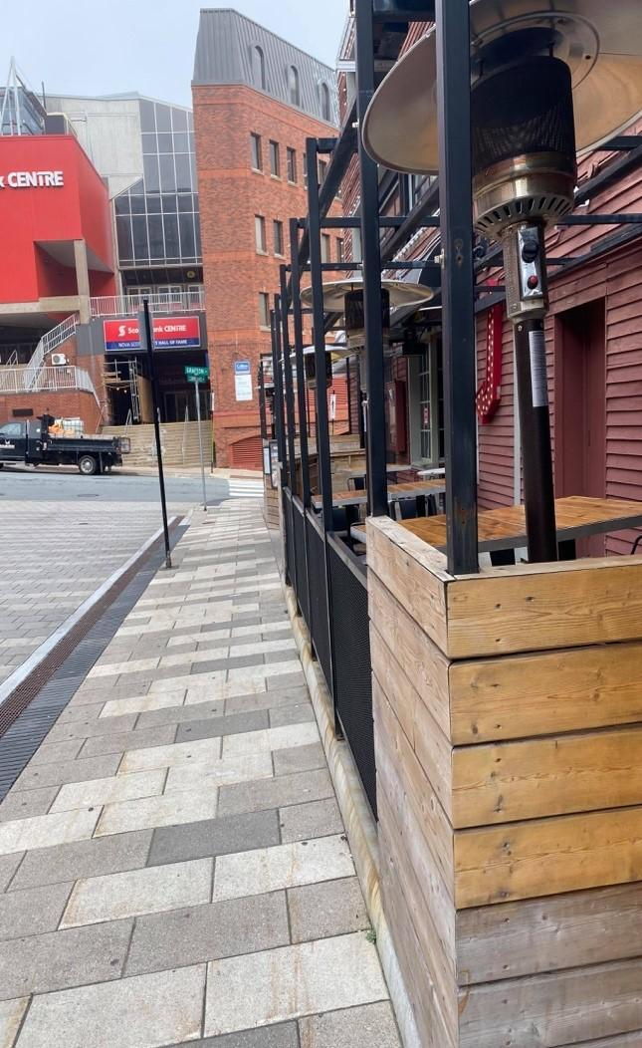
Image 14: Example of a wide path of travel directly in front of the patio.

