Innovations in Accessibility:

Dispatch Destination elevators, Beacons and other Wayfinding Techniques

- Introduction

Innovations in accessibility are continuously evolving. This discussion paper will present new technologies which provide people impacted by blindness and low vision a more equitable experience in accessing key information.

- Emerging Technologies

2.1 Destination Dispatch Elevators

As elevator technologies continue to evolve, it’s important for designers and specifiers to consider the usability of these technologies by people impacted by blindness. Assessing the accessibility of new technologies should be an integral part of the product evaluation and specification process.

For example, destination dispatch elevators, a recently introduced elevator technology, continue to pose significant barriers for people impacted by blindness.

Destination dispatch elevators should be equipped with an accessible means by which the elevator can be summoned. This could include a telephone style keypad or an electronic touch screen at each floor for users to identify the floor they wish to reach. Once the destination floor is entered, the screen returns visual information to identify which elevator cab to use. When the elevator arrives, the destination floor is pre-selected, and the user simply has to get on the elevator.

Unless appropriate features are provided, people impacted by blindness using this type of system will have difficulty entering their floor destination, identifying which elevator to go to and how to get to it. As such, the following design features should be incorporated into destination dispatch elevator systems:

- A push button to activate audio instructions.

- Audio instructions to guide the user through the process of entering their destination.

- Once a floor destination has been entered, audio instructions to guide the user to the location of the elevator that will take them to their destination.

- A tactile map to provide information on the layout of the elevator lobby and location of the elevators.

- Tactile signs to clearly identify each elevator.

  - BlindSquare- Beacon Technology

Beacon technology has become more and more popular with many buildings such as office buildings, airports, and sport stadiums integrating beacon GPS as part of their wayfinding strategy. Beacon technology has also been deployed in outdoor environments.

Beacons are a helpful tool for visitors who need direction when entering a building or navigating the outdoors. Beacons help to provide additional support to people impacted by blindness by giving audio cues about where important services and amenities are located and giving accurate directions to find one’s desired destination.

BlindSquare is one of the most popular and widely recognized GPS apps. BlindSquare is widely used by blind, deafblind and partially sighted individuals. BlindSquare delivers detailed points of interest both indoors and outdoors to provide safe and effective navigation.

BlindSquare is an app available for iPhone users to download. BlindSquare is a self-voicing app that provides information to users about their surroundings. BlindSquare will determine a user’s location and look up information about the users' surroundings through apps such as Open Street Map and Foursquare.

For more information about BlindSquare visit the BlindSquare user guide: https://www.blindsquare.com/user-guide/

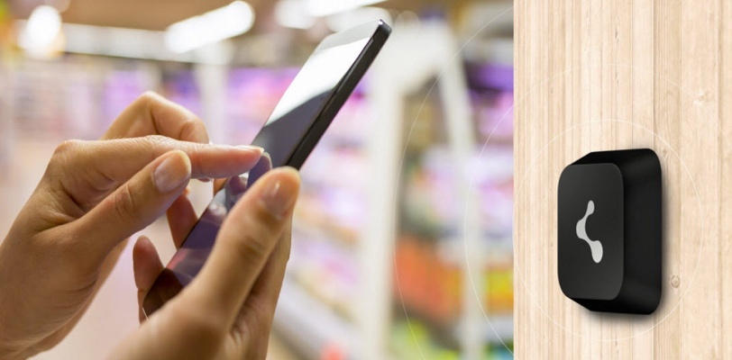
2.2.1 BlindSquare BPS -Indoor Beacons

BlindSquare has developed an indoor navigation system called BlindSquare BPS (Beacon Positioning System). The BPS consists of a set of Beacons. Beacons are small Bluetooth devices that can be attached to any wall of a building. Once a person enters a building that is equipped with a range of Beacons that is part of the BlindSquare BPS system, users who have downloaded the BlindSquare iOS app will receive information about their surroundings. Indoor Beacons help those who are visually impaired locate key features that are often found in buildings such as elevators, meeting rooms, and other amenities.
Photo of a BlindSqaure Beacon attached to a wall.
Source: BlindSquare, 2022.

BlindSquare BPS is being implemented at the Toronto Pearson Airport. A free version of the BlindSquare app named BlindSquare Event is available to download for passengers of Toronto Pearson.

The Toronto Pearson Airport has installed beacons to support the navigation of travelers who are blind or impacted by low vision. With the help of BlindSquare BPS, travelers who are visually impaired can independently navigate throughout the airport as it provides passengers the location of key points of interest such as check-in, security screening, pet relief areas, washrooms and more. https://www.torontopearson.com/en/accessibility/blindsquare

2.2.2 BlindSquare BPS -Outdoor Beacons

BlindSquare BPS has also been incorporated in many provincial parks to help park users who are visually impaired enjoy the outdoors independently. Wascana Park, located in Regina, is one of the largest parks in North America. 230 GPS points around the main walking path of Wascana Park have been implemented to provide park goers who are blind or those with low vision navigate the park safely. The GPS points give park users information about path splits, park entrances and exits, landmarks, buildings and other park amenities such as benches, lookouts and monuments.

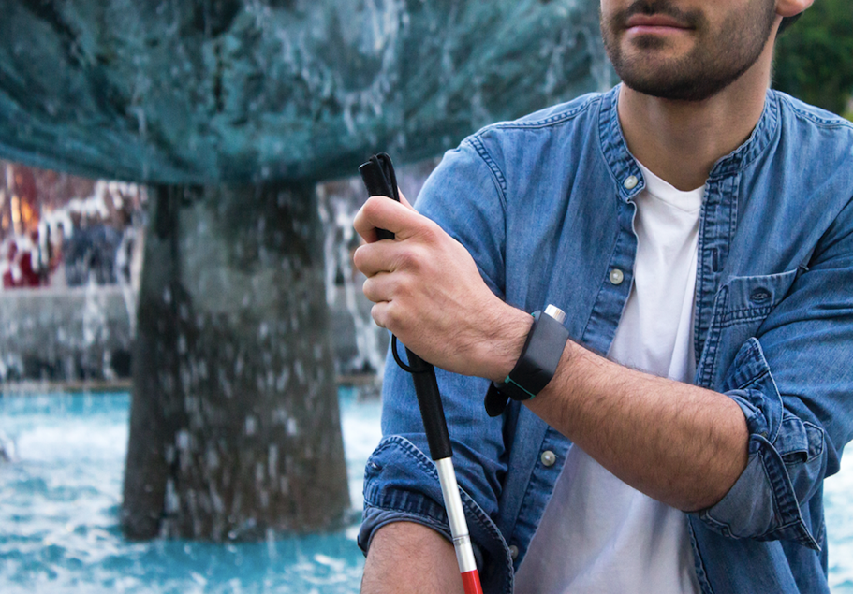
Parks in Alberta have also included beacon technology. Alberta Parks has partnered with CNIB Frontier Accessibility and Trans Canada Trail to make nature trails accessible for those with vision impairment. Because of BlindSquare, individuals with vision loss can explore Fish Creek Park safely without a guide, giving park-goers opportunities to discover amenities and go on a hike.

Photo of a man wearing the Sunu Band on his wrist.
Source: BlindSquare, 2021

  - Sunu Band

Sunu Band is an advanced mobility aid that was developed to help people who are blind and those with low vision avoid bumping into protruding objects.

While a cane detects objects at ground level, the Suna Band detects protruding objects and
objects that are above ground, thus
protecting the user’s upper body.

Suna Band is a small wearable wristband that resembles a smartwatch. The wristband transmits haptic vibrations to alert the user of objects and obstacles in their path. Sonar and echolocation are used to detect these objects.

Sunu Band has been on the market since 2018, helping users detect obstacles, reducing accidents to the upper body. Sunu Band is also working with BlindSquare to improve accessible navigation. With every Sunu Band sold, users can download the BlindSquare app at a much discounted price.

For more information about Sunu Band visit: https://www.blindsquare.com/2021/06/30/sunu-band-x-blindsquare-join-forces-for-enhanced-accessibility/

2.4 Wireless Accessible Pedestrian Systems

Some cities are experimenting with smart intersections that incorporate wireless pedestrian systems. In these installations, a pedestrian typically is able to interact with the intersection via a smartphone app. The pedestrian may be able to activate the APS device remotely but might also be able to access information about the intersection such as how much time is left in the current traffic phase, what the cross streets are, or problematic navigational issues. If a wireless pedestrian system is installed, it should be able to be activated using either a personal hand-held device or a smartphone.

Personal hand-held devices should be freely available to pedestrians requiring these adaptations. The smartphone option should be compatible with text to speech or screen magnification software, native to both iOS and android operating systems. A wireless APS should support both of Canada's official languages. If a wireless system is used, system should still be fully operational via a pushbutton for pedestrians who do not have the interface to connect with the wireless system. As with conventional APS, activation and information from the wireless system should be available 24 hours a day. Activation of the APS and interaction with the intersection system should only be possible within a 3,700 mm distance of any of the pushbuttons installed at the intersection. When activation of an APS is requested, the hand-held device or smartphone should use vibration and/or an auditory signal to confirm that the request has been received. Similarly, when the APS is activated, the hand-held device or smartphone should provide a vibratory signal when the auditory walk signal from the main system is activated. The APS system should not rely solely on a signal sent to the hand-held device or smartphone.
Wireless pedestrian systems should operate independently of current or future infrastructure. The system should operate at all types of intersections and be compatible with pushbuttons and APS. Just as an auditory APS signal is designed to augment information about the visual walk signal, a wireless pedestrian system should not be used to replace existing informational avenues but to provide additional avenues to make access to information easier. It is critical that any system designed to mitigate the impacts of blindness be thoroughly user tested by pedestrians who are blind, who have varying degrees of sight loss, and who are deaf-blind.

