Intersection Design

1.Introduction

Street crossing routes should be configured to limit exposure to vehicular traffic by following a line that is perpendicular to the vehicular route being crossed. Crossings should be fully outside the traffic, turning, or bus bay lanes of the parallel roadway and have curb ramps or depressed curbs which lead people directly into the crossing area designated for pedestrian use.

This discussion paper will present intersection design, focusing on curb ramps and depressed curbs, accessible pedestrian signals, islands and tactile warning surface indicators (TWSI). This paper will give guidelines to enhance these pedestrian infrastructures making navigation in the built environment more accessible for those impacted by blindness and low vision.

2. Curb Ramps and Depressed Curbs

The curbs that separate pedestrian walkways from vehicular roadways provide critical safety and directional information to individuals with blindness. Curbs are a useful orientation cue, as they are detectable by individuals using a long cane. People impacted by blindness and low vision may experience problems with the curb ramps and depressed curbs that are used to provide step-free access for people who use mobility aids (i.e., walkers and wheelchairs) at pedestrian crossings and vehicular loading areas. Unless appropriate safety features are incorporated into curb ramps and depressed curbs, individuals with blindness may not be able to tell when they are moving from the safety of a pedestrian sidewalk onto a vehicular roadway.

Curb ramps provide a sloped access route from a pedestrian walkway down to a vehicular roadway. They are typically at least 1,500 mm wide and used most frequently at pedestrian crossings and intersections. Depressed curbs also provide a sloped access route from a pedestrian walkway down to a vehicular roadway, but they are much wider than a curb ramp, typically running the entire length of an element such as a drop-off area.

It’s important to make sure that curb ramps and depressed curbs are properly identified, giving a person with blindness sufficient warning that the walkway is about to end and the road is about to begin.

2.1 Identifying Curb Ramps and Depressed Curbs

People impacted by blindness use the grade separation between a sidewalk and roadway as the primary distinguishing factor between the safety of the pedestrian and danger of the vehicular areas. The attention TWSI is the backup feature, particularly as the TWSIs can be obscured by snow, ice and debris.

The slope of curb ramps should be between 1:15 and 1:10. Shallower slopes would make the transition from sidewalk to curb ramp difficult to detect for people impacted by blindness. Steeper slopes would make the curb ramp difficult to use for people who use mobility aids such as wheelchairs or walkers. The use of different ground finishes should also be considered to differentiate the curb ramp from the sidewalk.

Where flared sides are integrated into a curb ramp or depressed curb, if they are too steep, they will be a tripping hazard. The slope of flared sides should be 1:10 in the direction parallel to the curb.

The slope of depressed curbs in any direction should be no steeper than 1:50, but never steeper than 1:20.

An attention TWSI should be used to alert people impacted by blindness to the presence of a curb ramp or depressed curb of any kind (i.e., at intersections and pedestrian crosswalks).

When a TWSI is used, it’s permissible to have no lip at the end of the curb, providing a completely blended curb-to-road transition for the benefit of people using wheelchairs.
Attention TWSIs should be set across the entire width of the curb ramp or depressed curb edge (exclusive of flares). They should be set back 150 – 200 mm from the curb’s edge and extend for a depth of 600 – 650 mm from the road boundary. Further information can be found in the section on TWSIs.

Curb ramps or depressed curbs should be located at the side of a path of travel. People impacted by blindness may not detect their presence if they are using the opposite side of the path as an orientation boundary. In such locations, use a 600 – 650 mm guidance TWSI across the path at the curb ramp or depressed curb.

2.3 Placement of Curb Ramps
It’s critical that curb ramps direct pedestrians onto a safe pedestrian crossing route across the roadway. The curb ramps on either side of a crossing should be aligned and the crossing route must be perpendicular to both curb ramps. Apex or diagonal ramps (ramps in the center of a corner, often not aligned with a crosswalk) should be avoided if possible. If used, there should be a safe pedestrian way in the roadway extending between the two crosswalks. If an apex or diagonal ramp is used, a 600 mm by 600 mm section of guidance TWSI should be used to indicate an optimal place to stand for each crossing and to provide alignment for the crossing.

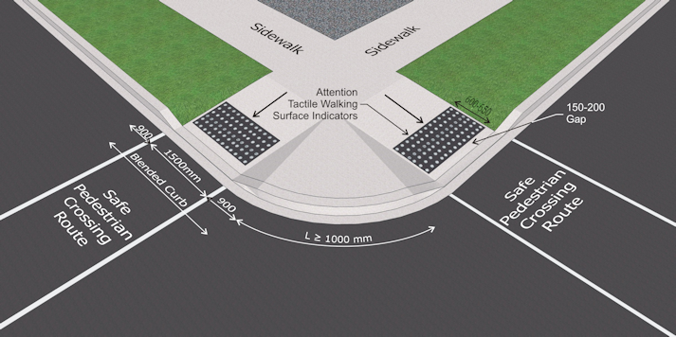A good example of curb ramps used at a four-way intersection.

The pedestrian crossing route on the roadway should be clearly identified for both pedestrians and drivers using markings or materials that contrast in colour and brightness to the road’s surface. If paint is used it should be slip resistant.

With a four-way intersection, there should be eight curb ramps: two for each corner, and each
independent of the other. This ensures a straight route of travel for all crossing paths.
When curb ramps are used at mid-block crossings, their presence should be identified using guidance TWSIs across the width of the sidewalk.
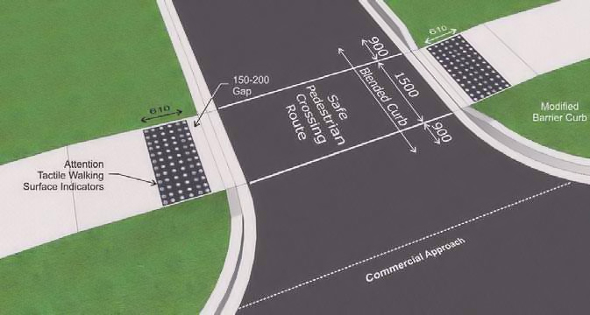
B

A good example of curb ramps that are aligned on the same axis.

2.4 Depressed Curbs
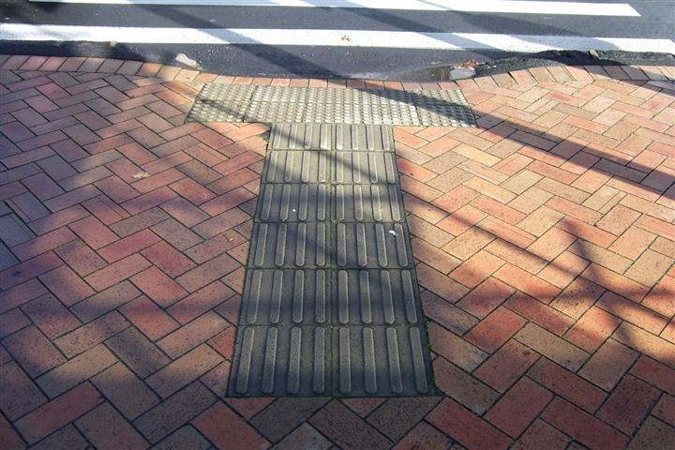
Depressed curbs can be difficult to detect for individuals with low vision, as the transition from a pedestrian sidewalk to a depressed curb may be subtle. Where these installations exist, it’s essential to provide appropriate tactile and colour-contrasted warnings to clearly delineate the boundary between pedestrian and vehicular areas.
Warning TWSIs (truncated domes) should be installed around the entire span of the corner where there is no level change between the walking surface and the road surface.
A good example of curb ramps at a mid-block crossing. Note that directional TWSIs are required to assist people impacted by blindness identify the presence of the curb ramp.

Avoid the use of wraparound depressed curbs at the corners of intersections, which can misdirect individuals into the intersection rather than to the safe pedestrian crossing route. Where these installations do exist, pedestrians impacted by blindness must be able to clearly identify the safe crossing route, and barriers must be installed to prevent vehicles from coming up onto the sidewalk. Directional or guidance TWSIs can be used to lead a pedestrian to an appropriate crossing point. The use of bollards or other features that are colour/brightness contrasted to the surrounding environment are recommended at depressed curbs to prevent vehicles from entering pedestrian areas.

3. Islands

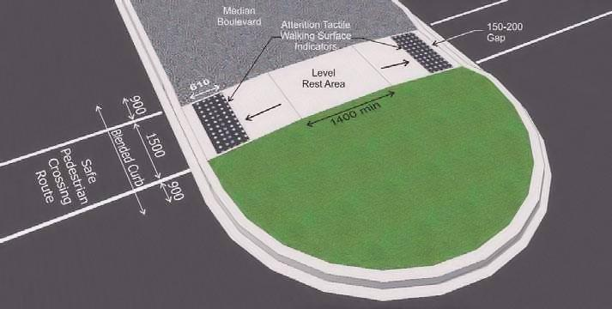
This section will discuss islands and the ways in which they should be enhanced to support people impacted by blindness.

A good example of using curb ramps to facilitate access to an island.

Wherever possible, street crossings should provide a direct route from one side of the street to another without a raised island in the middle. People impacted by blindness may otherwise assume that they’ve reached the other side of a street when they have in fact reached an island.
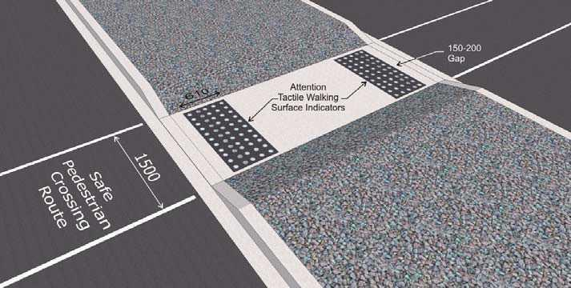

A good example of a walkway through an island that is level with the road surface.

However, for especially wide street crossings (e.g., crossings with six or more car lanes), an island can provide a safe place to stop before completing a crossing. For these exceptionally wide crossings, islands can allow pedestrians to complete the crossing in two segments. Islands are also generally used between the entry and exit lanes at roundabout intersections.
Where a raised island is used within a pedestrian crossing route, a level walkway should be cut through the island, or curb ramps should provide access to the island from both sides. Islands should incorporate a level rest area that is at least 1,400 mm long, with appropriate attention TWSIs installed at each side of the island.

When an island is level with the road surface, the walkway through the island should begin and end with attention TWSI across the entire walkway. The attention TWSI should be set back 150 – 200 mm from the curb line, be 600 – 650 mm deep and colour contrasted to the rest of the walkway.

Wherever possible, the line of travel through a traffic island should be a straight pathway from the original crossing point. Where this is not possible, a channelized configuration should be used to ensure that the entry points on both sides of the island align with the original crossing points on each side of the road. This channelization of pedestrians through an island can be helpful when, due to road configurations, entry points on each side of the island do not allow for a straight walk through. In this situation, additional barriers such as fencing can be used to direct pedestrians from one side of the island to the other.

4. Accessible Pedestrian Signals

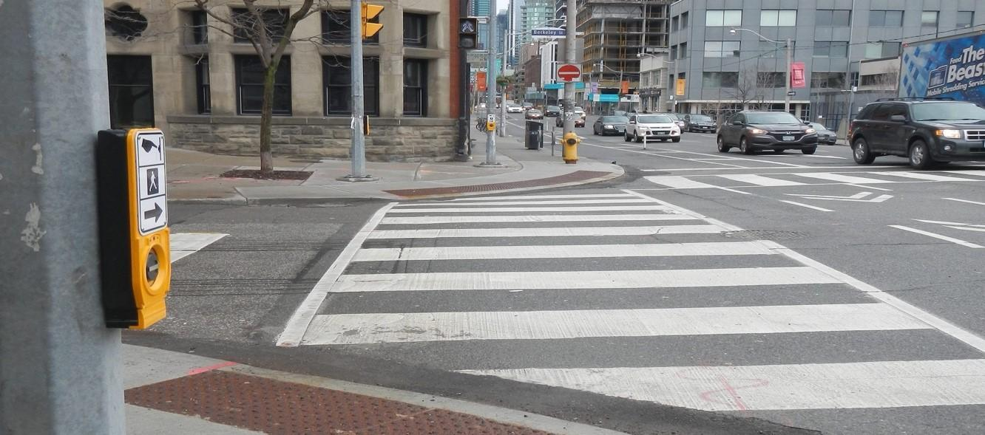
Photo of an accessible pedestrian signal.
Source: Toronto, 2022.

This section will discuss accessible pedestrian signals (APS). APS are commonly found at many signalized intersections. APS systems provide auditory, visual and tactile information so that a person with vision and/or hearing loss will know when the visual walk signal is lit. In addition, an APS may provide information to help a person with blindness travel in a straight line across a street or roadway

All intersections with traffic control signals should be augmented with APS devices to help with accessible travel for people impacted by blindness.

APS devices should be capable of activation 24 hours a day. In general, the time provided for crossing at any intersection or crosswalk, regardless of the presence of an APS, must be programmed to be long enough to accommodate people who may walk at a slower pace, according to this formula: at least one second of crossing time provided per 1,000 mm of crossing distance. A longer amount of crossing time might be able to be programmed into an APS unit to be accessed by pressing the button for more than 3 seconds. Developing technologies also exist that make use of smart intersections that have the capability of extending crossing times and activating APS units through a smartphone app, and specialized receiver, or a transit card. However, these developing technologies generally require additional training for the traveller and the use of a device or smartphone app in addition to the traveller's mobility device.

While extending the crossing time universally will enhance walkability for pedestrians who may not walk as quickly as others, cities around the world are beginning to implement smart technology.

These systems have the capability, when implemented, of providing a custom solution activated by a transit card or device which extends crossing signals based on individual preference or needs.

The CNIB Foundation encourages municipal planners to bare these capabilities in mind when sourcing new traffic control systems. Employ APS systems as follows:

4.1 Acoustic Locator Sound
An acoustic locator tone should be used to indicate the presence of an APS and its push button. The acoustic locator tone should be audible at no more than 3,700 mm from the push button, or at the closest building line, whichever is closer. The tone should sound no longer than 0.15 seconds and repeat every one to two seconds.

The sound-pressure level of an acoustic locator should be between 50 and 80 dB, automatically adjusted to be two to five decibels above ambient sounds.

4.2 Activating an APS
APS devices should be activated using one of three methods:
- An APS is automatically activated following the same cycles as crossing signals;
- A pedestrian is required to manually activate the APS by pressing a button; or
- Utilizing a wireless accessible pedestrian system

It is best if activation is based on manual activation. In this scenario, the pedestrian signal is not lit, and any pedestrian crossing timing is not enacted unless the button is pressed. This allows for optimal traffic flow through the intersection. If manually activated, then primary activation should only require a single press, not pressing and holding the activation button. Holding the button down longer can be used to activate additional features such as extended crossing time or a speech message about the intersection location. Note that when a button is pushed to activate an APS< the audible signal should not sound until the beginning of the next applicable traffic phase. If the button is pressed during a traffic phase in which the pedestrian crossing associated with that APS is in motion, the audible signal should not be activated immediately.

4.3 Confirmation of Activation
An audible, visual and vibro-tactile (vibrating) confirmation should be provided to indicate the system has been successfully activated by the push button.

4.4 Audible, Visual and Vibro-tactile Walk Signal
An audible, visual and vibro-tactile walk signal should indicate when it’s safe to cross the street.

The audible walk signal should be composed of multiple high and low frequencies, with the principal frequencies between 500 and 1,000 Hz with higher harmonics. It should sound during the entire walk cycle. The most easily heard signals in background noise are repetitive click trains (think of a metallic clanking). Additionally, walk signal voice messages can be provided, according to the principles outlined by the Transportation Association of Canada ["http://tac-atc.ca/en"].
The walk signal volume at the point of departure should be carefully controlled to ensure it is loud enough for someone at the departure curb to hear it properly. Unless sound beaconing is used, it should be automatically adjusted to be two to five decibels louder than the ambient noise level.

Take care to ensure that for people with hearing loss, the audible signal won’t be confused with other sounds, such as birds chirping.

4.5 Confirmation of Direction of Travel
A tactile, colour-contrasted arrow should unambiguously indicate the direction of travel associated with any push button.

The name of the street to be crossed should be made available in uncontracted braille, raised print characters and an audible format. Braille and raised print characters should be located on or near the push-button assembly.

The APS can also employ other features to unambiguously indicate the direction of travel:
• Sound beaconing of the acoustic walk signal assists people in establishing and maintaining a straight line of travel across the road.
• Careful placement of the APS push button close to the edge of where the crosswalk would be if it continued up onto the sidewalk will most easily allow it to be used to indicate the direction associated with it (for more information see Push-button location, below).
• A tactile map shows the lane configuration.

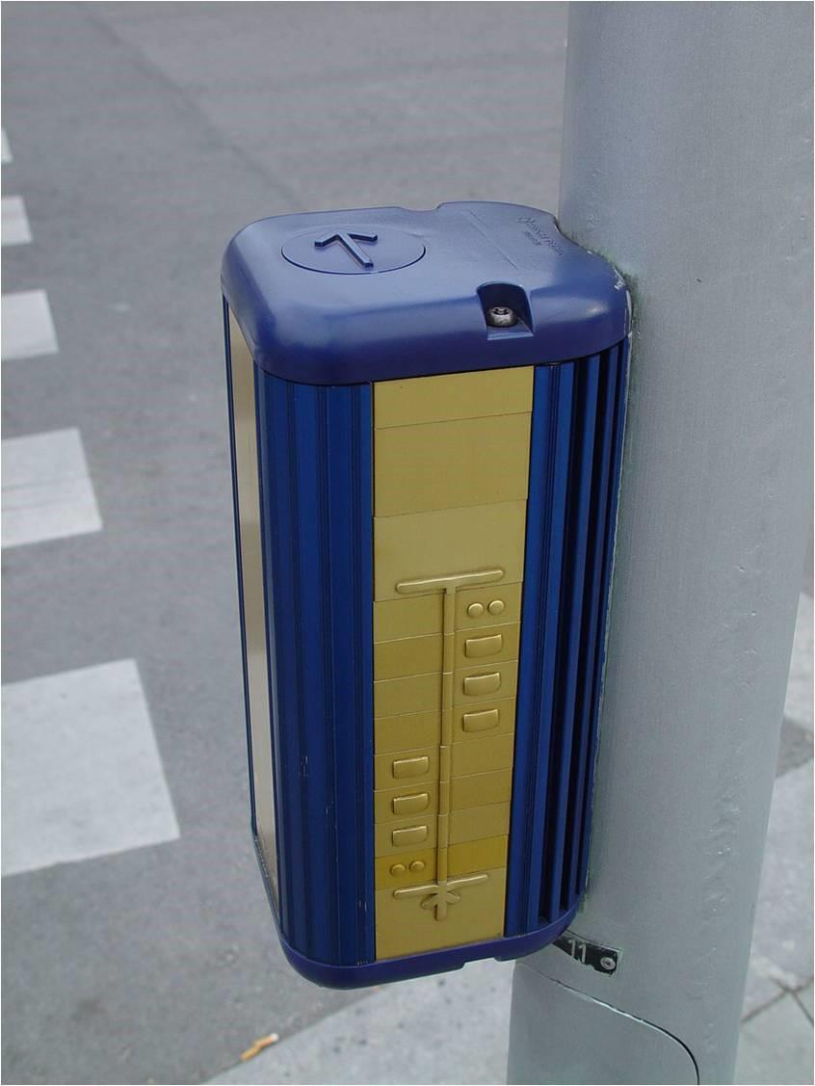
4.6 Push-Button Location

Photo of a pedestrian crossing with a push button that incorporates a tactile arrow to indicate the direction of crossing and a tactile map showing the lane configuration along the crossing route.

An APS push-button pole should meet these guidelines:

- Place it adjacent to a clear level ground surface that’s stable, firm and slip resistant within 300 mm of the push button. This may be adjacent to or part of the pedestrian sidewalk.

- Provide a high-contrast ratio information sign, mounted above the push button, with the face of the sign parallel to the crossing route.

- Mount the push button on the pole at a height of 1,000 - 1,250 mm. The microphone for adjusting sound levels, the walk speaker,
and the pushbutton should all be in the
same housing.

- Place the push button on the side of the pole
facing the pedestrian waiting area. Its face
should be parallel to the associated crosswalk.

- Locate the push button near the extended crosswalk line that’s farthest from the movement of parallel traffic. Set the APS back no farther than 600 mm from this line.

- In urban environments, locate the push button close to the curb, as appropriate for the environment. In suburban environments, locate it farther back to avoid damage from vehicles tracking across the corner. In these instances, locate the push button between 1,000 and 3,000 mm from the curb line of the roadway (as measured from the pedestrian walking path) to ensure accessibility of the push button from the pedestrian waiting area.

- If there are two APS buttons on the same corner (i.e., two separate directions of travel), separate them by at least 3,000 mm.

- In some locations, circumstances may dictate the placement of APS push buttons for two directions of travel on a single pole (a situation to be avoided wherever possible). If this is necessary, place each push button on the side of the pole facing the pedestrian waiting area. Align the face of each unit to be parallel to the associated crosswalk. In these situations, differentiating signals for different crossings is very difficult so speech messages that indicate which street is being signaled should be used.

- Snow collected in snow removal shouldn’t be piled at the base of poles where APS push buttons are mounted. It should be piled on the far side of poles to ensure an unobstructed path of travel.

4.7 Pedestrian Crosswalks
When APSs are used at pedestrian crosswalks, follow the same guidelines listed for APS devices at intersections above.

For detailed information on APS devices, refer to “Guidelines for Understanding, Use and Implementation of Accessible Pedestrian Signals,” available from the Transportation Association of Canada’s website bookstore.

4.8 Non-Accessible Pedestrian Signals
If using standard push-button signals at an intersection instead of APSs, follow these guidelines:
- Ensure push buttons for traffic lights are free of obstacles (i.e., guardrails).
- Mount push buttons between 1,000 and 1,200 mm high.
- Contrast the colour of the push buttons to adjacent materials.

4.9 Limitations of Accessible Pedestrian Systems
Being able to locate a pole with an activation button, even if the locator beacons are functioning as expected, locating a pole and activating the APS system can be difficult for many pedestrians. Activating an APS via a push button requires a combination of reach, strength and dexterity. A large range of conditions can affect these abilities such as Amyotrophic Lateral Sclerosis (ALS), Parkinson’s, Rheumatoid Arthritis, Muscular Dystrophy, Cerebral Palsy, Multiple Sclerosis or any degenerative disease. Where more than one APS activation button exists, the need to make contact with it requires finding the appropriate button for the direction sought; this can prove particularly daunting for someone who is blind and unfamiliar with the layout of an intersection.

Locating a button housing may require a pedestrian impacted by blindness or low visionto veer from their path of travel to activate an APS, then to realign themselves with a crossing. This can significantly hinder their orientation.

4.9.1 Pole placement
Activating an APS via a pushbutton requires a combination of reach, strength and dexterity. A large range of conditions can affect these abilities (e.g., Amyotrophic Lateral Sclerosis (ALS), Parkinson's, Rheumatoid Arthritis, Muscular Dystrophy, Cerebral Palsy, Multiple Sclerosis, or any degenerative disease). Where more than one APS activation exists on a corner, the need to make contact with it requires finding the appropriate button for the direction sought; this can prove particularly daunting for someone who is blind and unfamiliar with the layout of an intersection. It is important to consistently place poles with activation buttons on the side of the pedestrian waiting area away from the parallel traffic, within 3,000 mm of the roadway, and within 1,500 mm of the extended lines of the crosswalk. Consistent placement of pushbuttons will reduce the amount of searching a pedestrian must do to find a button.
Nonetheless, locating and pressing a button might require that a pedestrian impacted by blindness veer from their path of travel to activate an APS and then realign to their crossing afterward. To allow the most time for this realignment, the button should be pushed when parallel traffic is moving, and the APS signal should not be enacted immediately but be held until the beginning of the next parallel traffic phase. The provision of a returned curb, plantings, or other tactual boundary along the side of the pedestrian waiting area and in line with the crosswalk would also aid in realignment to the crossing.

Pole placement also becomes an issue for pedestrians with mobility impairments. For example, when poles are located in beds of grass, they are often entirely inaccessible to pedestrians using mobility devices as they often cannot come close enough to make contact with the button. Seasonal conditions, placement of sidewalk elements and other mitigating factors can result in poles being situated beyond a pedestrian’s easy reach.

4.9.2 Uncertainties around crossing cycles:
Conventional traffic control systems are extremely limited with respect to the information provided to pedestrians who are blind.

At best, a traditional APS system can provide an audible signal when the walk is on, however, there are other key pieces of information that sighted pedestrians receive that help them cross the street safely. This can include count down timers or general orientation information.

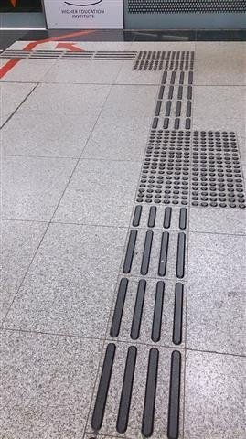
5. Tactile Walking Surface Indicators (TWSI)

TWSIs, also known as detectable warning surfaces or tactile attention indicators, are standardized walking surfaces that convey information to people impacted by blindness through texture and, occasionally, sound.

TWSIs are produced in a range of materials (e.g., concrete, ceramic, metal, rubber, stone or resin). They can be applied as a tile laid in place while concrete is setting or bolted to a walking surface. Some applications can be applied with a spray-on technique. TWSIs should have a texture that can be felt underfoot and detected by a long cane with the adjacent walking surfaces smooth to improve tactual contrast. Their edges should be bevelled to decrease the likelihood of tripping.
A guidance TWSI consisting of elongated bars arranged in a linear pattern.

There are two types of TWSIs:

- Attention TWSIs - sometimes called warning TWSIs which call attention to key hazards such as the start of a staircase or the edge of a platform. Attention TWSIs are grids of truncated domes.

- Guidance TWSIs - also known as wayfinding TWSIs, provide information about the direction of travel through open spaces. They are designed to guide a person on a designated path of travel. These TWSIs are parallel series of raised bars or lozenges set so that the raised bars are in line with the pedestrian's line of travel.

TWSIs should be colour contrasted to the surrounding walking surface. The preferred colour for attention TWSIs is safety yellow (RGB Colour System: 236, 232, 26). Also effective is using a light colour on a dark ground surface or a dark colour on a light ground surface so that the light reflectance value (LRV) is 70% or greater. To clearly differentiate warning information from guidance information, safety yellow should not be used for guidance TWSIs. For more information, refer to the section on Colour and Brightness
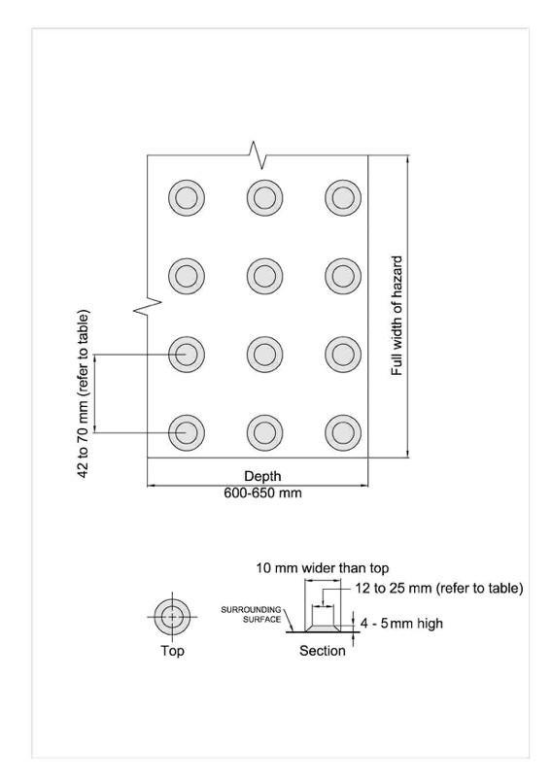
When TWSIs are installed as pre-manufactured panels or surface-mounted onto an existing ground or floor surface, the panels should have bevelled edges. The base surface of the TWSI panels should be no more than three millimetres above the existing surface. Surface-mounted installations are not ideal and should only be considered when cast-in-place or recessed installations can’t be achieved.
TWSIs should always be attached firmly to prevent edges from lifting.

Attention TWSIs provide critical safety information to everyone at potentially dangerous locations, and particularly to people impacted by blindness. They should only be used to identify potential hazards.

It’s important to provide consistent safety information so that people impacted by blindness will recognize potentially dangerous situations in any town or province.
A drawing of attention TWSIs showing dimensions (described in text).

Attention TWSIs should consist of circular, flat-topped, truncated domes or cones installed on a walking surface.

Attention TWSIs should have the following specifications:

- Flat-topped truncated domes or cones should be used, arranged in a square grid pattern, parallel or diagonal at 45 degrees to the main direction of travel.

- The height of the flat-topped domes or cones should be four to five millimetres. In interior environments with exceptionally smooth surfaces, such as polished concrete or terrazzo, the minimum height of four millimetres is preferred.

- The diameter of the top of the flat-topped domes or cones should be between 12 and 25 mm.

- The diameter of the lower base of the flat-topped domes or cones should be 10 mm (+/- 1 mm) more than the diameter of the top.

The spacing between adjacent flat-topped domes or cones should be adjusted depending on their size, as shown in the table below. The larger the individual domes/cones, the more distant the space between them:

A table showing the spacing between domes/cones, based on their top diameter.
Top diameter of flat-topped domes or cones (mm) | Spacing between the centres of adjacent domes or cones (mm)
12 | 42 to 61
15 | 45 to 63
18 | 48 to 65
20 | 50 to 68
25 | 55 to 70

A top diameter of 12 mm is the optimal size of domes or cones for people impacted by blindness to detect and distinguish through the soles of their footwear.

Attention TWSIs should be used at the following locations:
• Platform edges
• Ferry dock edges
• Edges of reflecting pools and fountains that are unprotected at ground level
• Tops of stairs, at landings where there is a door leading onto the landing
• At landings longer than 2,100 mm where there are not continuous handrails
• Both sides of ground-level railway crossings
• Curb ramps and depressed curbs
• Unprotected edges with a drop-off greater than 250 mm in height
• Unprotected edges where the slope down is greater than 1:3 (33 per cent)
• Entry points to vehicular routes where no curb or other element separates pedestrians from vehicles
• At the beginning of ground-level moving walkways (e.g., used in airport terminals)
• At intersecting paths where guidance TWSIs are being used

Attention TWSIs used on platforms, ferry docks and other drop-offs should be:
• 600 – 650 mm deep
• Located at the edge of the drop-off
• Running the full length of all unprotected platform/dock edges that border the drop-off
At stairs, attention TWSIs should commence one tread depth (approximately 300 mm) back from the leading edge of the nosing at the top step, be 600 - 650 mm deep, and extend across the width of the stairs. The attention TWSI alerts a person impacted by blindness that there is a set of stairs ahead and to seek the support of a handrail for safe navigation. For more information, refer to our section on Stairs.

6. Railway Crossings

At railway crossings, attention TWSIs should be located so that the edges of TWSIs are 1,800 – 4,600 mm from the centre line of the nearest rail. Attention TWSIs should be installed in addition to any mechanical barriers that are activated with the arrival of trains.

Railway crossings can present significant accessibility issues for pedestrians impacted by blindness. Railway crossings should include a combination of audible and visual devices to support people who are visually impaired and as well as pedestrians who are deaf and hard of hearing.

To ensure the safety of people impacted by blindness and low vision while crossing a railway, railway crossings must adhere to the following guidelines by Transport Canada. Visit: https://tc.canada.ca/en/rail-transportation/standards/grade-crossings-standards/part-b-existing-grade-crossings#crossing-surface

7. Guidance Tactile Walking Surface Indicators

Guidance TWSIs should consist of a pattern of parallel, flat-topped, elongated bars that extend in the direction of travel.

Guidance TWSIs are appropriate at the following locations:
- Transit stops
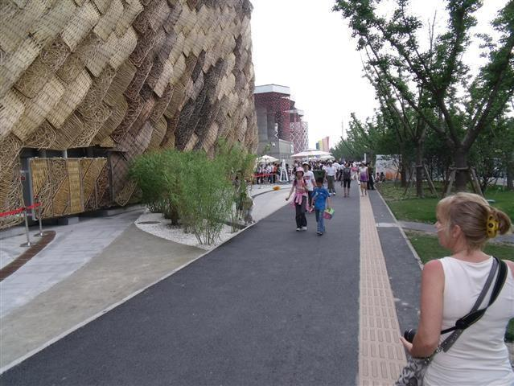
- Train stations
- Subway or light rail transit (LRT) platforms
- Airports
- Sports arenas and stadiums
- Large open spaces (e.g., public squares)
- In the door areas of expansive open areas (e.g., shopping malls)
An asphalt pathway with light-coloured pre-cast concrete guidance TWSIs inset into the surface.

Follow these specifications for guidance TWSIs:

- Where installed to define a route, their width should be 250 – 300 mm.

- Where installed across a route as an indicator of an amenity or diverging route, their width should be 600 – 650 mm.
- They should have a minimum continuous clearance of 600 mm on both sides.
- The height of the bars should be four to five millimetres.
- The top of the flat-topped elongated bars should have a width between 17 and 30 mm.
- The bars should be colour contrasted to surrounding surfaces to make them easily identifiable by people with low vision.
- The width of the base of the bars should be 10 mm (+/- 1 mm) wider than the top.
- The top length of the bars should be at least 270 mm. A space of at least 30 mm should be provided at the ends of the bars.
- The spacing between adjacent flat-topped bars should be adjusted depending on the size of the bars, as shown in the table below. The larger the individual bars, the more distant the space between them.

- Attention TWSIs should be used along tactile guidance paths to identify turns and other decision-making points. The attention TWSIs should be configured in a square pattern centred on the guidance TWSIs, with each side of the square being 600 mm – 650 mm.

A table showing the spacing between the flat-topped bars, based on the top width of the bars.
Top width of flat-topped bars (mm) | Spacing between the centre of adjacent bars (mm)
17 | 57 to 78
20 | 60 to 80
25 | 65 to 83
30 | 70 to 85

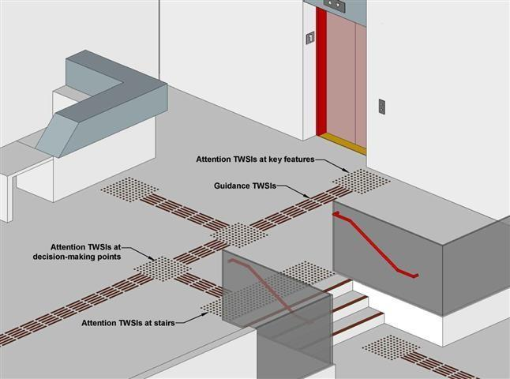

An alternate type of guidance TWSI should be used on road surfaces to assist persons with blindness to navigate complex road crossings including, but not limited to crossing at:
- Roundabouts, also known as traffic circles
- Mid-block crossings with four or more lanes
- Skewed intersections
- Offset crossings
A drawing of a TWSI installation incorporating both guidance and attention TWSIs. Guidance TWSIs provide information to locate a reception desk, stair and elevator. Attention TWSIs are used at changes in direction along the guidance path, as well as at the top of the stairs.

It is important that the guidance TWSIs used on
road surfaces are clearly different and
distinguishable from the guidance surfaces
used in pedestrian areas. Guidance TWSIs on
road surfaces at pedestrian crossings should:
- Be configured as a straight path
- Be 250mm - 300mm wide
- Be detectable underfoot
- Be detectable with a long cane
- Be at least 50% colour/brightness contrasted with adjacent road surfaces
- Not present a tripping hazard
- Not present a barrier for persons who use wheelchairs or other types of mobility devices
- Be configured to mitigate damage from snow plowing

