The Importance of Lighting, Acoustics and Colour Contrast in Interior Spaces

1.Introduction

The importance of lighting, acoustics and colour contrast in interior spaces is incredibly important to help support people who are impacted by blindness or low vision. Having appropriate light levels, adequate colour contrast and paying special attention to the acoustics of a space helps to create an interior environment that is accessible for all users. This discussion paper presents guidelines to enhance the overall accessibility of a space, focusing on elements such as lighting, colour contrast and acoustics. Best practice from San Francisco, California, LightHouse for the Blind and Visually Impaired will also be presented in this section.

2. Interior Lighting

For most people impacted by blindness, good lighting is the most important tool in the built environment because it helps reveal most of the key areas in a space (e.g., stairs and signage). Lighting is also one of the most complex elements of architectural design.

As people age, their eyes require more light to function effectively. An adult in their middle to senior years will need much more light to see well than a younger person. An eye condition can also affect a person’s lighting needs. The same level of light may be fine for a fully sighted person, excessive for someone with glaucoma and too low for someone with macular degeneration. Because of these variations, there is no standard set of guidelines that will meet everyone’s needs.

Listed below are general concepts to keep in mind when designing lighting for a built environment:

2.1 Minimum Lighting Requirements

Existing legislation and standards outline minimum lighting requirements for people who are sighted, but don’t provide definitive lighting levels for people impacted by blindness. In general, provide illumination that is 25 to 50 percent higher than the standard illumination levels specified for rooms and spaces by the Illuminating Engineering Society of North America.
In addition, use the following lighting levels for specific locations:

Lighting levels (in Lux) required by various public spaces.
Location | Lighting Level (in Lux)
Halls | 200
Inquiry/reception stations | 500
Circulation areas: corridors, elevators, stairs | 200
Lounges | 200 to 300
Kitchen and food preparation areas | 200 to 300
Offices, general lighting | 500
Computer workstations | 300 to 500

Note that some people will find enhanced illumination levels overly bright and may be temporarily blinded. Lighting designers should allow users to control lighting intensity wherever possible. This can be achieved in many ways but the most obvious is to use dimmer switches placed prominently and easily locatable.

3. Types of Lighting

There are six principal types of lighting which include:

- Natural daylight
- Incandescent lighting
- Fluorescent lighting
- Tungsten-halogen lighting
- LED lighting
- High-intensity discharge (HID) lighting

Each one affects people impacted by blindness in different ways. Both natural light and artificial lighting can cause glare, which can cause issues for a person living with blindness. The effects of glare are compounded when high-gloss materials are used. Use low-lustre finishes for all vertical and horizontal surfaces.

3.1 Natural Daylight
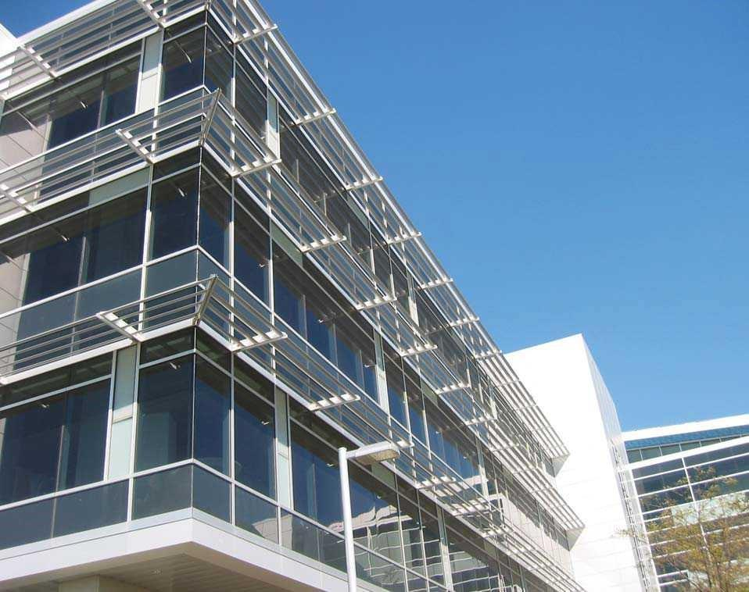
Natural daylight is the source by which all other light sources are judged. Its use has advantages and disadvantages. Although daylight is widely accepted as having a positive psychological effect on people, outdoor luminance varies greatly – it can be as high as 120,000 lux when there is direct sunlight at noon, which can be painful to look at, or it can be as low as five lux when there are storm clouds and the sun is on the horizon.

People impacted by blindness may have problems adapting to different amounts of natural light on days that are intermittently sunny and cloudy.
A photograph of sunshades used on the exterior of the Loblaw Companies Limited facility.
Designed by Sweeny Sterling Finlayson & Co Architects Inc.

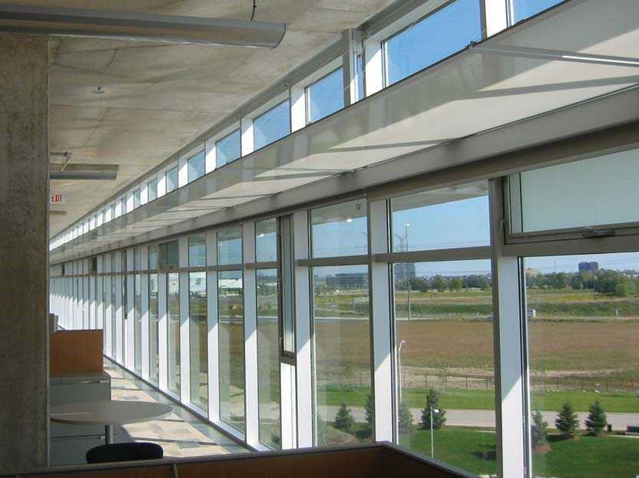

Natural daylight is one of the greatest causes of glare and shadow in building interiors. Inside a building, daylight should be diffused and even, without causing glare or shadowing. Both can be problematic for people impacted by blindness. Effective methods to control glare and shadow include tinted window glass, translucent wall panel systems and exterior awnings and canopies. Special films that reduce solar and visible radiation can be installed on existing windows and glazing.
Viewed from the interior, a photograph of a light shelf within a window assembly in the horizontal position. The exterior louvres are in the same plane and partly visible. A rigging system raises and lowers the light shelves and the valence of the window coverings in response to late, low afternoon sun penetrating the building. Loblaw Companies Limited facility designed by Sweeny Sterling Finlayson & Co Architects Inc.

People impacted by blindness experience
difficulty moving between areas
where there is great contrast in light levels.
It’s important to moderate light levels, especially near entrances. Interior and exterior light levels should be as close to equal as possible. Consider the effects of natural lighting and shadowing when deciding where to place items such as entrance canopies and staircases. Entrance canopies can be effective in reducing glare from natural light sources, but they can also hide the entrance from the view of a person with blindness.

Similarly, staircases located outside should be in clear view at all times and never shadowed by canopies or other objects.

For buildings, there are many ways to mitigate both glare and solar heat gain. Exterior sun shades protect the exterior skin from direct exposure and eliminate glare. Interior window coverings with a maximum of three percent open fabric (one percent is recommended for western exposures) can be automated to respond to glare conditions. Computerized control systems allow the glare condition to be defined to suit users of the occupied spaces and can be easily modified if the use changes.

Natural lighting can be enhanced with the use of light shelves, which are horizontal planes or a series of parabolic louvres about 2,280 mm off the finished floor that bounce indirect light off the ceiling and deeper into the building.

Using these in tandem with automated artificial lighting controls (i.e., that turn off light fixtures when there is enough natural light) is effective in creating more indirect light that is free of glare. It also saves energy.

Skylights and other sources of natural light should be positioned so that sunlight does not shine directly into an interior space. If this isn’t possible, use tinted glazing or incorporate a shading device.

3.2 Incandescent Lighting

Incandescent lighting is produced by light bulbs that give off both heat and light and is a good alternative to natural light. Because its colour spectrum is closer to natural light than many other light sources, it was traditionally the preferred source for general-purpose illumination.

However, incandescent bulbs are energy inefficient and are being replaced in many applications by devices such as fluorescent lamps, HIDs and LEDs, which give more visible light for the same amount of electrical energy input. Some jurisdictions are attempting to ban the use of incandescent light bulbs in favour of more energy-efficient lighting. In the United States, the Energy Independence and Security Act of 2007 required a 25 percent increase in the efficiency of light bulbs. Incandescent bulbs from 100 watt to 40 watt bulbs not meeting efficiency standards are prohibited by law and are being replaced by other lighting technologies.

3.3 Fluorescent Lighting
A photograph illustrating the use of linear overhead lighting along the centre of a hallway to assist with navigation. High colour contrast used at the edge of the floor and base of the walls distinguishes width and also aids with navigation.

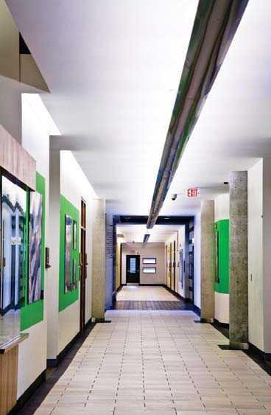
Fluorescent lighting consumes less electricity, lasts longer and does not radiate as much heat as incandescent bulbs. It can come in the form of tubes that create a line of light, which is the traditional lighting environment in large buildings and offices. It can also come in the form of bulbs, known as Compact Fluorescent Lamps (CFLs). CFLs provide good overall light and are increasingly popular in the built environment. Many jurisdictions encourage their use as an energy-saving measure through incentive programs and legislation.

A fluorescent tube is a more diffuse and physically larger light source than an incandescent lamp. In suitably designed lamps, fluorescent light can be more evenly distributed without a point source of glare as produced by an incandescent filament.
Fluorescent lighting has a major disadvantage in the slight flicker it produces. There are several ways to counteract this effect. Use proper lenses or shield the light source to provide even, indirect lighting. Or, use two tubes operating in phase opposition. These fixtures produce a substantially reduced flicker when used as an indirect light source or combined with prismatic diffusion covers, lattices, translucent shades or cover panels.

Today, most offices have well-designed lighting. Banks of overly bright, improperly shaded fluorescents are becoming a thing of the past.

Fluorescent lighting now comes in a range of shades in the light spectrum. The cool “blue” tones of the past were not a good match for natural or incandescent light. Today’s better formulations of phosphor inside the tubes provide warmer tones. The best “soft” or “warm” white fluorescent bulbs available now are similar in colour to standard incandescent lighting.
Dimmable fluorescent lighting fixtures, which use electronic ballasts working at a high frequency, will reduce both the flicker of light and energy consumption. Reduced flickering is less tiring and distracting for older adults and people impacted by blindness – particularly those who rely on peripheral vision.

If using a linear arrangement of fluorescent lighting in corridors, designers can take advantage of their directional attribute by installing the tubes in one of two ways:

- Center: Placing the light fixture in the middle of the corridor provides a visual cue for orientation by helping to define the right and left sides of the corridor. This can be achieved by either indirect or direct lighting. In the case where indirect lighting is used, the center of the corridor ceiling appears as a dark line with even, diffused, indirect and glare-free light on the ceiling.

- Sides: Placing light fixtures at the two sides of the corridor where walls meet the ceiling provides a similar visual cue that defines the width of the passageway and facilitates navigation. In this case, the lighting is indirect - the fluorescent tubes are tucked into valances or light coves along the sides. The bulbs are not visible and the cove system produces an acceptable “soft” light effect.

3.4 Tungsten-Halogen lighting

Tungsten-halogen lighting is a type of incandescent lighting where a bulb’s filament is surrounded by an inert gas and a small amount of halogen, which makes the bulb more efficient and increases its lifespan.

Halogen lighting produces a bright white light and provides more light per watt than regular incandescent bulbs, making it a good source of task lighting. Because halogen lights are so bright, the positioning of light bulbs needs to be considered to reduce glare and shadow.

Halogen lights also give off a great deal of heat, which is an important safety consideration in any built environment. Don’t position halogen lights in an area beneath which someone with blindness might inadvertently sit or stand and be injured from the heat. If sight is required to notice the danger, either the lights should be moved out of the way or a barrier (e.g., a railing) should be used to prevent injury.

3.5 Light-Emitting Diode lighting

LED lighting emits an energy-efficient source of light when electricity is applied to a simple circuit. LED bulbs produce light that is very similar to daylight, making these bulbs practical. They are frequently used as a directional light source, to focus light on an object or building element such as a sign or reception desk. LEDs can also be configured in arrays within bulbs, providing multi-directional illumination similar to that produced by incandescent bulbs.
LED bulbs produce no ultraviolet (UV) radiation and little heat, making them ideal for illuminating objects that are sensitive to UV light, such as works of art.

Traditionally used as indicator lights on electronic devices, LED bulbs are now used in wider applications including signage, streetlamps and architectural detail lighting. LED lighting is also used as task or spot lighting (e.g., under kitchen cabinets to illuminate countertops).

Many bulbs and lamps (especially the older T12 fluorescents) are being phased out, partly due to inefficient lighting, and partly due to the use of higher mercury content in the bulbs. This increases the push to use LED lighting.

LED Sources:
- Light up instantly
- Can be easily dimmed
- Operate silently
- Require only a low-voltage power supply (which increases safety)
- Are increasingly more common and affordable

3.6 High-Intensity Discharge lighting

HID bulbs are a type of arc lamp that have a longer life and provide more light (lumens) per watt than any other light source. They are available in mercury vapour, metal halide, and high- and low-pressure sodium types.

Low-pressure sodium vapour lamps are extremely efficient. They produce a deep yellow-orange light and have an effective colour rendering index of nearly zero. Items viewed under their light appear monochromatic, which has implications for people impacted by blindness. Metal halide and ceramic metal halide lamps can be made to give off neutral white light, which is useful for applications where normal colour appearance is critical (e.g., TV and movie production, indoor or night-time sports games, automotive headlamps and aquarium lighting).
High-pressure sodium lamps tend to produce a much whiter light, but still with a characteristic orange-pink cast. New colour-corrected versions producing a whiter light are available, but some efficiency is sacrificed for the improved colour.

HID lamps are typically used in large areas that require high levels of overhead light and when energy efficiency and/or light intensity are desired (e.g., gymnasiums, large public areas, warehouses, movie theatres, football stadiums, outdoor activity areas, roadways, parking lots and pathways). More recently, HID lamps, especially metal halide, have been used in small retail and residential environments. HID lamps have made indoor gardening practical, particularly for plants that require a good deal of high-intensity sunlight.

4. Acoustics

Sounds can give a person useful information about a space. People impacted by blindness may snap their fingers, tap a long cane or make another noise to listen for a reflected sound, a process known as “echolocation”

Echolocation may help to detect the size of a room, presence of corridors or proximity of structural barriers (e.g., walls and poles). Within a built space, specific sounds can provide information about the location of specific features, such as elevators. However, the space must be designed to allow all of these sounds to be heard.

High levels of reflected and ambient sound (sound glare) within an environment will result in sound masking. Sound glare interferes with the process of locating an auditory cue and can confuse and tire a listener. Crowds of people, construction or maintenance noise, a jet plane flying overhead or background music in lobbies and elevators can drown out useful auditory information. Layouts that feature large rooms with high, open ceilings can result in excessive noise, making navigation or orientation extremely difficult for someone impacted by blindness. If possible, avoid this kind of layout to ensure all guests and patrons have the best possible experience. Otherwise, consider using material for ceilings or walls that baffle or muffle sound reflection in very noisy environments or installing noise-masking devices such as white noise generators.
A solid object located between a sound source and a listener can create a sound shadow. Sound shadows can provide useful information, but they can also cause disorientation for a person who relies on specific sound cues for mobility. For example, a temporary display, scaffolds used for building maintenance and repairs, or decorative items that are positioned after building construction can distort or block critical sounds.

While a building designer can’t control every occurrence of sound glare or shadowing, several steps should be considered when planning the acoustic design of a space:

- Well-defined, acoustically alive spaces are easier for people impacted by blindness to traverse safely. Position elements such as water fountains, elevators or escalators to create useful sounds. For example, a water fountain could be positioned to indicate a garden or reception hall. An escalator would be a good indicator of a central location that’s an important part of the building’s design.

- Carpets, acoustic ceiling tiles and upholstered furniture absorb sound and dampen reflected sound. Create a good balance of sound absorption and sound reflective materials so that people can “hear” the space (i.e., get information about the space through sound).

- Sound sources may mask other sounds intended to provide important directional cues. Consider the noise produced by elements such as ventilation ducts or air conditioning units. These sounds can be useful in wayfinding, but they should not obscure other important audio cues, such as the sounds from an elevator’s arrival or a public address system.

- Sound masking devices (e.g., white noise devices) can be used effectively in many situations to block unwanted noise, but make sure they don’t dampen all sounds in a space.

- Glass can be an effective sound buffer. Use double-glazed glass that has an established sound-reduction capacity.

Reflected sounds that enable a person to use echolocation are frequently a good source of auditory cues. Consider how the structure and texture of planned circulation routes might interact with user-created sounds (e.g., the tapping of a cane) before building or retrofitting a space.

5. Colour and brightness contrast

The role of colour and brightness contrast is integral to how people negotiate and understand the built environment.

Colour contrast is the degree of difference between one colour and another on the colour wheel: the more visually different the colours, the greater the contrast. Brightness contrast (also known as luminance contrast) is the difference in brightness between one object or surface and another: the greater the difference in brightness levels, the greater the contrast.

A person with excellent vision could enter a well-designed and logically organized building with good signage, little or no glare and minimum shadowing and still experience a sense of disorientation if there’s little contrast in the colour or brightness of their surroundings. These problems increase significantly for a person with blindness.

In the built environment, colour and brightness contrast can be used effectively for many purposes. It can be used to identify a door opening, to draw attention to signage and to define a route of travel. It can also be used for orientation. For example, a building designer may opt to use different colours for different sections or floors in a building. However, consistency and simplicity are also important. Providing colour and brightness contrast at every turn or change in architectural detail can be confusing.
To benefit someone with blindness, all parts of a built environment must be considered when it comes to colour and brightness contrast. For example, a light-coloured door against a light-coloured wall would be easier to identify if the door frame and door were a dark colour, such as brown. A sign is much easier to locate when its colour and brightness contrast to the surrounding wall surface.
Wherever possible, the colour and brightness contrast of key elements in the built environment should be at least 50 per cent (higher levels are preferred). The colour and brightness contrast on signs and pictograms should be at least 70 per cent.

Use a light meter to measure the colour and brightness contrast of surfaces. Hold the light meter 200 – 250 mm above the brighter surface (B1) to measure its light reflectance value (LRV). Then do the same with the darker surface (B2). Plug your measures into this formula:
• Colour/brightness contrast = [(B1 – B2)/B1] x 100
Manufacturers often provide LRVs on paint chips and other material samples. LRV calculators can also be found online.
Follow these guidelines to produce colour and brightness contrast for exterior spaces, interior spaces and signs:

Use noticeably different colours side by side to distinguish different key building elements.

Some good combinations are:

- Black/white
- Yellow/black
- Chocolate brown/white
- Dark blue/white
- Dark red/white
- Dark purple/white
- Dark green/white
- Orange/black

Avoid these colour combinations, which have poor contrast:

- Yellow/grey
- Yellow/white
- Black/violet
- Red/black
- Grey/white
- Light blue/white

Avoid these colour combinations, which have poor contrast and are particularly difficult for people with colour blindness:

- Red/green

- Blue/green

- White lettering on a dark background is easier to read for people impacted by blindness than dark letters on a white background. Further information is provided in the Signage section.

- Keep colour schemes simple to avoid confusion in your design. Too many colours and busy patterns create confusion.

- Be consistent in the use of colours to convey specific information. For example, use one colour for all entrances to women's washrooms in a building and a contrasting colour for all entrances to men's washrooms.

- When it's impossible to adjust the colour or contrast of an item, consider other options. For example, when the colours in a corporate logo can't be changed and the logo includes colours with poor contrast, place a contrasting border around logo signage.

Case Study
Best Practice: LightHouse for the Visually Impaired
About LightHouse

1. Introduction

LightHouse for the visually impaired is a not-for-profit organization located in San Francisco, California and is one of the oldest social-services organizations in the state. LightHouse provides training and education for people who are blind to help them navigate public transit, safely use kitchen appliances and use screen reading software to listen to emails and messages. LightHouse offers a strong sense of community and has helped thousands of people living with blindness to gain confidence and independence (LightHouse, 2021).

Recently, LightHouse has undergone renovations in order to expand their services. Architects at Mark Cavagnero Associates had the opportunity to look at architecture and design with a different perspective. New methods and skills were needed to create a building that would be fully designed to benefit those with sight impairment.

The new LightHouse headquarters was designed with careful consideration and focused heavily on incorporating elements such as appropriate lighting, acoustics, texture and wayfinding cues to support clients and staff members with visual impairment (CSI, 2018).

to of LightHouse: Reception area

Photo of LightHouse: Reception Area
Source: The LighHouse, 2021

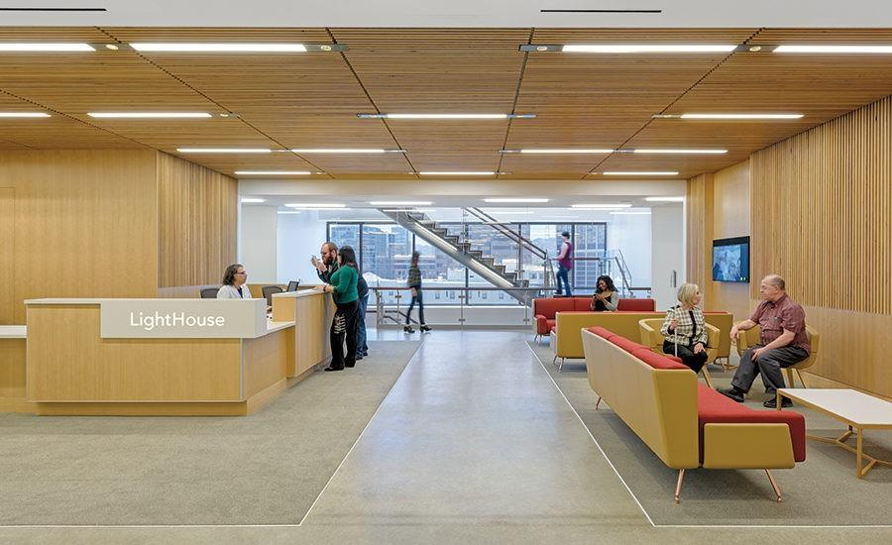

2. Acoustics

Acoustics was a very important component of the new LightHouse headquarters. The design team focused on emphasizing the right types of sounds, therefore, unnecessary sounds such as mechanical noises were addressed early on in the design process. The goal was not to block all sounds but instead create a space that was warm and lively (CSI, 2018).

Architects, engineers and designers worked closely with Arup, an engineering firm in San Francisco and used their sound lab where they created 3D acoustics models of spaces in LightHouse to test prior to construction. They did a test run of different floor materials and ran it through a computer simulation which enabled them to listen to what the room would sound like. LightHouse stakeholders spend two days in the sound lab listening to which materials generated the most positive and warm sounds (Arup Americas, 2016).

Polished concrete was chosen as the primary flooring material due to its acoustics. The concrete allowed individuals to hear other people’s cane taps against the floor as well as the sound of service dogs walking on the floor, thus resulting in a lively, energetic space filled with human interaction (CSI, 2018). Several other materials were tested such as carpet and bamboo flooring. Carpet generated no cane feedback while bamboo flooring gave a plastic sound.

Secondary acoustic glazing was also used to keep outside vehicle noise from interrupting meetings and other activities in the boardroom and multipurpose room. It was also decided that a higher level of acoustic separation be required between private offices in order for staff not to be able to hear their neighbours, therefore, a Noise Isolation Class (NIC) of 42 was specified (CSI, 2018). However, too much sound separation at the office front would have resulted in an office occupant being unaware of events taking place outside, thus a lower NIC of 30 was set. This NIC 30 performance is achieved with 9.5 mm (3/8-in.) laminated glass and acoustic door seals, which suppress distracting noises while allowing a sense of activity and vitality to filter through (CSI, 2018).

3. Staircase

A large open staircase was also included in the building which connects the 3 floors of the LightHouse. The staircase includes multiple elements that were tested and mocked- up, including acoustics.
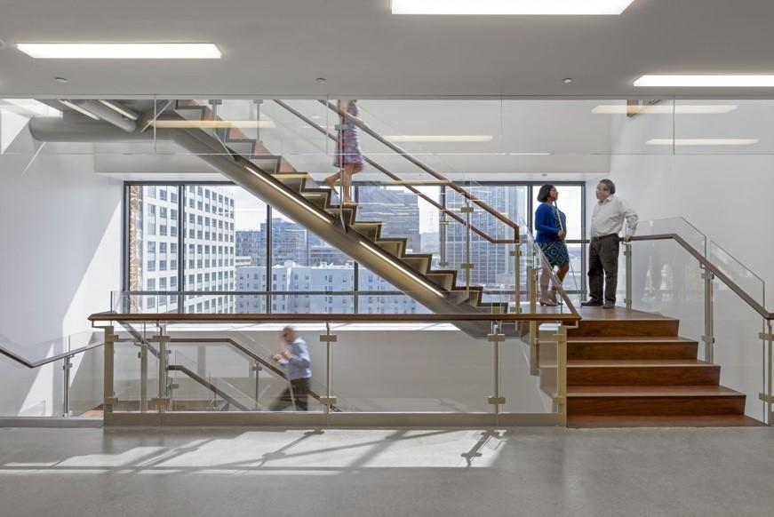
A large open staircase was also included in the building which connects the 3 floors in LightHouse. The staircase includes multiple elements that were tested and mocked- up, including acoustics.

Source:

Large open staircase which connects the 3 floors of the LightHouse.
Source: The LighHouse, 2021

Strong woods for the stairs, particularly ipe wood was used for the staircase as it worked best for people with metal tip canes and it generated the most useful and pleasant feedback. A contrasting strip was also used on the edge of each step instead of just at the top and bottom of the stair run as required by California
H

Photo of 3D printed stair nosing profile mock-ups
Source: Mark Cavagnero Associates Architects
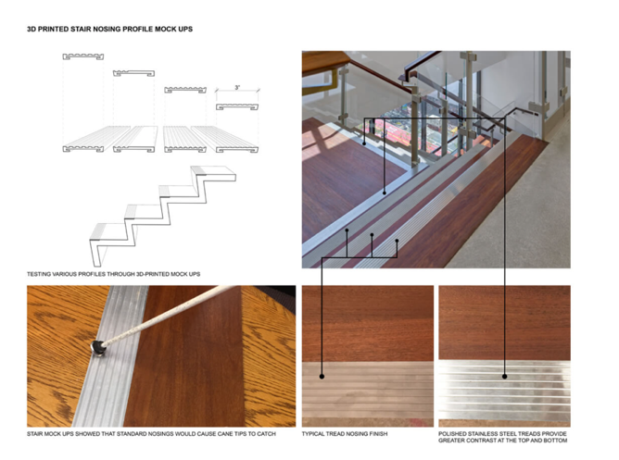
Building Code. For low vision users having a strip on each step made the staircase much more accessible (CSI, 2018).

3.1 Nosing
The nosing of each step was carefully designed. At first, architects had chosen
a standard grooved aluminum bar for
the nosing but after putting it to the
test, it was evaluated that canes got
caught on the grooves thus presenting
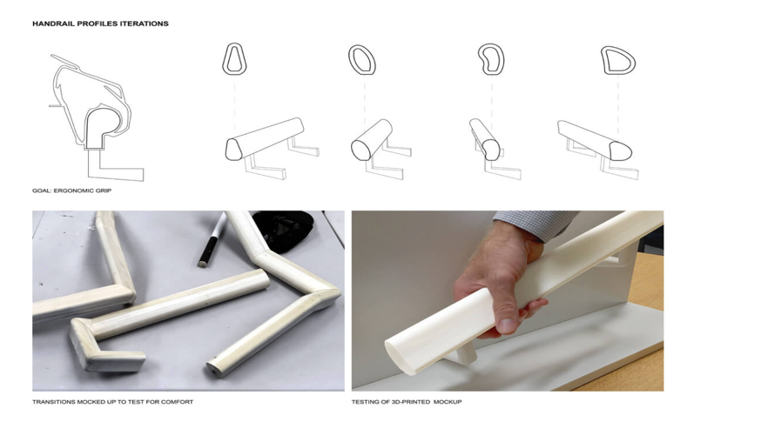
an uncomfortable navigation while

Photo of 3D Handrail mock-ups
Source: Mark Cavagnero Associates Architects

walking up and down the staircase. To
solve the problem additional mock-ups were created. This resulted in narrow grooves to avoid canes from catching on the grooves (CSI, 2018).

3.2 Railing
The railing on the staircase was another important element. Approximately 5 mock- ups were conducted to see which types of materials and shapes
were the most universally accessible
for people of all ages. The top of the
rail is a rounded half ellipse allowing
for the fingers to wrap around, and beneath is a slightly concave groove that provides a nice resting spot for the thumb as it glides along the rail (CSI, 2018).

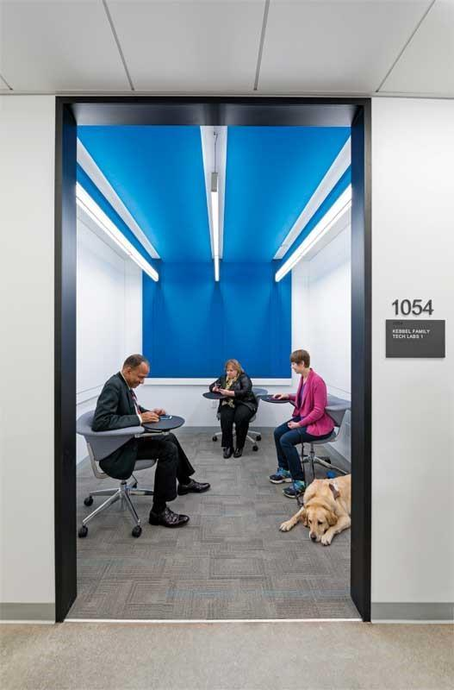
4. Lighting

Lighting was a crucial aspect of LightHouse space. 90% of people who are blind do have some form of vision, therefore appropriate lighting levels are needed to support people who are visually impaired. Through extensively evaluating different lighting mock-ups, soft balance light with no source of brightness or glare was preferred by the LightHouse staff who had visual impairment. However, this created a challenge since these types of light fixtures use a lot of energy therefore, it did not meet the California Energy Code. A petition was created to get some latitude on the energy code for blind patrons and staff to have a space that was designed to support their needs. Adjustments were done everywhere else in the building to conserve energy therefore the state allowed the light fixtures (CSI, 2018).

Photo of lighting in the LightHouse.
Source: CSI, 2018

5. Wayfinding:

Photo shows LED Panels, signage and layout
Source: The LightHouse, 2021

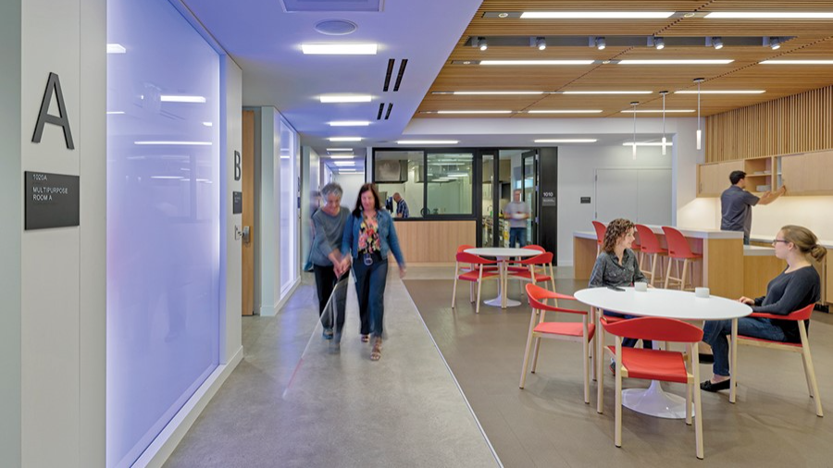

The use of wayfinding in an indoor building is incredibly important as it helps people navigate independently. Signage, acoustics and lighting were all used as part of LightHouse wayfinding strategy.

Outside each room/office space, there is an oversized 3D letter/number which contrasts nicely with the wall making it easier to be identified. Underneath the letter there is a smaller, code- confirming raised room number that is placed at an appropriate height for people to touch the tactile lettering. Braille is also provided on the sign. Lighting was also used to help with navigation. LED panels were placed at the end of each floor on the walls and vivid colors were used to make it easier for people of lower vision to identify. Wayfinding was incorporated by separating spaces with different flooring and textures to create a contrast. A ring of polished concrete encircles public areas on each floor such as lounge areas and information desks while open spaces are defined by metal floor transition strips to give an indication of spatial demarcation to cane users. Acoustics were also used to create intuitive wayfinding. By choosing a polished concrete flooring, the space generated useful cane feedback thus helping people visualize their surroundings through echolocation (CSI, 2018).

6. Finishes

When it came to selecting finishes, the tactile quality of surfaces was heavily considered. Wood slates wrap the ceilings and walls so they can be felt by touch as well as seen. Furthermore, wood-slate ceiling finishes were used in large spaces such as boardrooms, to create a sense of warmth while still providing adequate acoustical control (CSI, 2018).

For more information about LightHouse for the Blind and Visually Impaired, visit:

https://lighthouse-sf.org/safestreets/

https://www.constructionspecifier.com/illuminating-design-visually-impaired/

https://www.youtube.com/watch?v=hqL0zZspwac

