Communication Systems

1.Introduction
While it’s important to review the characteristics and common features of the built environment that support independent wayfinding, it is also important to proactively provide information to people impacted by blindness about building services and safety. This information can be provided in a variety of formats (i.e., visual, audible or tactile) and in a variety of ways.

This discussion paper will focus on the different types of communication systems available. This includes information desks, kiosks, directories and virtual agents.

2. Communication Systems
2.1. Information Desks

Many buildings have information desks staffed by an attendant. It’s often easier for a person impacted by blindness to ask an attendant for directions than find information from a directory.

Attendants should receive specific customer service training on how to provide good information to people with disabilities. This includes teaching attendants to communicate effectively with people impacted by blindness and use appropriate devices such as assistive listening systems (which augment sound for people with hearing aids) to communicate with people who are deafblind. In addition, training for information desk attendants should include appropriate guiding and etiquette techniques for assisting customers or visitors who have blindness.

An information desk should be strategically located in relation to the main entrance of a building so that it’s easy to find and quickly accessed (i.e., placed in front of or at right angles to the main entrance). It could be highlighted using colour and brightness contrast in both the design of the desk and the path leading towards it. Consider using directional TWSIs or textural contrasts in floor materials (detectable by a long cane and underfoot) to lead individuals directly from the main entrance to the information desk.

2.2. Information Telephones

If there is no information desk available, consider placing an information telephone near the entrance, accompanied by instructions on the purpose of the phone and how to use it. It is best to present instructions visually and in braille.

Employees answering information phones should be trained to provide assistance to people impacted by blindness. The phones should also include a system for people with hearing loss, as pre-recorded messages are not sufficient.

Use colour contrast to easily distinguish information phones from their surroundings. Use directional TWSIs or textural contrasts in floor materials (detectable by a long cane and underfoot) to lead individuals directly from the main entrance to the information phone.

2.3. Directories 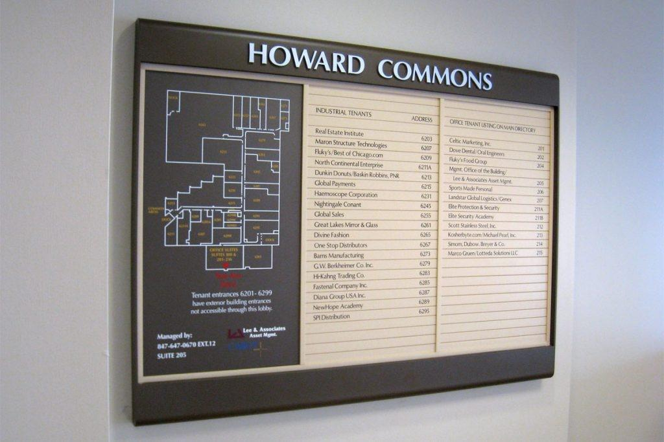
Photo example of a directory that illustrates the layout of the floor by a tactile map. Services are provided in tactile lettering.
Source: Desk & Door Nameplate Co.

Directories that provide information about a building’s layout and services should be easy to use and locate. Place them near all entrances in logical locations. If a building requires a number of different directories for different areas, place them in a consistent location on each floor (i.e., beside the elevators).

Directories should include raised print as well as print lettering, with characters at least 16 mm in height. They should also include braille.

Ideally, directories will incorporate a tactile map that is readable by sight and touch. This should illustrate the layout of the floor on which the directory is located, as well as the principal paths of travel to features and services on the floor. Tactile maps should not try to present too much information or be too cluttered as this will obscure what information is presented.

In multi-story buildings, it’s useful to include a tactile cross-sectional map of the building, indicating the number of floors and the features and services provided on each floor.

Use directional TWSIs or textural contrasts in floor materials (detectable by a long cane and underfoot) to lead individuals directly from the main entrance to the building directory. In multi-story buildings, they should be used from the elevator to the floor directories.

2.4. Information Kiosks
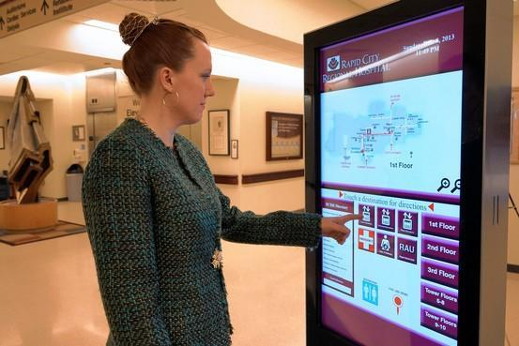

Photo of a women interacting with an information kiosk by touching the screen to look at a photo of a map.
Source: The wall Street Journal

Some spaces have stand-alone interactive information centres, also known as information kiosks. Such centres or kiosks may consist of a video display unit with a touch screen, tactile keypad and auditory information. It’s important to note that providing visual information alone is not enough.

Information kiosks are more helpful when they are accessible. The first step is making sure that someone impacted by blindness can determine the location of the kiosk.
Information kiosks can create serious barriers for people impacted by blindness if the kiosk does not provide accessibility features. In recent years, considerable progress has been made in making self-serve kiosks accessible, but these devices are few and far between.
When deploying information kiosks ensure that the devices are:
- Located in an area easily found by visitors with sight loss;
- Placed outside the path of travel;
- Usable by people impacted by sight loss with either large high contrast adjustable text and/or text to speech output;
- Navigable by visitors with physical disabilities who may use a wheelchair or other mobility device.

Detailed specifications for accessible kiosks and self serve devices can be found on the CSA Group website; see B651.2-07 Accessible design for self-service interactive devices

Kiosks should provide voice output, possibly through a earphone jack. If using touch-screen systems for user input, keyboard or keypad input should be available, or precise directions via the voice output.
Incorporate software packages that can magnify text on information kiosk screens from two to 16 times. Make sure users are able to adjust the colour contrast between the text and the background. This will help users with limited vision to see the screen. Locate monitors so that users can position themselves within a few centimetres of the screen, if necessary.
Additional information on information kiosks can be found in the Canadian Standards Association’s “Accessible Design for Self-Service Interactive Devices” document, CAN/CSA-B651.2-07 (R2017). The document is available through the ShopCSA website ["https://www.csagroup.org/store/product/2702626/"].

2.5. Audible signs

Audible signs are signs that use speech technology to supplement the information typically found on print signs. Using audible signs exclusively is not recommended, as they don’t provide an accessible solution for individuals with hearing loss.

More and more, audible signs are becoming part of the built environment for the benefit of most users, not just those with blindness. They are commonly used in elevators to direct passengers to the correct floor. They are being used increasingly by public transit systems to automate the announcement of upcoming stops and the destination of arriving transit. They are also becoming more common in complex environments such as transit stations and malls to provide wayfinding information.
Audible signs should be simple and intuitive to use. They should be audible only when required (i.e., to the user only, not to all passing people) and silent when necessary.

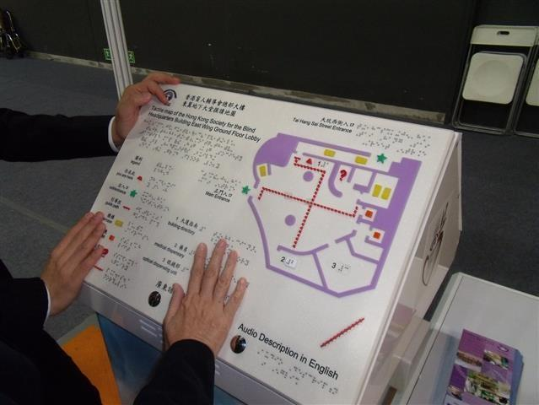
Audible signs can be manually activated by a button or other control, or automatically activated using technologies such as radio-frequency identification (RFID), infrared (IR) transmitters, or Bluetooth. Applications of these technologies and new technologies are evolving rapidly. Automatic activation is preferred, as buttons/controls can be difficult to locate by people impacted by blindness. Audible signs with automatic activation might continuously provide a simple message such as "approaching end of moving walkway", provide information when a pedestrian is detected, or provide information only to users with a special receiver. When a special receiver is used, information can be more expansive and be designed specifically for pedestrians impacted by blindness however, provision of the receiver is necessary in such a case.

2.6. Tactile Map and Pre-Recorded Instructions

Tactile maps or pre-recorded instructions can help people impacted by blindness find their way independently in complex buildings or groups of buildings. There are two main types of tactile maps: large-scale maps that provide information about the general layout and small hand-held maps that give specific route information.
A tactile directory and map located on an inclined podium featuring braille and tactile lettering. The map incorporates colours and shape coding to identify key elements and routes. The directory also provides audio information through the push of a button.

Maps that include a considerable amount of information sometimes incorporate one or more of the following design elements:
- A braille overlay that folds over and locks onto a map, giving details about facilities
- A brief braille commentary on the side of the map
- Separate spaces embossed on the map indicating different things (i.e., destinations, routes, spaces and rooms)

Tactile maps or pre-recorded instructions should be available at a building’s main entrance or reception area. They could also be sent to visitors upon request prior to their arrival.
Another strategy to assist people impacted by blindness to better understand the layout of a facility is to make maps and route descriptions available on a company website. This allows individuals to print the map in advance and enhance the map’s accessibility as required
(i.e., magnification and other screen-reading technologies). A route description should accompany any downloadable maps and the instructions should be formatted using CNIB’s Clear Print guidelines. Maps can be downloaded in advance and used to navigate the building on site using a printout or a text-to-speech application on a smartphone. Companies or organizations can also explore the use of services such as Click and Go Maps that provide a range of mapping services for buildings from tactile and auditory maps to web-based maps that allow visitors to "pre visit" the location virtually. link: "https://www.clickandgomaps.com/"]
Another approach to providing accessible maps is the use of 3D printed maps. While this technology is relatively new it is becoming increasingly more affordable. CNIB will be exploring methods of generating tactile maps using 3D printing to increase the availability of accessible maps and signs. This work is in its early days however the hope is to have recommendations and guides available in the coming years.

2.7. Virtual agents

There are numerous virtual agent apps available that have been designed to support those impacted by blindness to navigate seamlessly in any environment, no matter the complexity. These virtual agents can serve as a useful, convenient tool, especially when traveling independently in unfamiliar areas.

AIRA and Be My Eyes, are both leading app-based services that help guide blind and low sighted individuals find their desired destination. At the touch of a button, people who are blind or partially sighted can connect with sighted volunteers and agents to receive visual information and support through the convenience of their smartphones.

2.7.1 AIRA and Be My Eyes

AIRA is the world's fastest-growing subscription-based service provider for those who are impacted by blindness or those who are partially sighted. It enables travelers to connect to professionally trained agents who give visual information to those impacted by blindness or low vision to safely reach their destination. Furthermore, the app can locate their environment due to the camera app built into the user’s smartphone, thus helping to provide adequate direction, helping users find their way safely and gain independence.

AIRA, while initially designed for people living with blindness, can provide useful assistance to anyone. This service may be particularly useful to persons with cognitive challenges, especially in unfamiliar environments.

AIRA uses a team of highly skilled agents that are ready to help with any tasks. Agents go through extensive training therefore, any agent that picks up the call will be able to guide users in an effective manner. Aira agents have access to a multifunctional dashboard that includes a satellite image of the person's surroundings as well as internet map integration. AIRA agents are also available 24/7, seven days a week, giving users access to assistance at any time.

Be My Eyes is another popular app-based service that gives assistance to blind and low sighted individuals. However, Be My Eyes uses volunteers instead of highly trained professionals to give visual information. Furthermore, since the team of Be My Eyes consists of volunteers, wait time might be more lengthy and less consistent compared to AIRA who will answer the users' call within 30 seconds or less.

Both virtual agent apps; Be My Eyes and AIRA are two of the most popular services to assist blind and low sighted individuals to safely find their desired destination. Both apps are available for either the iOS and Android platforms.

